**PRACTICAL NO :- 1**

**Aim:-Configure IP SLA Tracking and Path Control Topology**

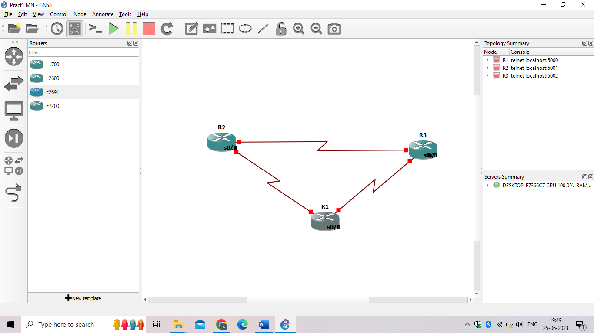

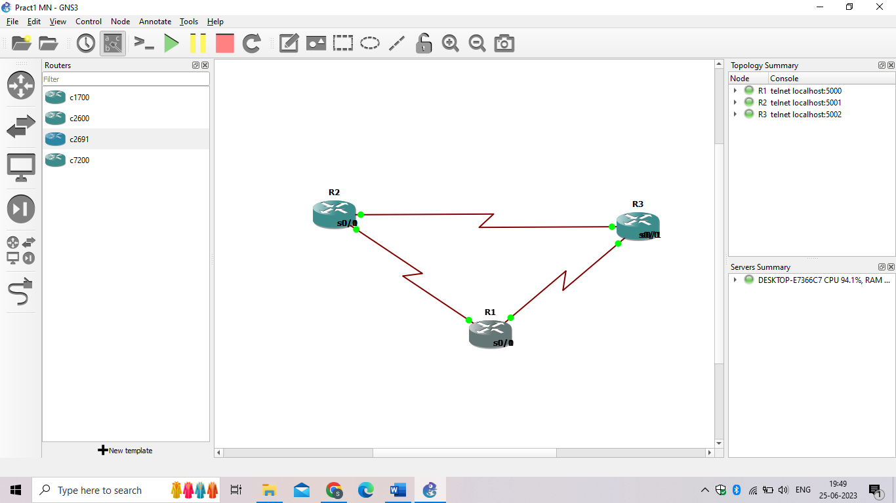

**Step 1: Configure loopbacks and assign addresses.**

1. Cable the network as shown in the topology diagram. Erase the startup configuration and reload each router to clear the previous configurations. Using the addressing scheme in the diagram, create the loopback interfaces and apply IP addresses to them as well as the serial interfaces on R1, ISP1, and ISP2.
2. Verify the configuration by using the **show interfaces description** command. The output from router R1 is shown here as an example.

R1# **show interfaces description | include up**

**Router R1**

hostname R1

interface Loopback 0

 description R1 LAN

 ip address 192.168.1.1 255.255.255.0

interface Serial0/0

 description R1 --> ISP1

 ip address 209.165.201.2 255.255.255.252

 clock rate 128000

 bandwidth 128

 no shutdown

interface Serial0/1

 description R1 --> ISP2

 ip address 209.165.202.130 255.255.255.252

 bandwidth 128

 no shutdown

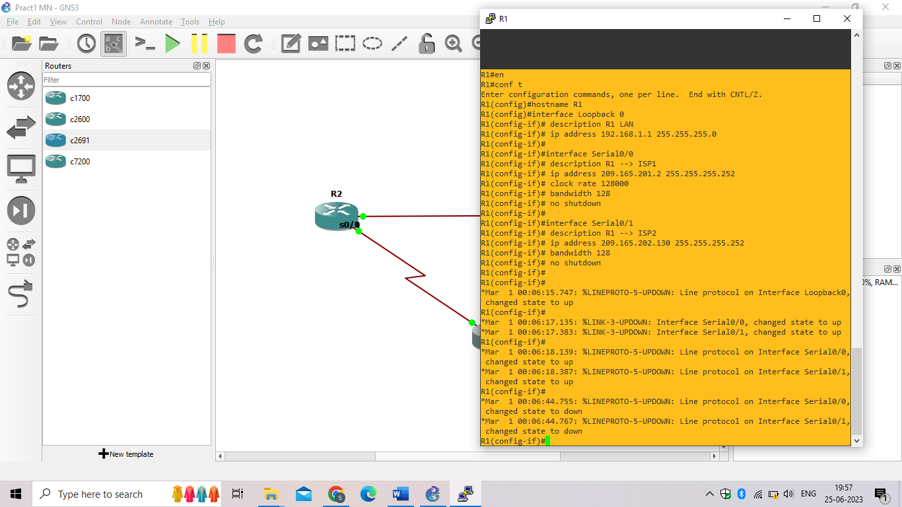

**Router ISP1 (R2)**

hostname ISP1

interface Loopback0

 description Simulated Internet Web Server

 ip address 209.165.200.254 255.255.255.255

interface Loopback1

 description ISP1 DNS Server

 ip address 209.165.201.30 255.255.255.255

interface Serial0/0

 description ISP1 --> R1

 ip address 209.165.201.1 255.255.255.252

 bandwidth 128

 no shutdown

interface Serial0/1

 description ISP1 --> ISP2

 ip address 209.165.200.225 255.255.255.252

 clock rate 128000

 bandwidth 128

 no shutdown

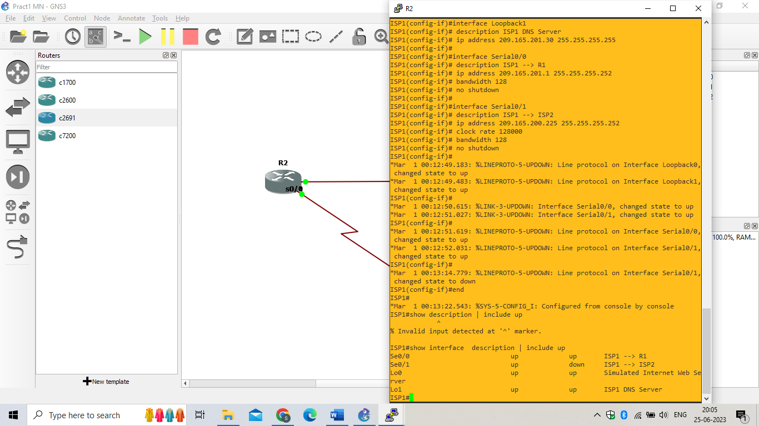

**Router ISP2 (R3)**

hostname ISP2

interface Loopback0

 description Simulated Internet Web Server

 ip address 209.165.200.254 255.255.255.255

interface Loopback1

 description ISP2 DNS Server

 ip address 209.165.202.158 255.255.255.255

interface Serial0/0

 description ISP2 --> R1

 ip address 209.165.202.129 255.255.255.252

 clock rate 128000

 bandwidth 128

 no shutdown

interface Serial0/1

 description ISP2 --> ISP1

 ip address 209.165.200.226 255.255.255.252

 bandwidth 128

 no shutdown

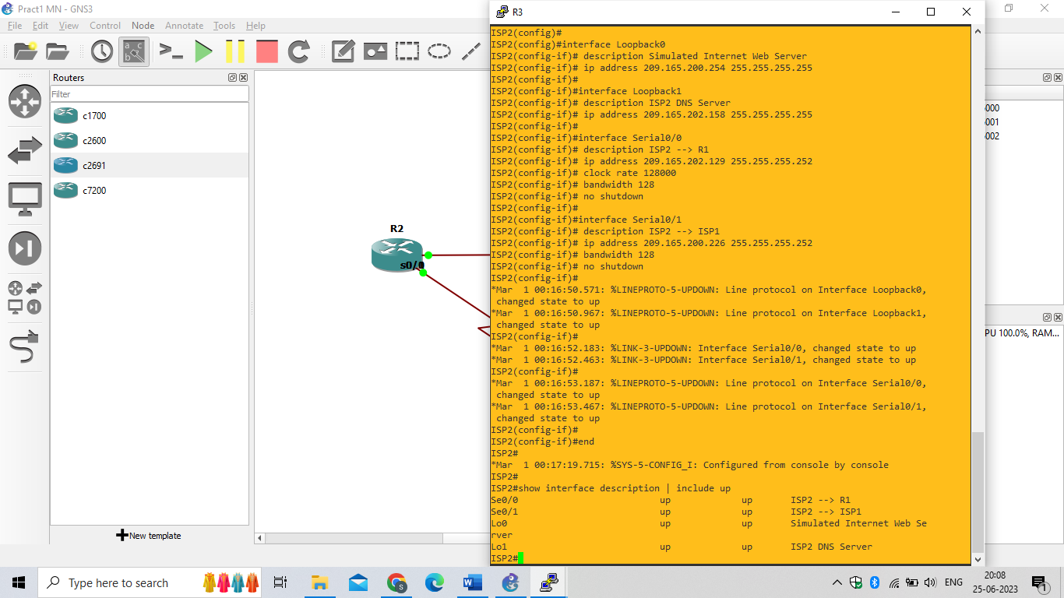

### Step 2: Configure  static routing.

1. Implement the routing policies on the respective routers. You can copy and paste the following configurations.

**Router R1**

R1(config)# **ip route 0.0.0.0 0.0.0.0 209.165.201.1**

R1(config)#

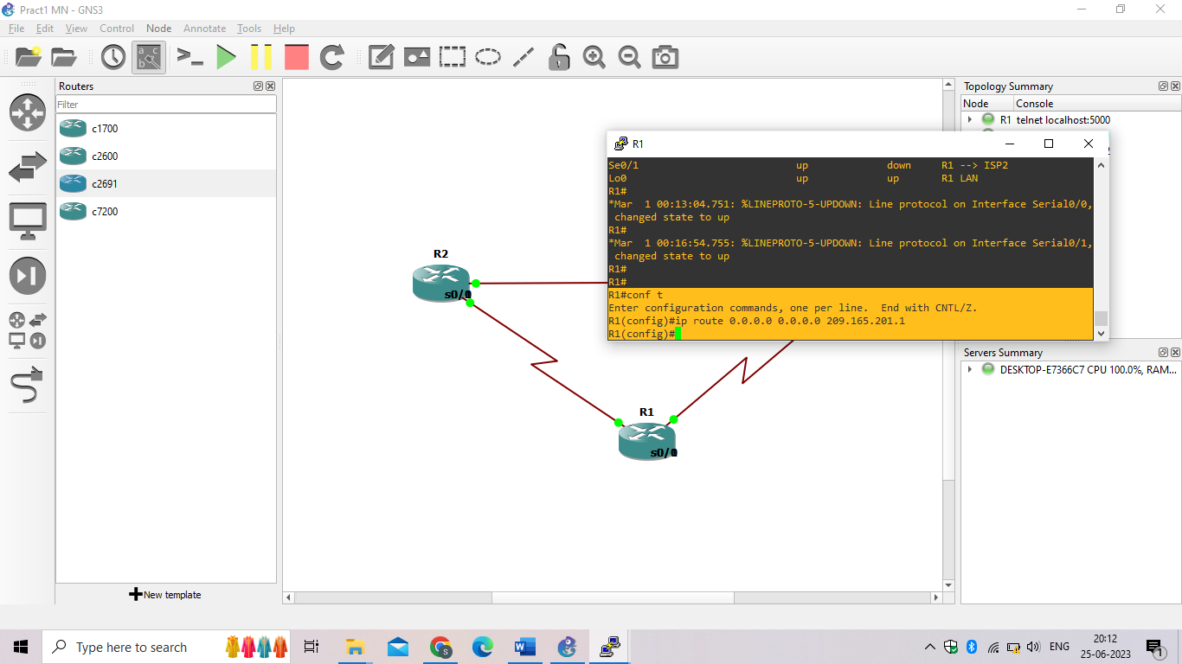

**Router ISP1 (R2)**

ISP1(config)# **router eigrp 1**

ISP1(config-router)# **network 209.165.200.224 0.0.0.3**

ISP1(config-router)# **network 209.165.201.0 0.0.0.31**

ISP1(config-router)# **no auto-summary**

ISP1(config-router)# **exit**

ISP1(config)#

ISP1(config-router)# **ip route 192.168.1.0 255.255.255.0 209.165.201.2**

ISP1(config)#

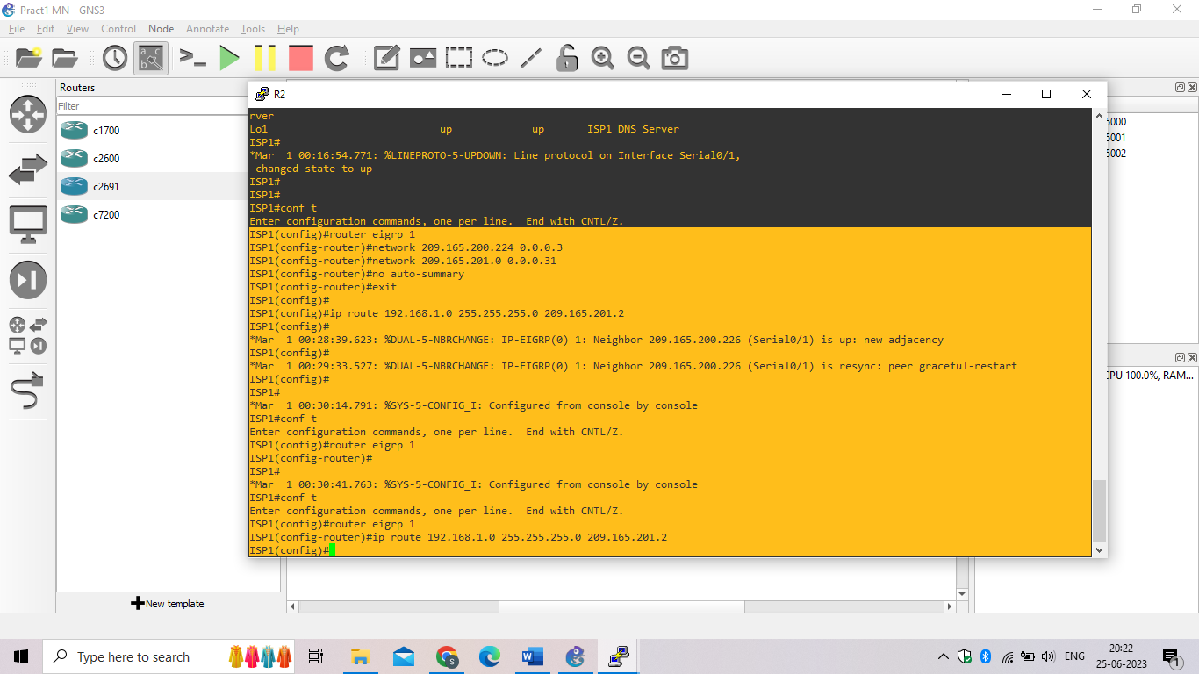

**Router ISP2 (R3)**

ISP2(config)# **router eigrp 1**

ISP2(config-router)# **network 209.165.200.224 0.0.0.3**

ISP2(config-router)# **network 209.165.202.128 0.0.0.31**

ISP2(config-router)# **no auto-summary**

ISP2(config-router)# **exit**

ISP2(config)#

ISP2(config-router)# **ip route 192.168.1.0 255.255.255.0 209.165.202.130**

ISP2(config)#

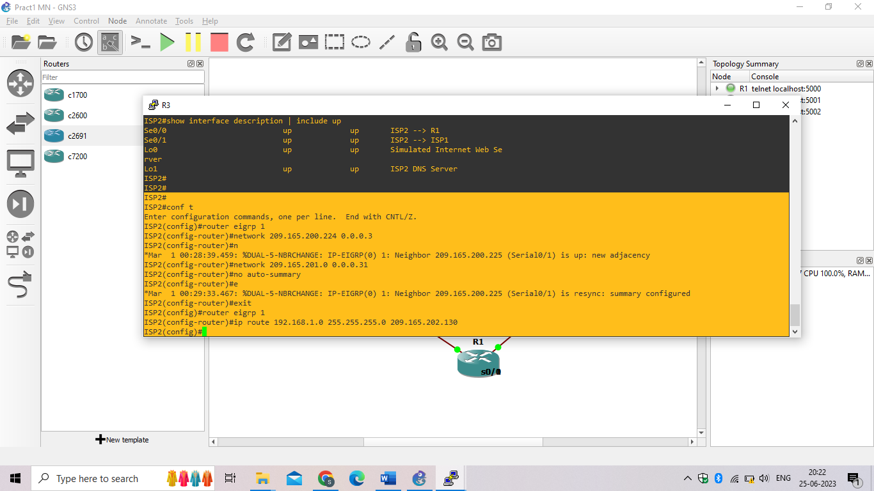

1. The Cisco IOS IP SLA feature enables an administrator to monitor network performance between Cisco devices (switches or routers) or from a Cisco device to a remote IP device. IP SLA probes continuously check the reachability of a specific destination, such as a provider edge router interface, the DNS server of the ISP, or any other specific destination, and can conditionally announce a default route only if the connectivity is verified.

Before implementing the Cisco IOS SLA feature, you must verify reachability to the Internet servers. From router R1, ping the web server, ISP1 DNS server, and ISP2 DNS server to verify connectivity. You can copy the following Tcl script and paste it into R1.

**foreach address {**

**209.165.200.254**

**209.165.201.30**

**209.165.202.158**

**} {**

**ping $address source 192.168.1.1**

**}**

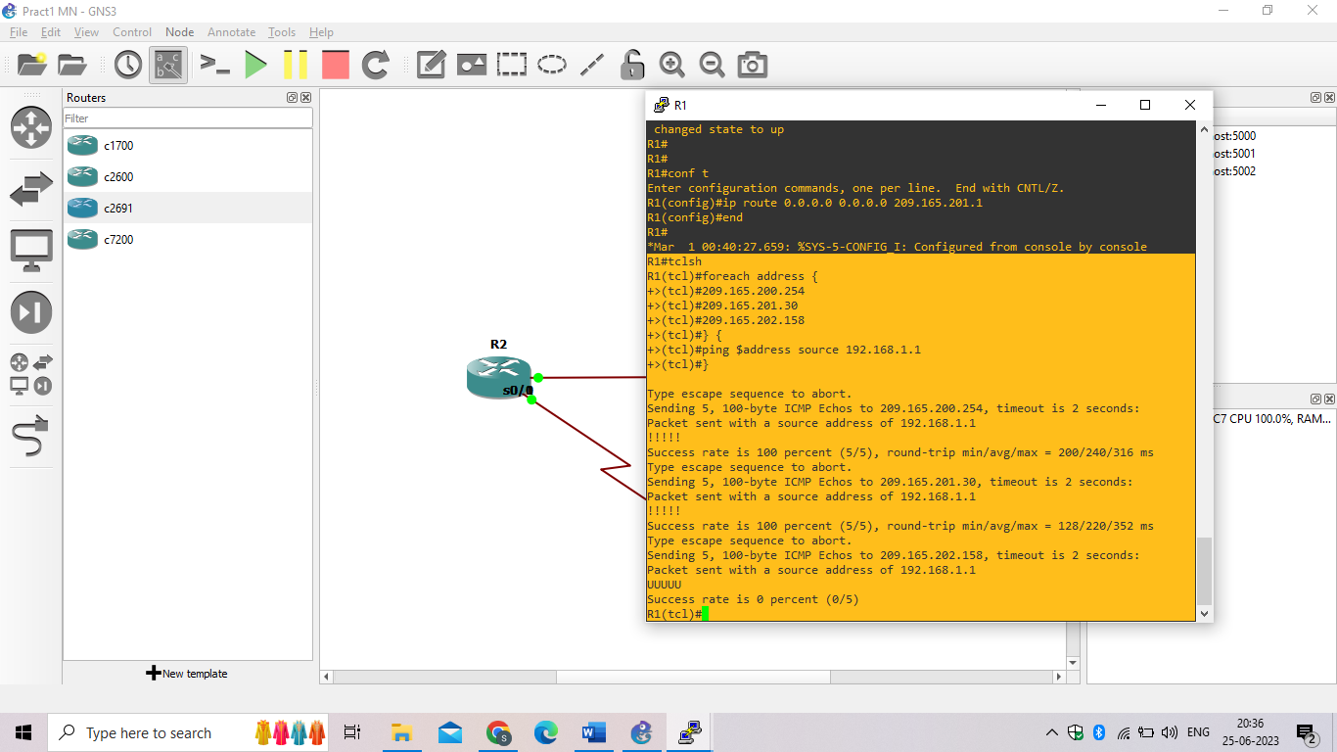

1. Trace the path taken to the web server, ISP1 DNS server, and ISP2 DNS server. You can copy the following Tcl script and paste it into R1.

**foreach address {**

**209.165.200.254**

**209.165.201.30**

**209.165.202.158**

**} {**

**trace $address source 192.168.1.1**

**}**

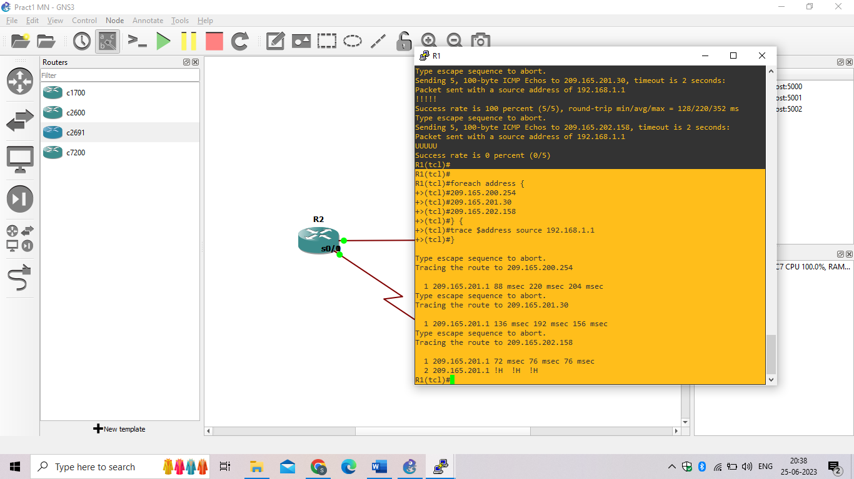

### Step 3: Configure IP SLA probes.

1. Create an ICMP echo probe on R1 to the primary DNS server on ISP1 using the **ip sla** command.

R1(config)# **ip sla monitor 11**

R1(config-sla-monitor)#type echo protocol ipIcmpEcho 209.165.201.30

R1(config-sla-monitor-echo)#frequency 10

R1(config-sla-monitor-echo)#exit

R1(config)#

R1(config)#ip sla schedule 11 life forever start-time now

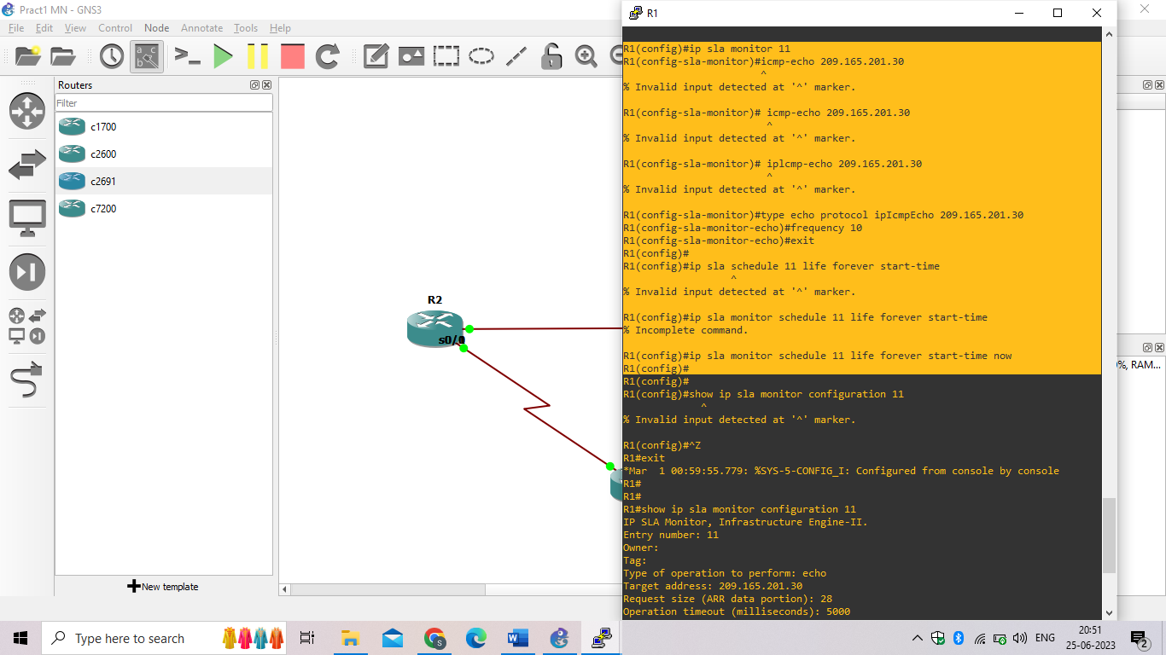

1. Verify the IP SLAs configuration of operation 11 using the **show ip sla configuration 11** command.

R1# **show ip sla monitor configuration 11**

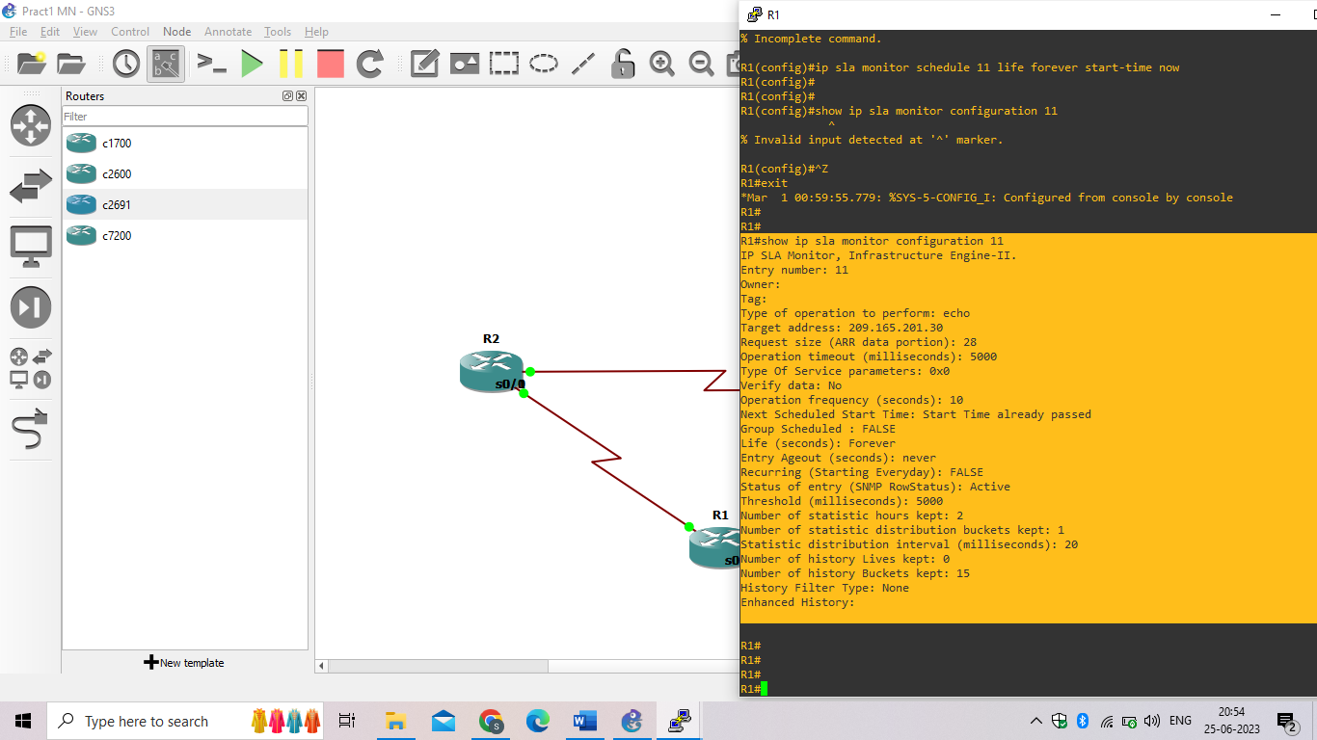

1. Issue the **show ip sla statistics** command to display the number of successes, failures, and results of the latest operations.

R1# **show ip sla statistics**

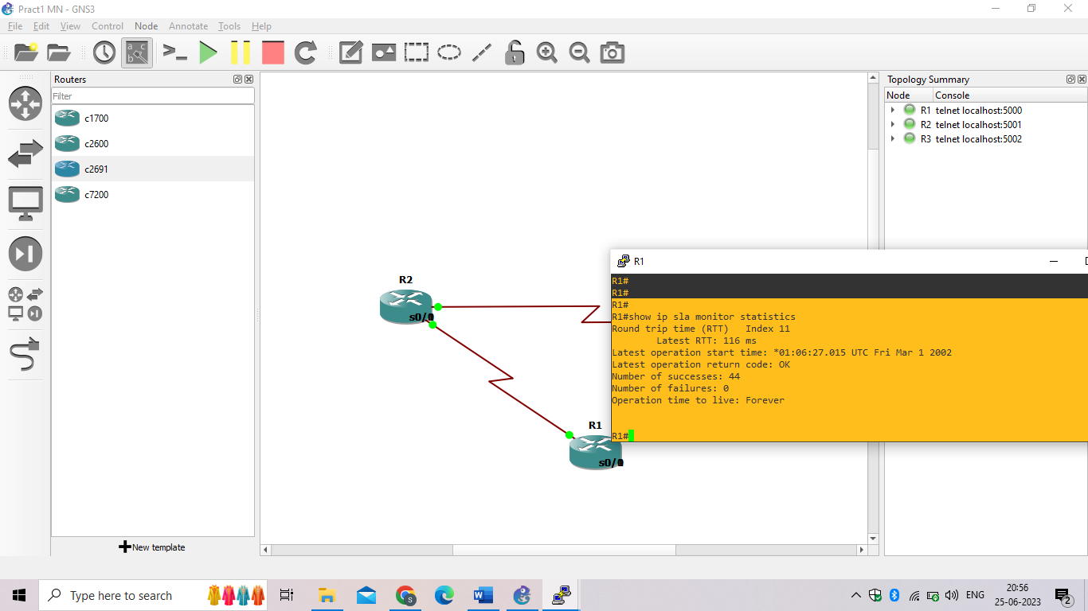

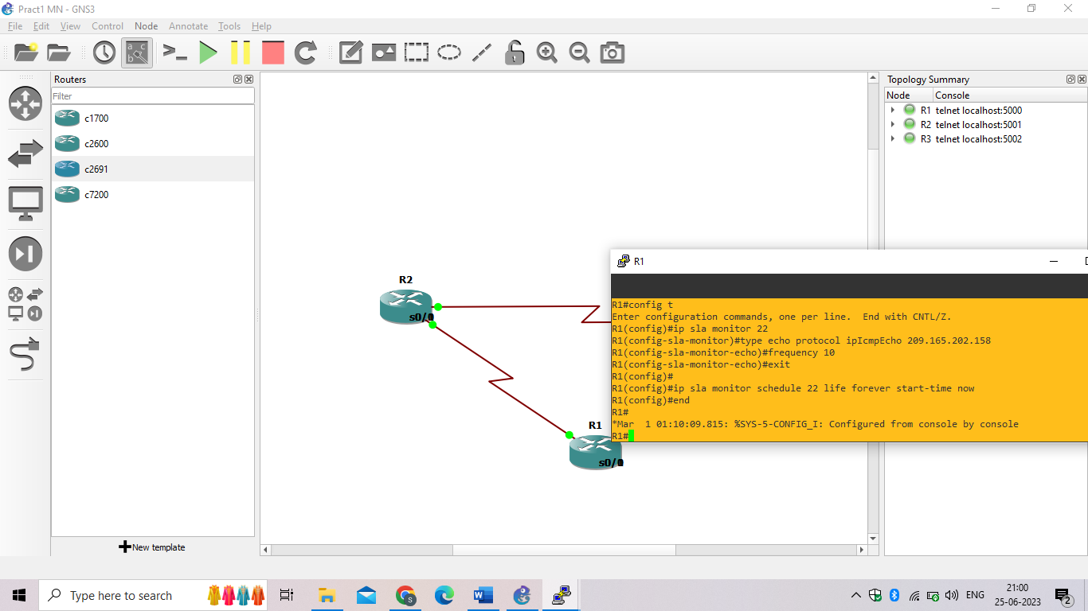

1. Verify the new probe using the **show ip sla configuration** and **show ip sla statistics** commands.

R1# **show ip sla configuration 22**

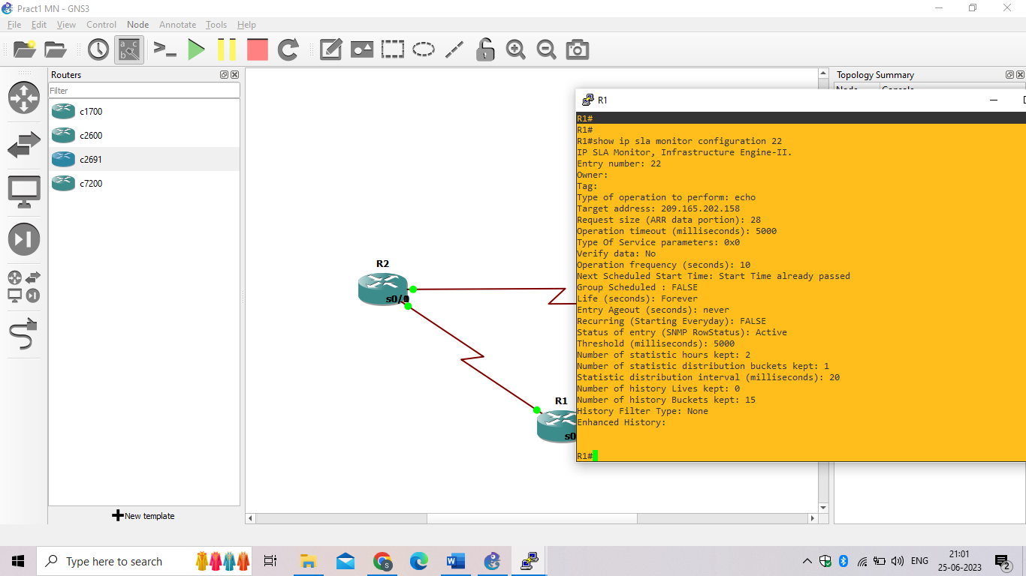

R1# **show ip sla statistics 22**

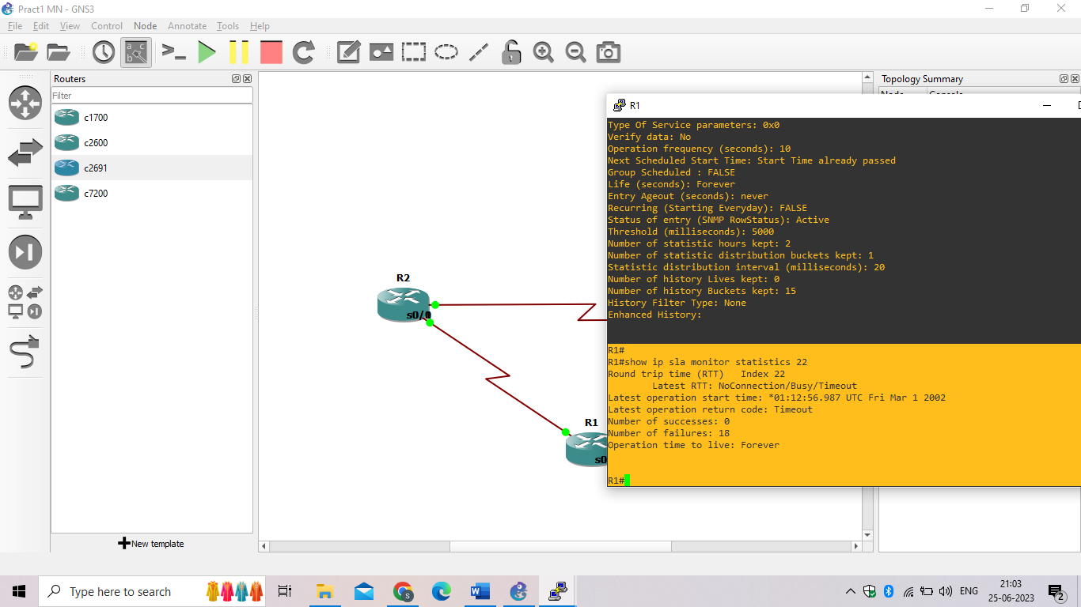

### Step 4: Configure tracking options.

1. On R1, remove the current default route and replace it with a floating static route having an administrative distance of 5.

R1(config)# **no ip route 0.0.0.0 0.0.0.0 209.165.201.1**

R1(config)# **ip route 0.0.0.0 0.0.0.0 209.165.201.1 5**

R1(config)# **exit**

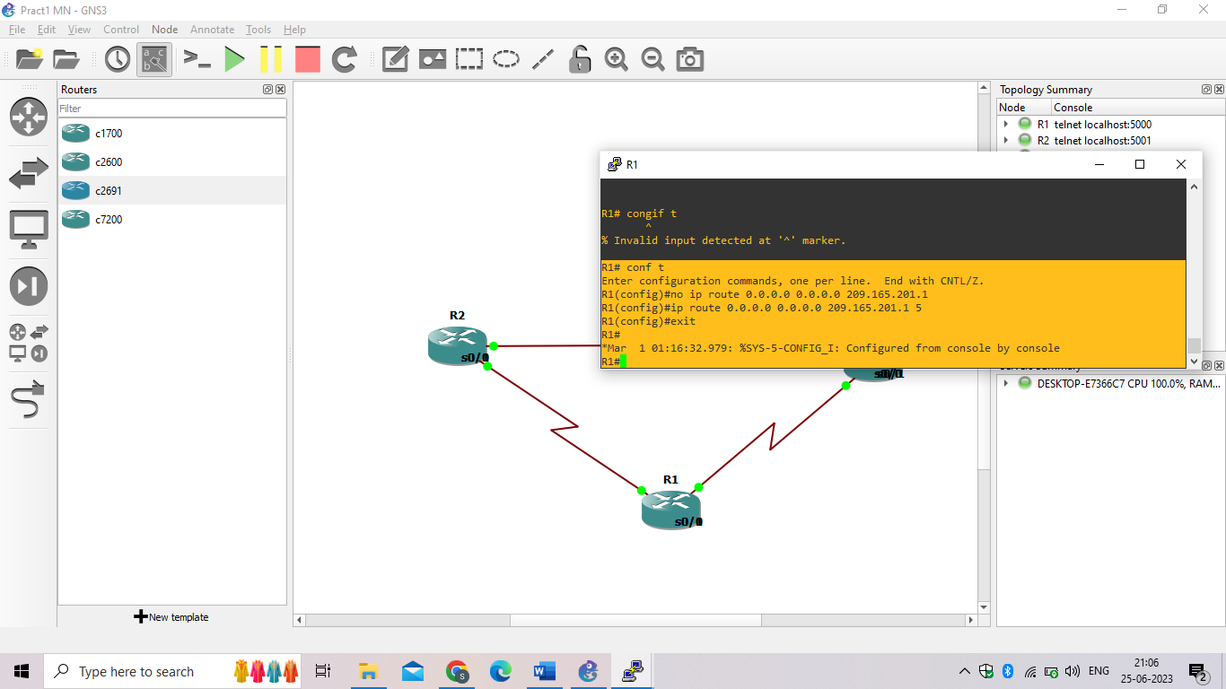

1. Verify the routing table.

R1# **show ip route | begin Gateway**

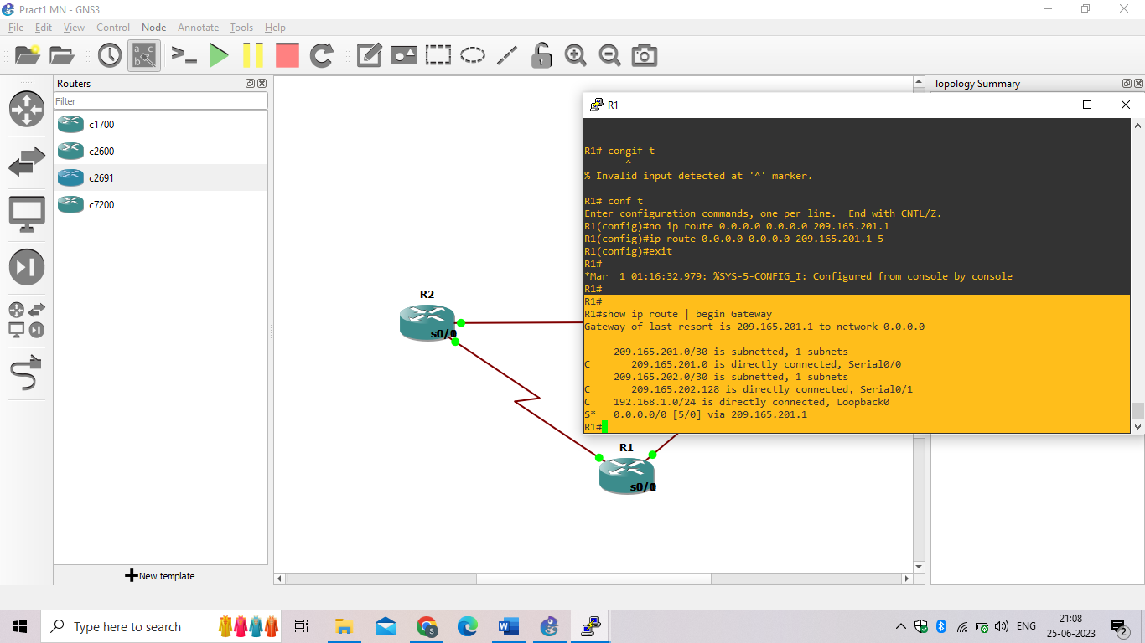

c. From global configuration mode on R1, use the **track 1 ip sla 11 reachability** command to enter the config-track subconfiguration mode.

R1(config)# **track 1 ip sla 11 reachability**

R1(config-track)#

**PRACTICAL NO:-2**

**Aim:- Using the AS_PATH Attribute**

**Step 1: Prepare the routers for the lab.**

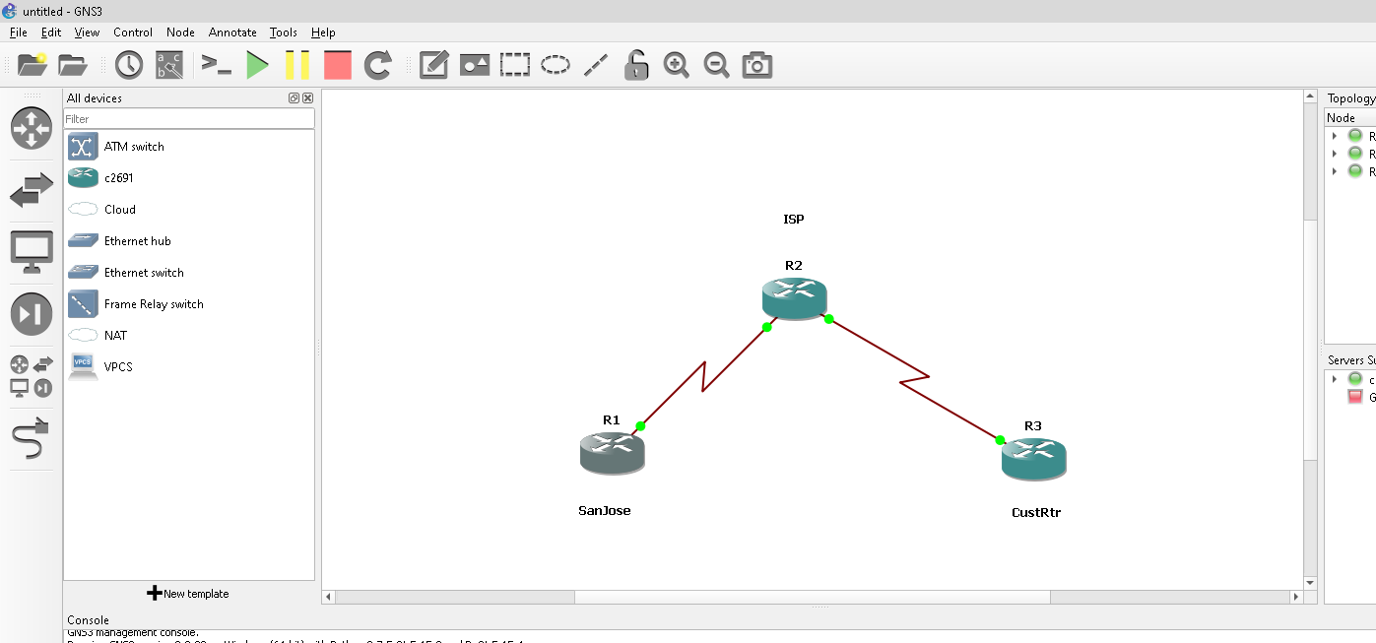

**Step 2: Configure the hostname and interface addresses.**

**Router R1 (hostname SanJose)**

hostname SanJose

interface Loopback0

ip address 10.1.1.1 255.255.255.0

interface Serial1/1

ip address 192.168.1.5 255.255.255.252

clock rate 128000

no shutdown

**Router R2 (hostname ISP)**

hostname ISP

interface Loopback0

ip address 10.2.2.1 255.255.255.0

interface Serial1/1

ip address 192.168.1.6 255.255.255.252

no shutdown

interface Serial1/0

ip address 172.24.1.17 255.255.255.252

clock rate 128000

no shutdown

**Router R3 (hostname CustRtr)**

hostname CustRtr

interface Loopback0

ip address 10.3.3.1 255.255.255.0

interface Serial1/0

ip address 172.24.1.18 255.255.255.252

no shutdown

**Step 3: Configure BGP.**

**a.** Configure BGP for normal operation. Enter the appropriate BGP commands on each router so that they identify their BGP neighbors and advertise their loopback networks.

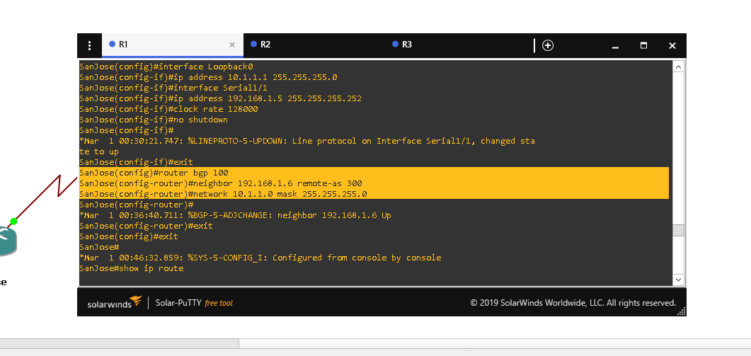

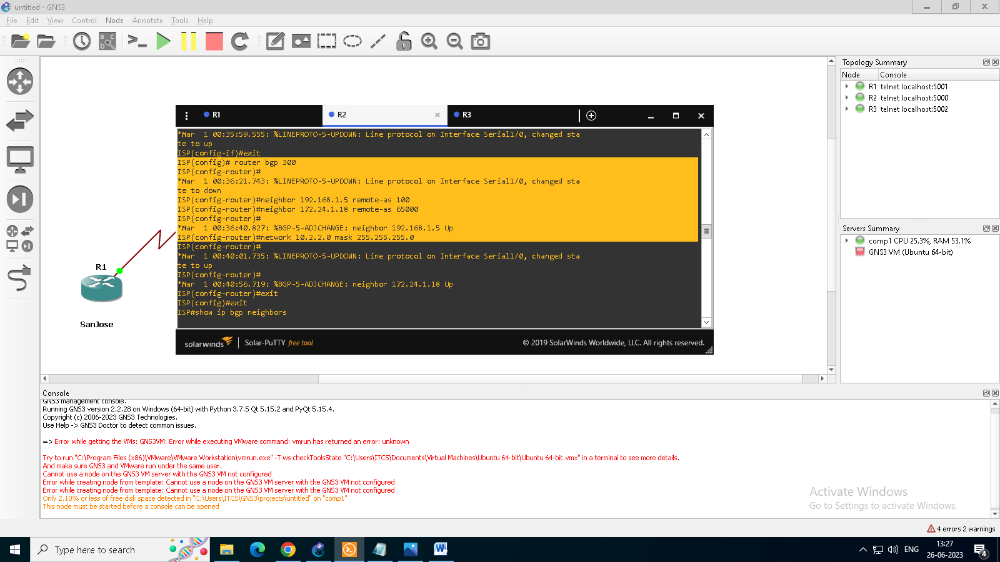

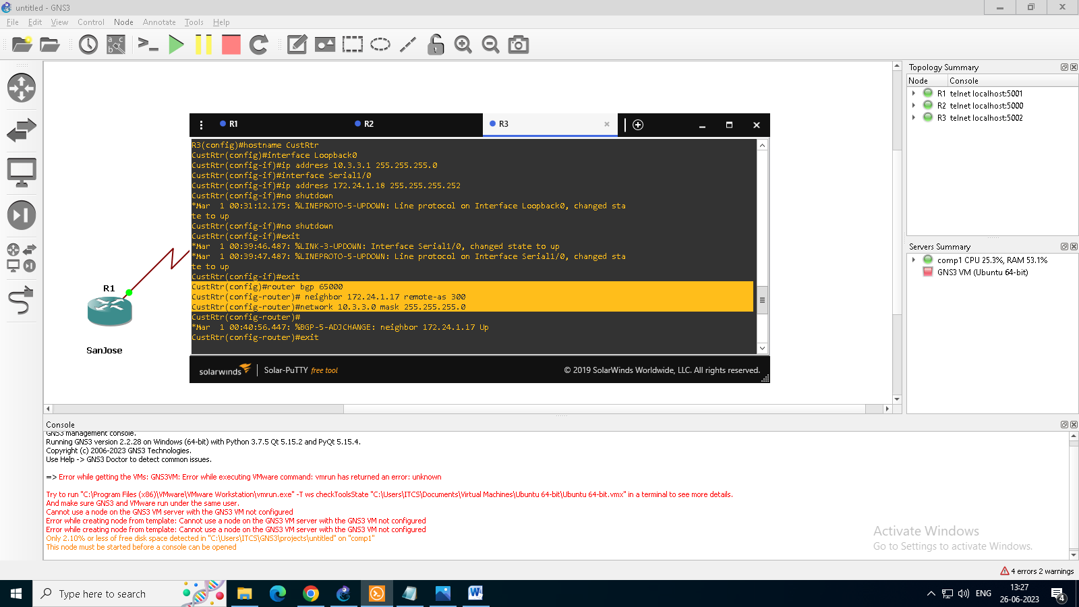

**b**. Verify that these routers have established the appropriate neighbor relationships by issuing the show ip bgp neighbors command on each router.

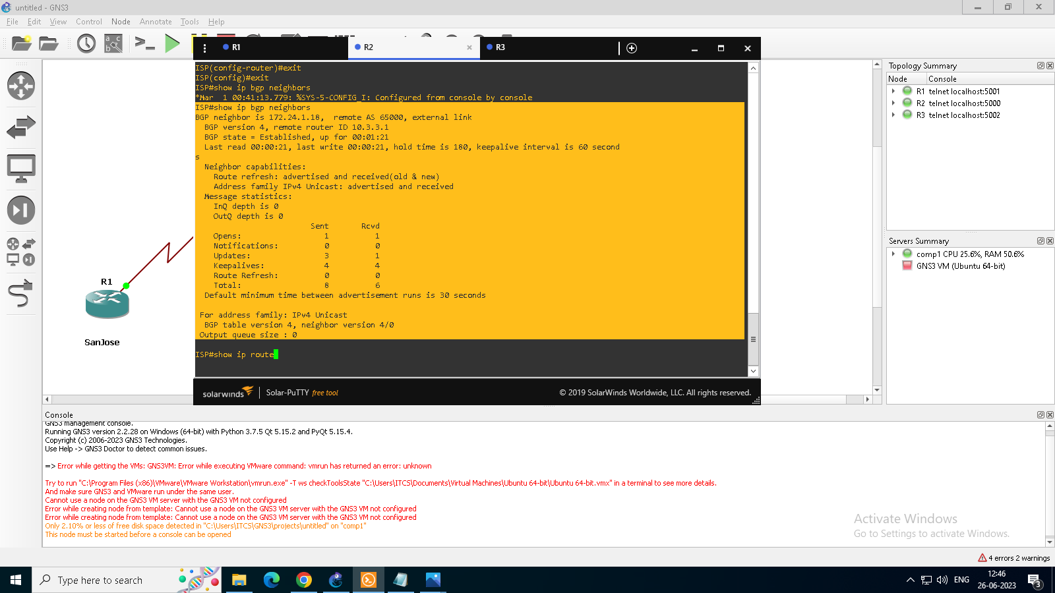

**Step 4: Remove the private AS.**

a. Display the SanJose routing table using the show ip route command. SanJose should have a route to both 10.2.2.0 and 10.3.3.0. Troubleshoot if necessary.

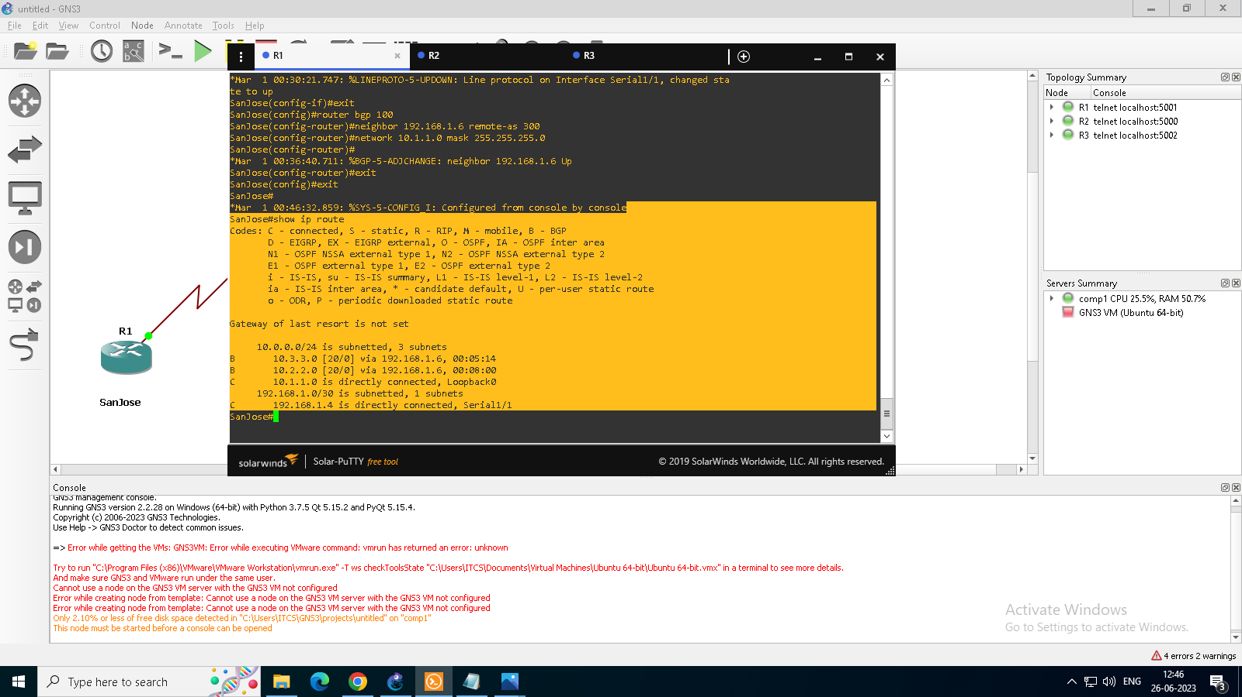

B & C. Ping the 10.3.3.1 address from SanJose.

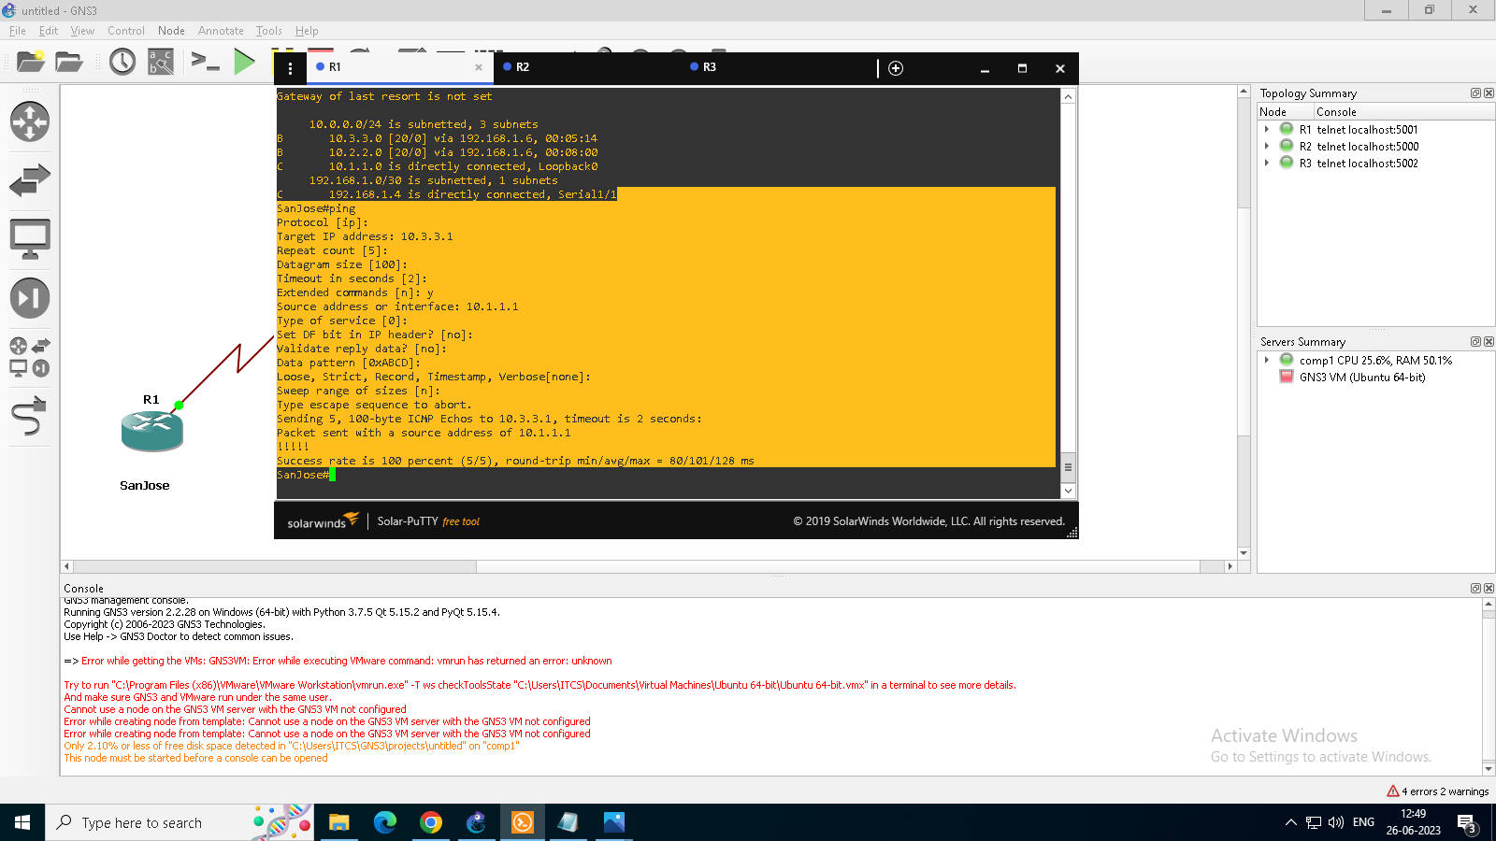

d. Check the BGP table from SanJose by using the show ip bgp command. Note the AS path for the 10.3.3.0 network. The AS 65000 should be listed in the path to 10.3.3.0.

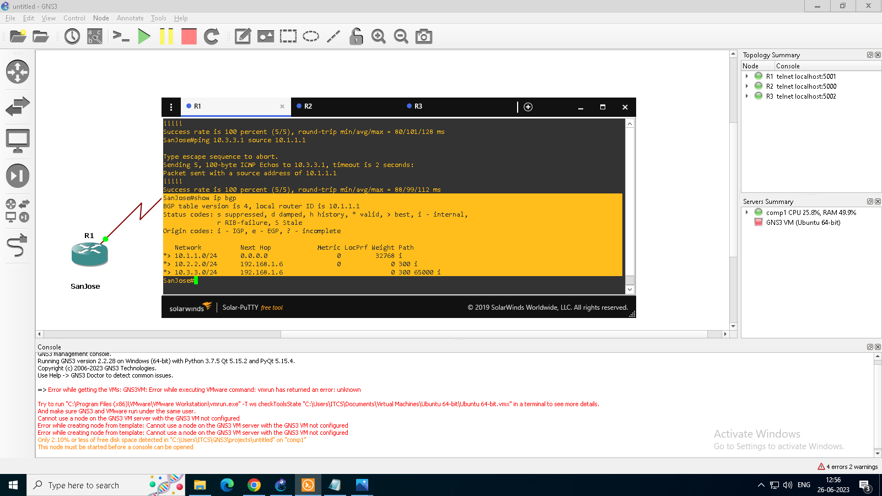

e. Configure ISP to strip the private AS numbers from BGP routes exchanged with SanJose using the following commands.

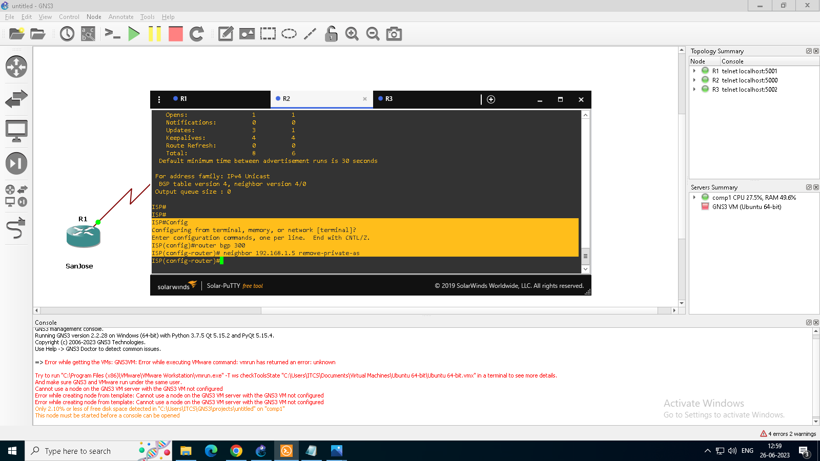

f. After issuing these commands, use the clear ip bgp * command on ISP to reestablish the BGP relationship between the three routers. Wait several seconds and then return to SanJose to check its routing table.

Note: The clear ip bgp * soft command can also be used to force each router to resend its BGP table.

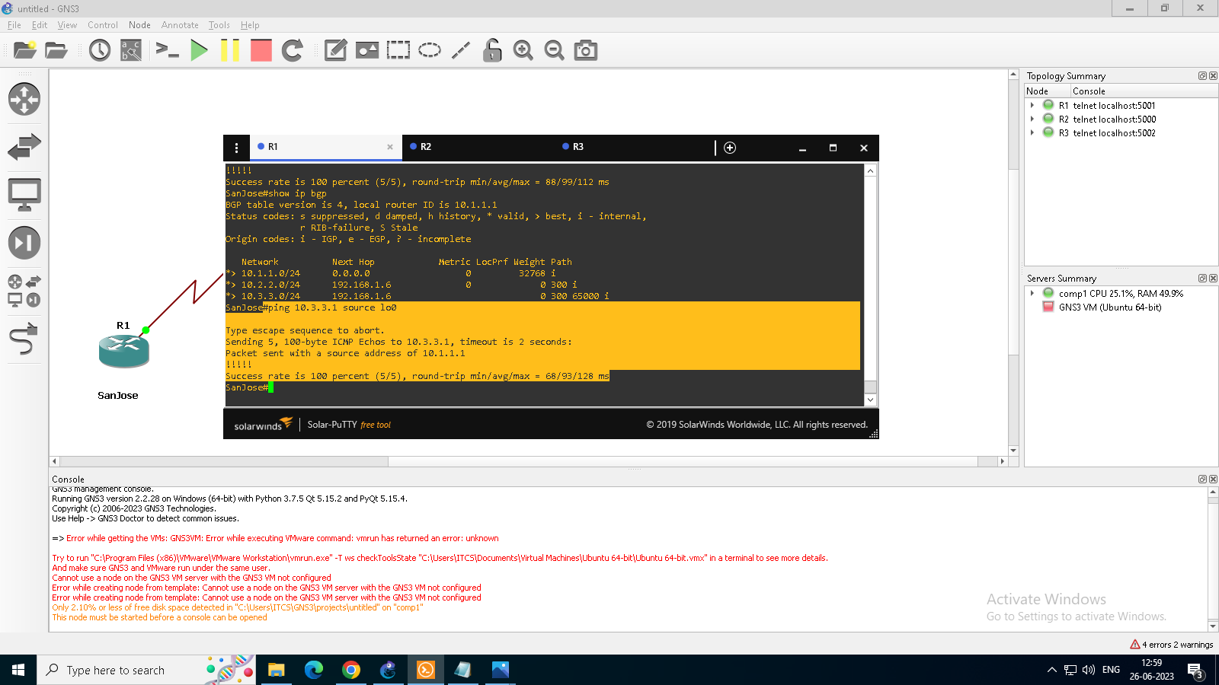

g. Now check the BGP table on SanJose. The AS_ PATH to the 10.3.3.0 network should be AS 300. It no longer has the private AS in the path.

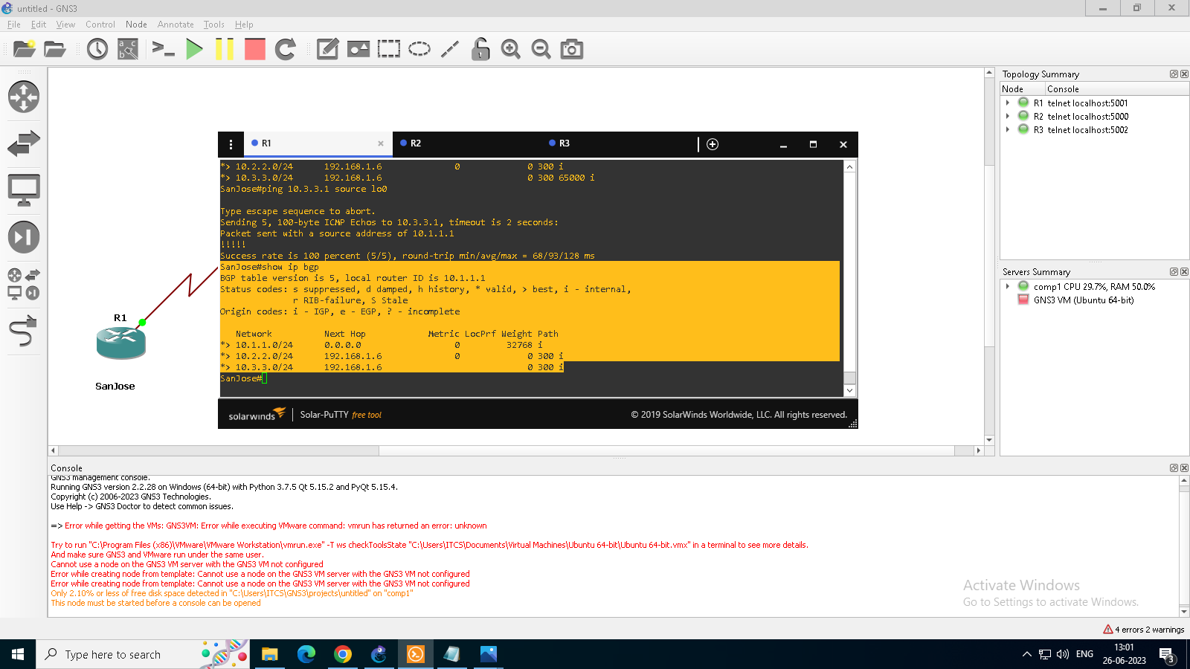

**Step 5: Use the AS_PATH attribute to filter routes.**

a.Configure a special kind of access list to match BGP routes with an AS_PATH attribute that both begins and ends with the number 100. Enter the following commands on ISP.

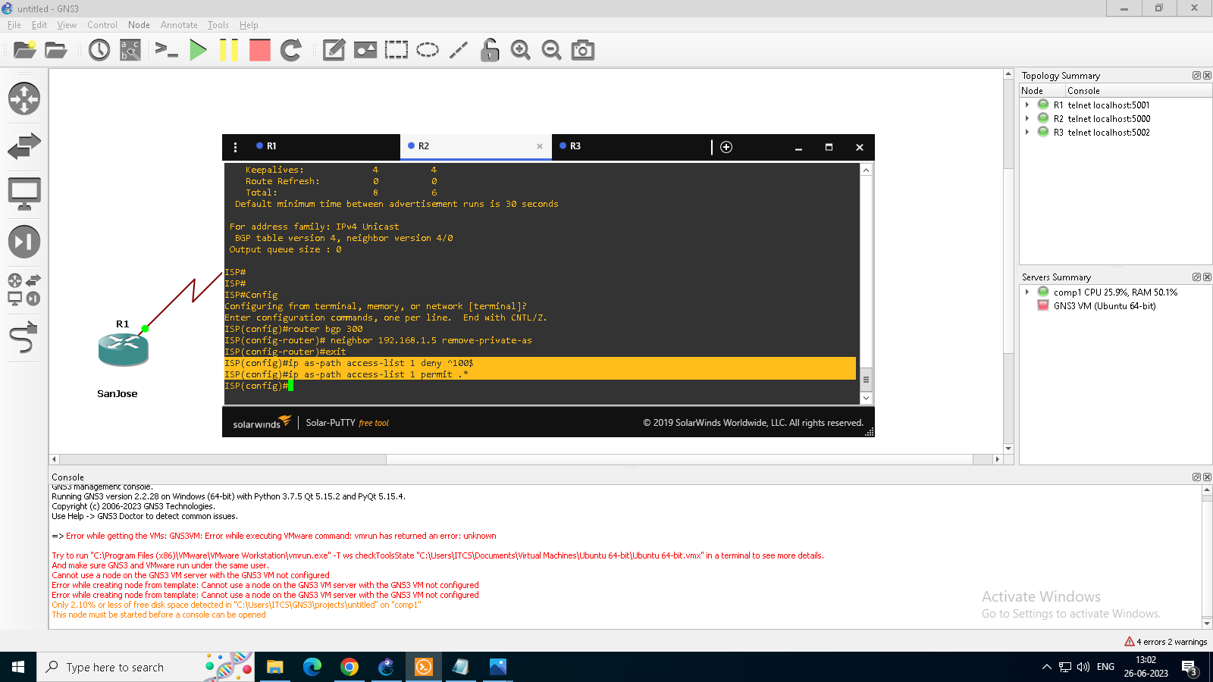

b. Apply the configured access list using the neighbor command with the filter-list option.

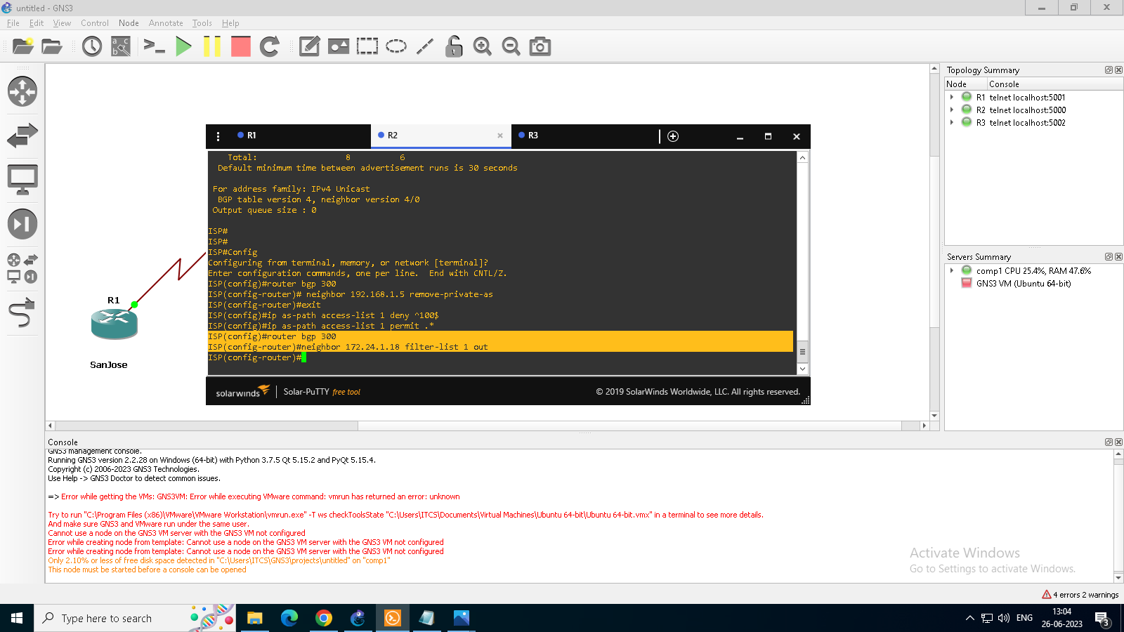

c. Use the clear ip bgp * command to reset the routing information. Wait several seconds and then check the routing table for ISP. The route to 10.1.1.0 should be in the routing table.

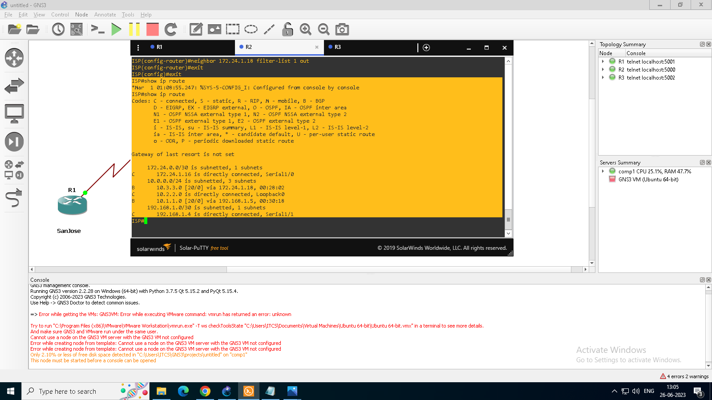

d. Check the routing table for CustRtr. It should not have a route to 10.1.1.0 in its routing table.

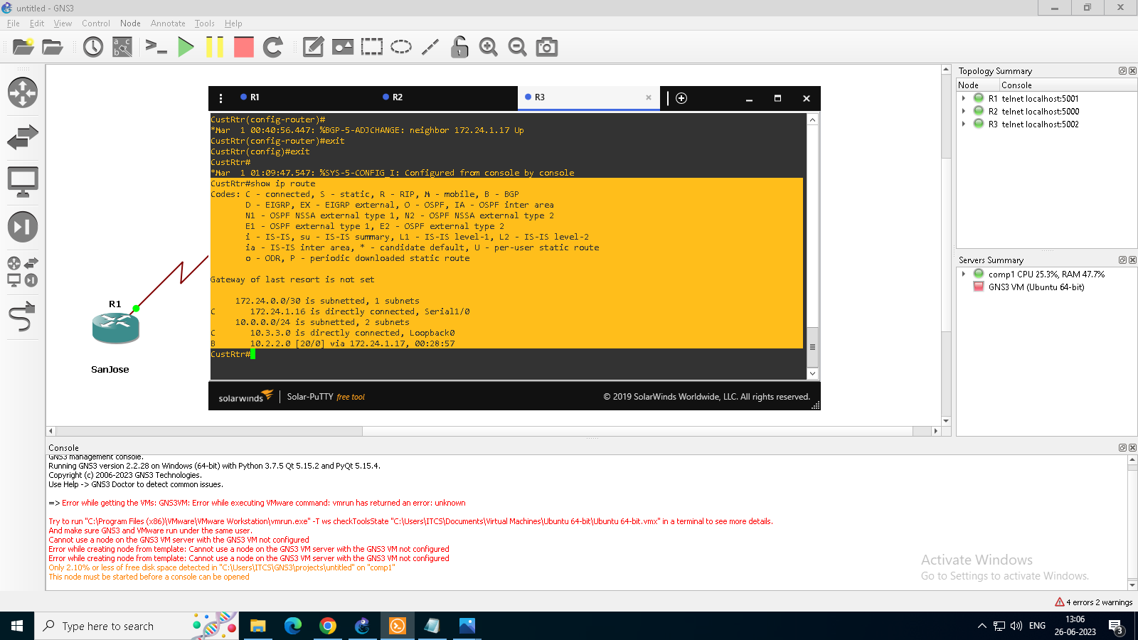

e. Return to ISP and verify that the filter is working as intended. Issue the show ip bgp regexp ^100$ command.

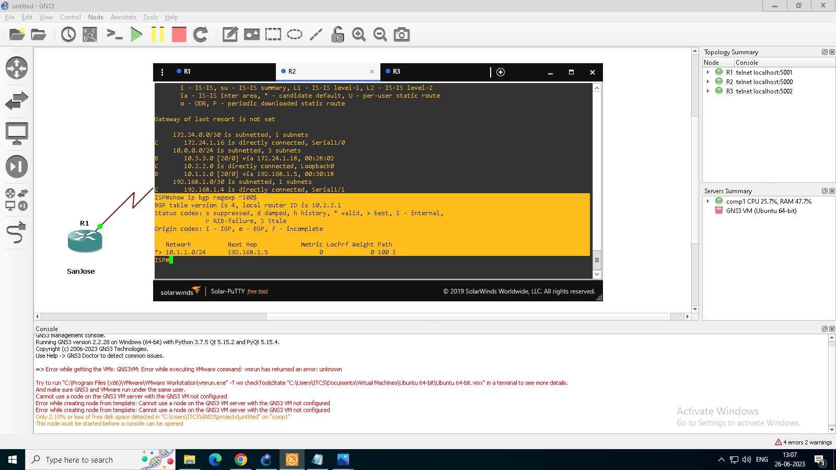

f. Run the following Tcl script on all routers to verify whether there is connectivity. All pings from ISP should be successful. SanJose should not be able to ping the CustRtr loopback 10.3.3.1 or the WAN link

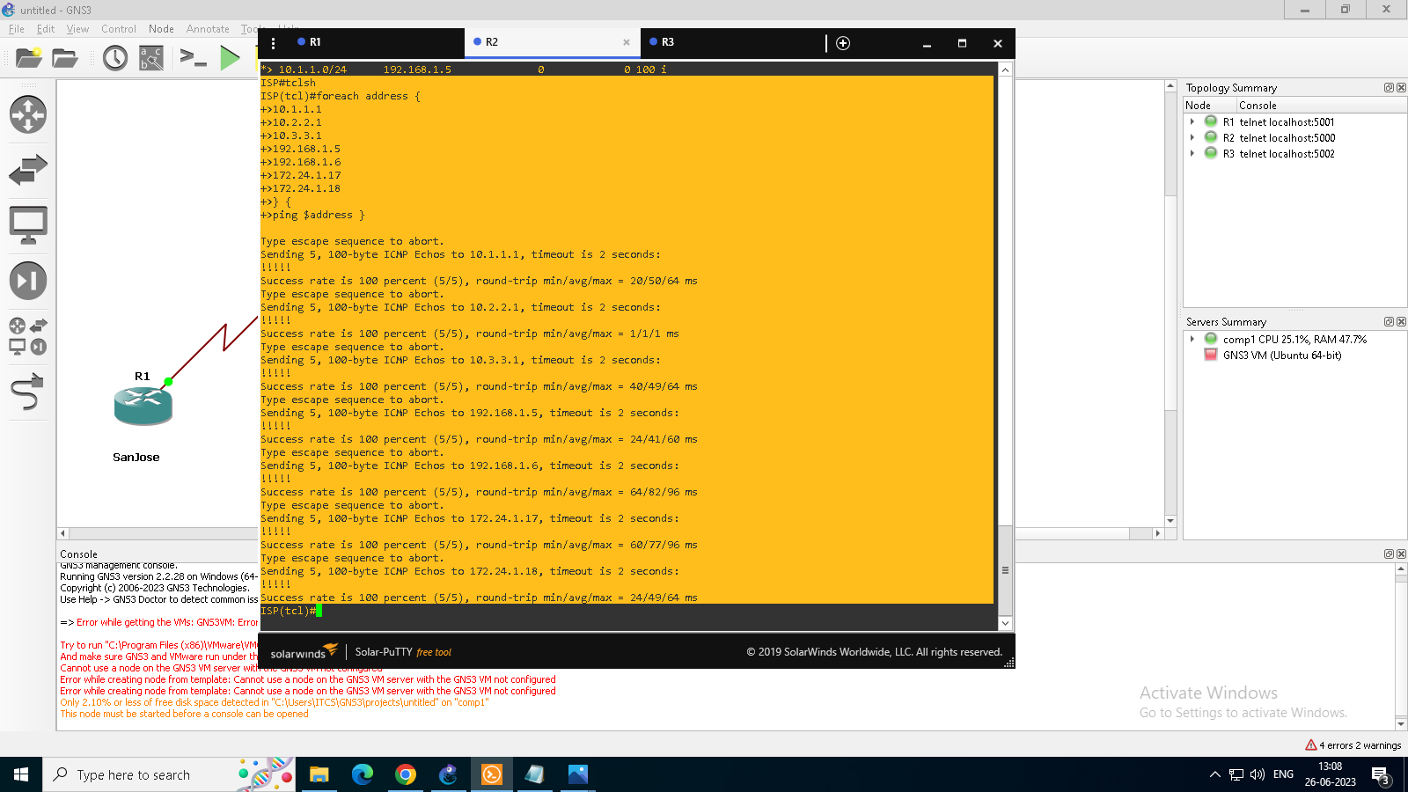

**PRACTICAL NO:- 3**

**Aim:- Configuring IBGP and EBGP Sessions, Local Preference, and MED**

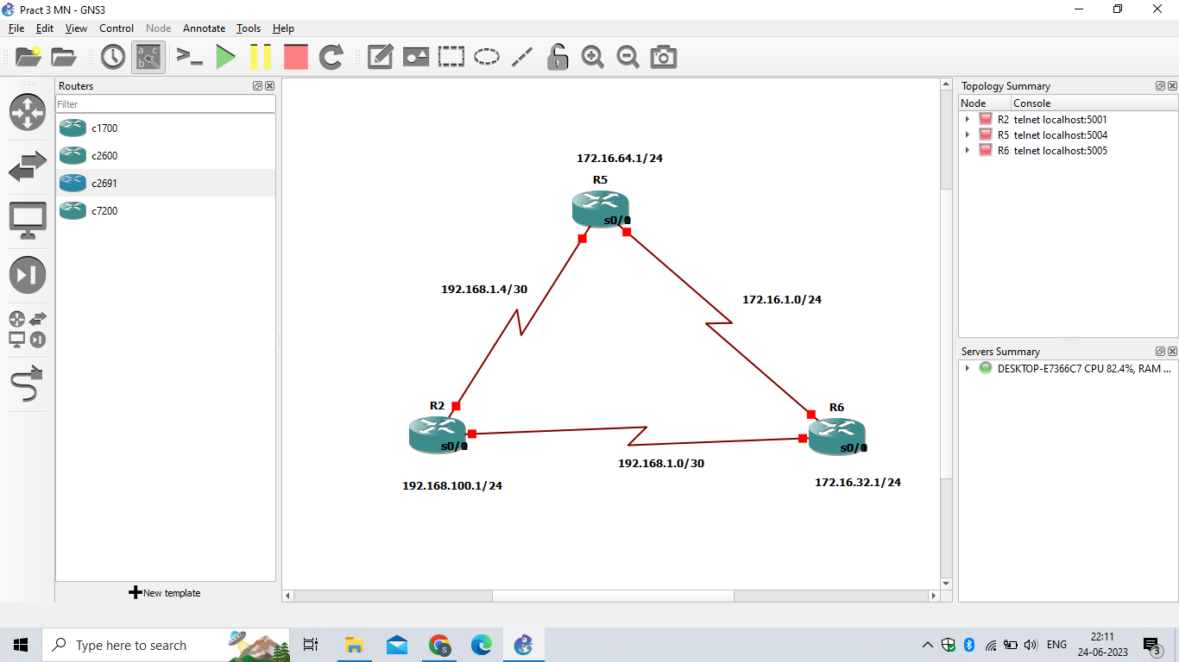

* Click on start button for start routing connection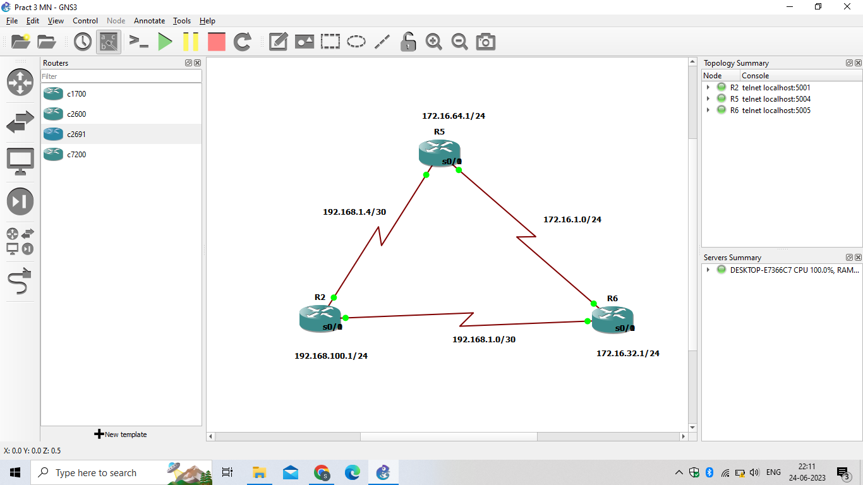

**Step 0: Suggested starting configurations**

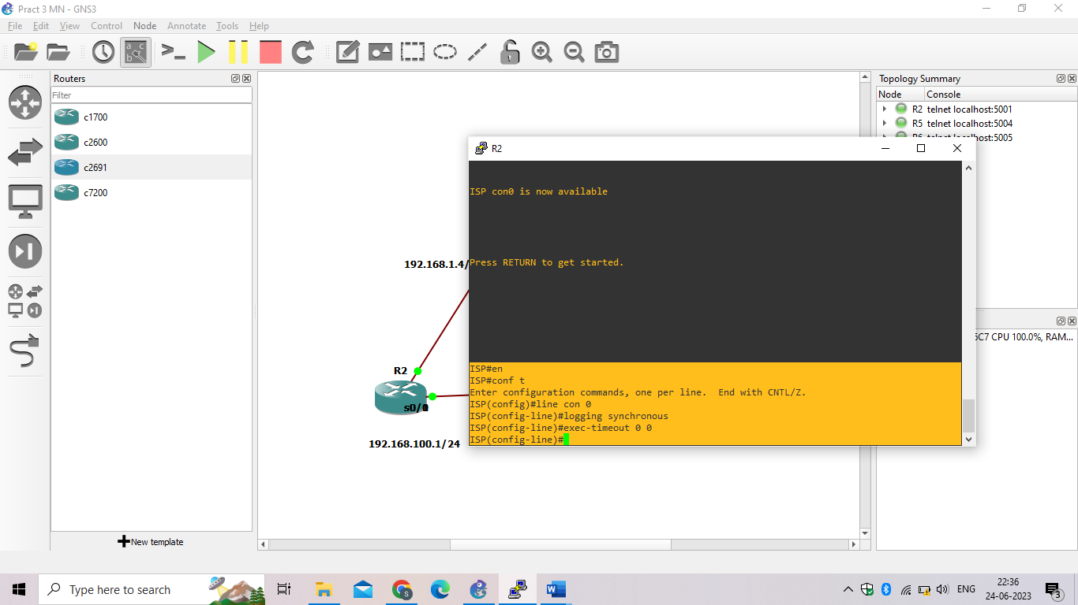

Step 1: Configure interface addresses.

1. Using the addressing scheme in the diagram, create the loopback interfaces and apply IPv4 addresses to these and the serial interfaces on ISP (R1), SanJose1 (R2), and SanJose2 (R3).

**Router R1 (hostname ISP)**

ISP(config)# **interface Loopback0**

ISP(config-if)# **ip address 192.168.100.1 255.255.255.0**

ISP(config-if)# **exit**

ISP(config)# **interface Serial0/0/0**

ISP(config-if)# **ip address 192.168.1.5 255.255.255.252**

ISP(config-if)# **clock rate 128000**

ISP(config-if)# **no shutdown**

ISP(config-if)# **exit**

ISP(config)# **interface Serial0/0/1**

ISP(config-if)# **ip address 192.168.1.1 255.255.255.252**

ISP(config-if)# **no shutdown**

ISP(config-if)# **end**

ISP#

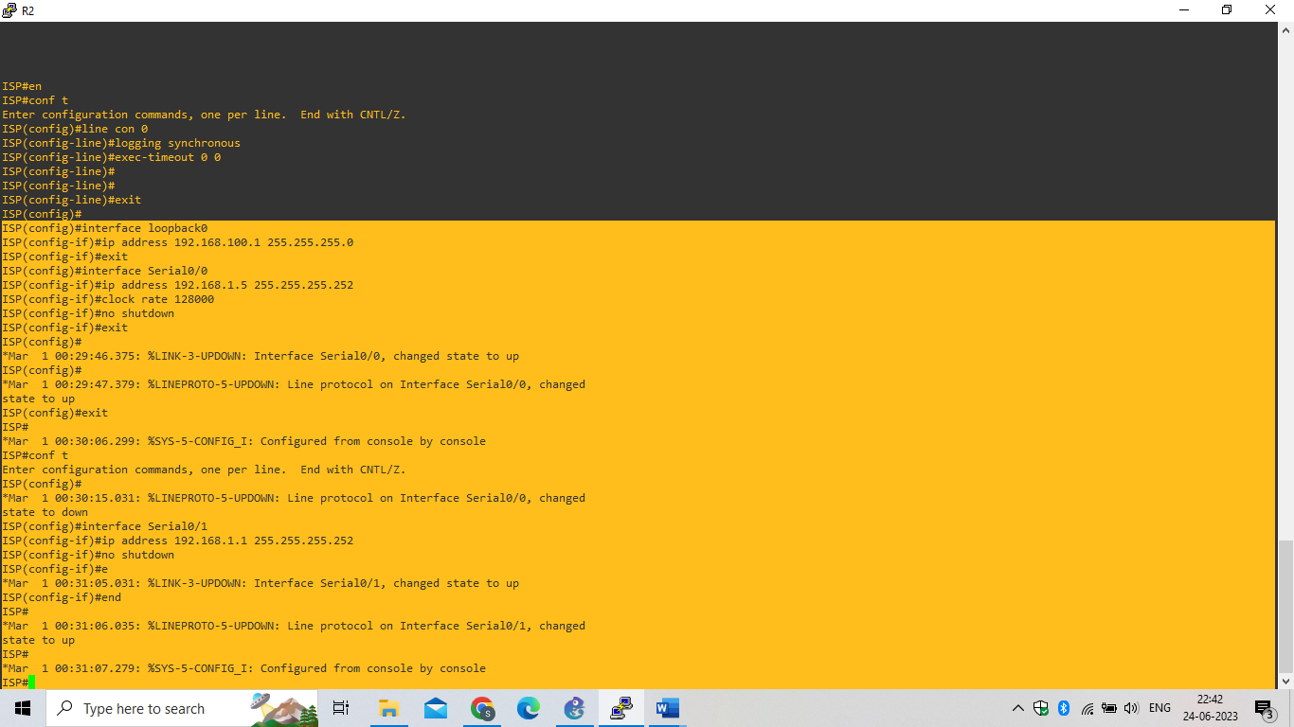

**Router R2 (hostname SanJose1)**

SanJose1(config)# **interface Loopback0**

SanJose1(config-if)# **ip address 172.16.64.1 255.255.255.0**

SanJose1(config-if)# **exit**

SanJose1(config)# **interface Serial0/0/0**

SanJose1(config-if)# **ip address 192.168.1.6 255.255.255.252**

SanJose1(config-if)# **no shutdown**

SanJose1(config-if)# **exit**

SanJose1(config)# **interface Serial0/0/1**

SanJose1(config-if)# **ip address 172.16.1.1 255.255.255.0**

SanJose1(config-if)# **clock rate 128000**

SanJose1(config-if)# **no shutdown**

SanJose1(config-if)# **end**

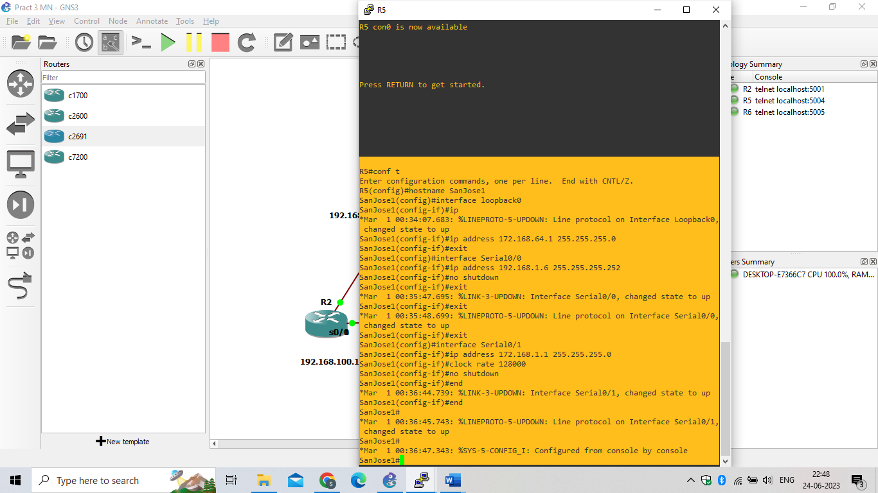

**Router R3 (hostname SanJose2)**

SanJose2(config)# **interface Loopback0**

SanJose2(config-if)# **ip address 172.16.32.1 255.255.255.0**

SanJose2(config-if)# **exit**

SanJose2(config)# **interface Serial0/0/0**

SanJose2(config-if)# **ip address 192.168.1.2 255.255.255.252**

SanJose2(config-if)# **clock rate 128000**

SanJose2(config-if)# **no shutdown**

SanJose2(config-if)# **exit**

SanJose2(config)# **interface Serial0/0/1**

SanJose2(config-if)# **ip address 172.16.1.2 255.255.255.0**

SanJose2(config-if)# **no shutdown**

SanJose2(config-if)# **end**

SanJose2#

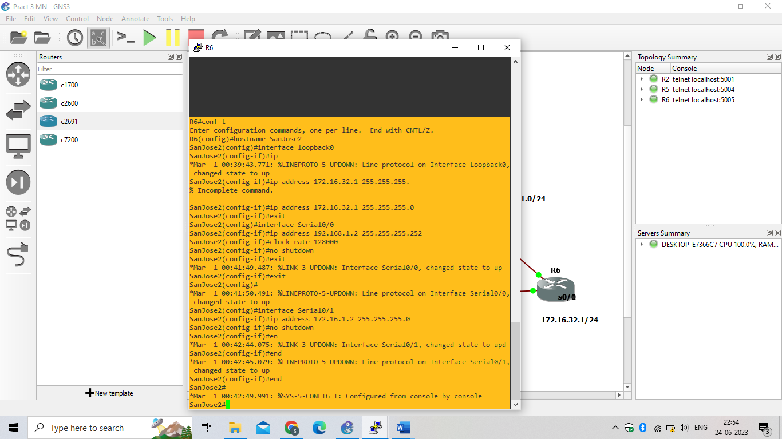

Step 2: Configure EIGRP.

Configure EIGRP between the SanJose1 and SanJose2 routers. (Note: If using an IOS prior to 15.0, use the no auto-summary router configuration command to disable automatic summarization. This command is the default beginning with IOS 15.)

SanJose1(config)# **router eigrp 1**

SanJose1(config-router)# **network 172.16.0.0**

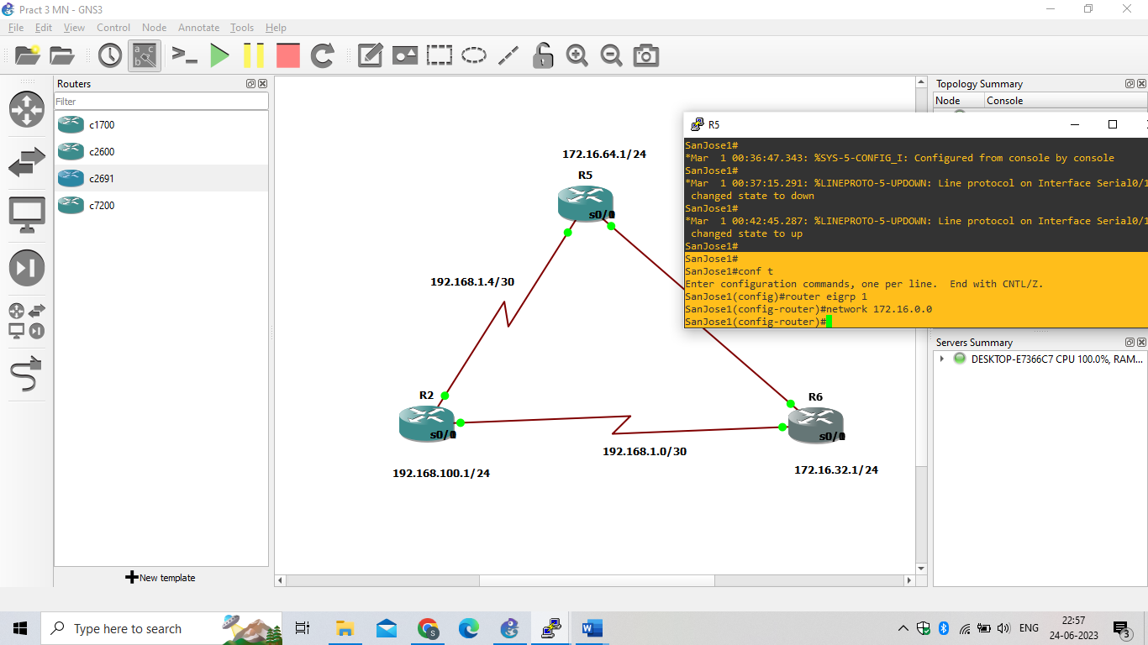

SanJose2(config)# **router eigrp 1**

SanJose2(config-router)# **network 172.16.0.0**

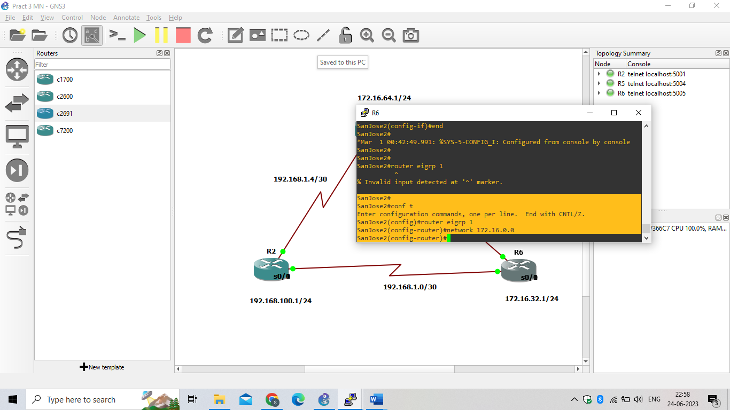

Step 3: Configure IBGP and verify BGP neighbors.

1. Configure IBGP between the SanJose1 and SanJose2 routers. On the SanJose1 router, enter the following configuration.

SanJose1(config)# **router bgp 64512**

SanJose1(config-router)# **neighbor 172.16.32.1 remote-as 64512**

SanJose1(config-router)# **neighbor 172.16.32.1 update-source lo0**

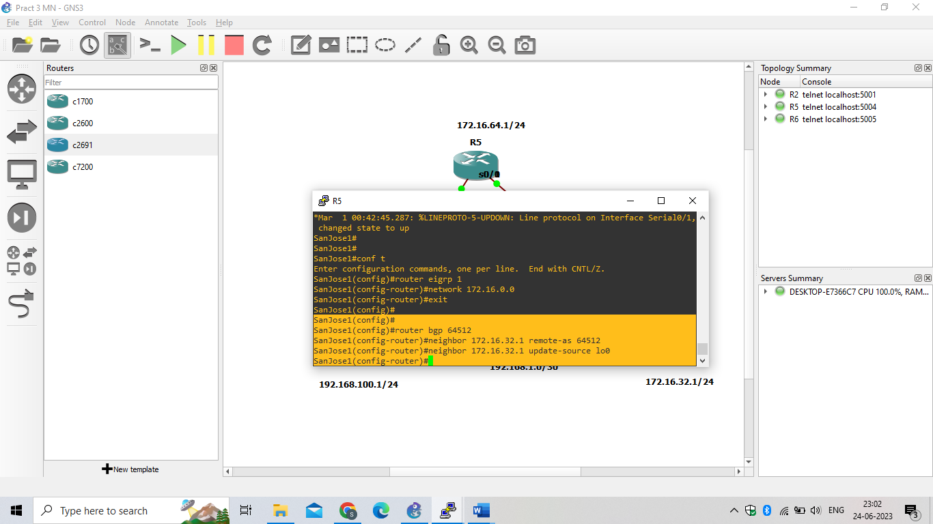

1. Complete the IBGP configuration on SanJose2 using the following commands.

SanJose2(config)# **router bgp 64512**

SanJose2(config-router)# **neighbor 172.16.64.1 remote-as 64512**

SanJose2(config-router)# **neighbor 172.16.64.1 update-source lo0**

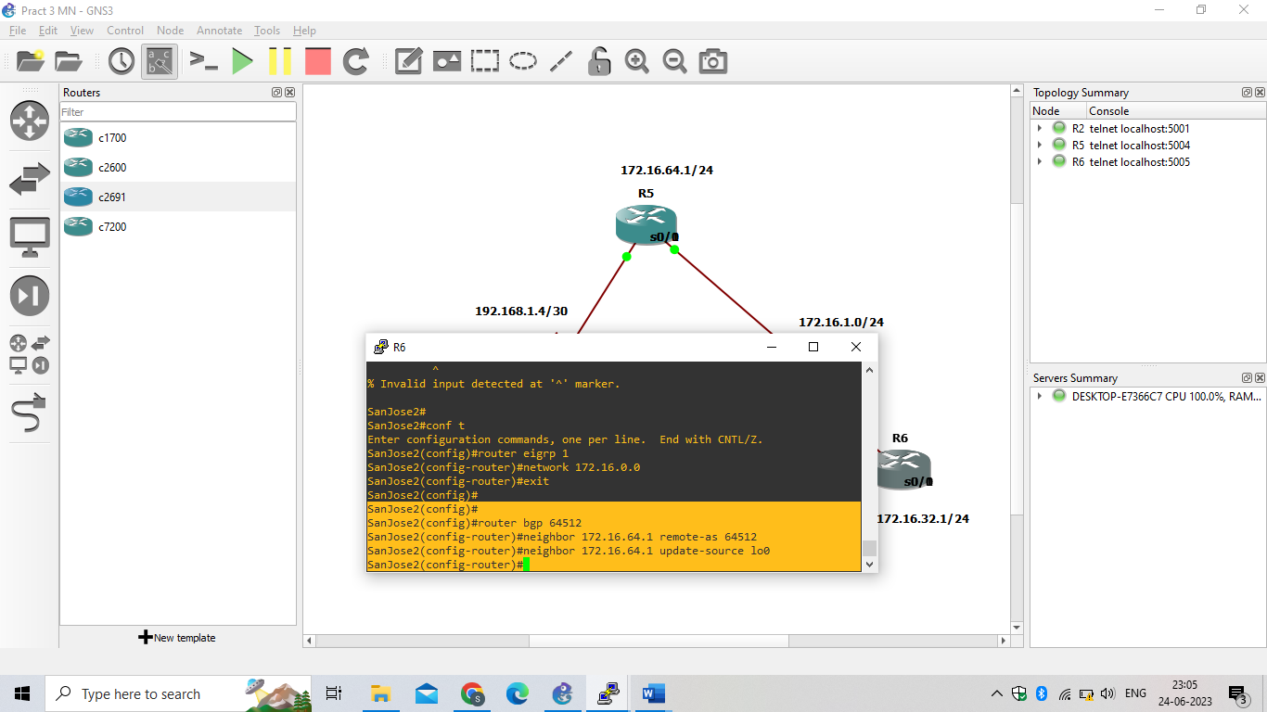

1. Verify that SanJose1 and SanJose2 become BGP neighbors by issuing the show ip bgp neighborscommand on SanJose1. View the following partial output. If the BGP state is not established, troubleshoot the connection.

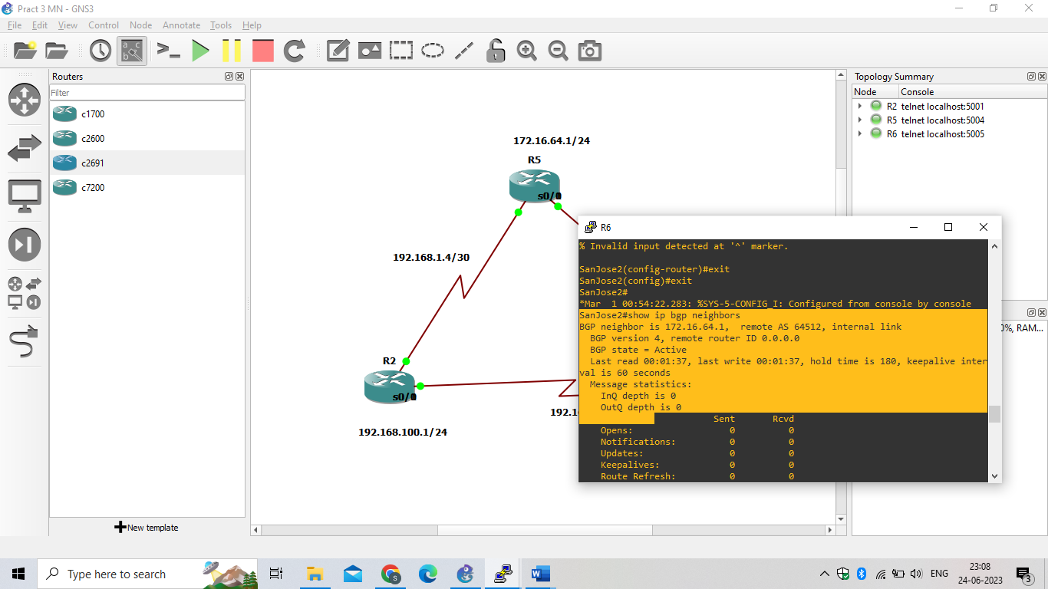

Step 4: Configure EBGP and verify BGP neighbors.

1. Configure ISP to run EBGP with SanJose1 and SanJose2. Enter the following commands on ISP.
   1. ISP(config)# **router bgp 200**
   2. ISP(config-router)# **neighbor 192.168.1.6 remote-as 64512**
   3. ISP(config-router)# **neighbor 192.168.1.2 remote-as 64512**
   4. ISP(config-router)# **network 192.168.100.0**
   5. 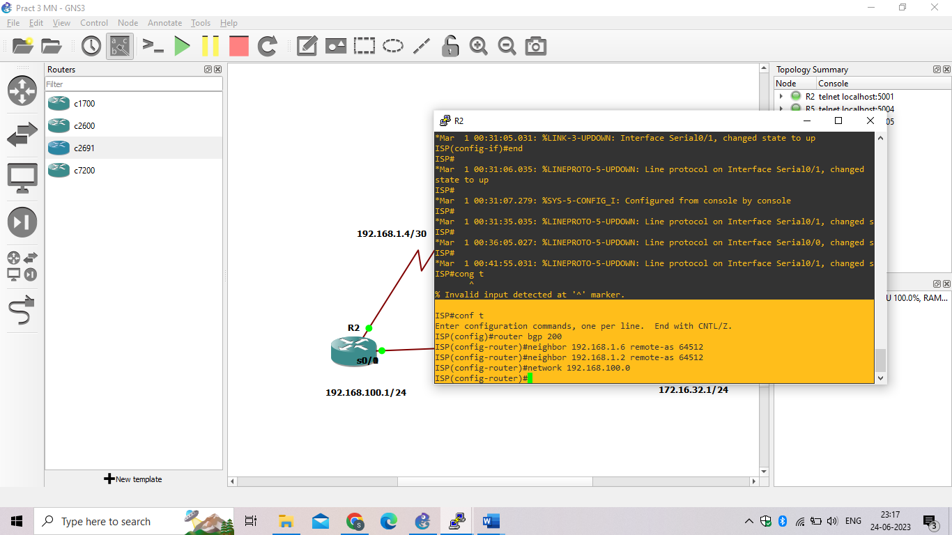
2. Configure a discard static route for the 172.16.0.0/16 network. Any packets that do not have a more specific match (longer match) for a 172.16.0.0 subnet will be dropped instead of sent to the ISP. Later in this lab we will configure a default route to the ISP.
   1. SanJose1(config)# **ip route 172.16.0.0 255.255.0.0 null0**
   2. 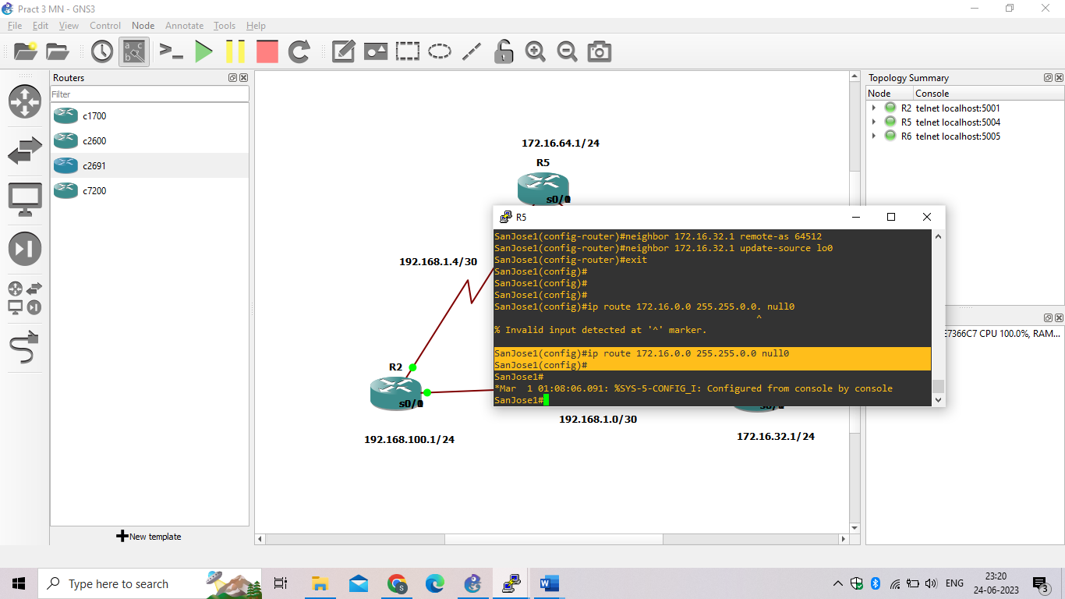
3. Configure SanJose1 as an EBGP peer to ISP.
   1. SanJose1(config)# **router bgp 64512**
   2. SanJose1(config-router)# **neighbor 192.168.1.5 remote-as 200**
   3. SanJose1(config-router)# **network 172.16.0.0**
   4. 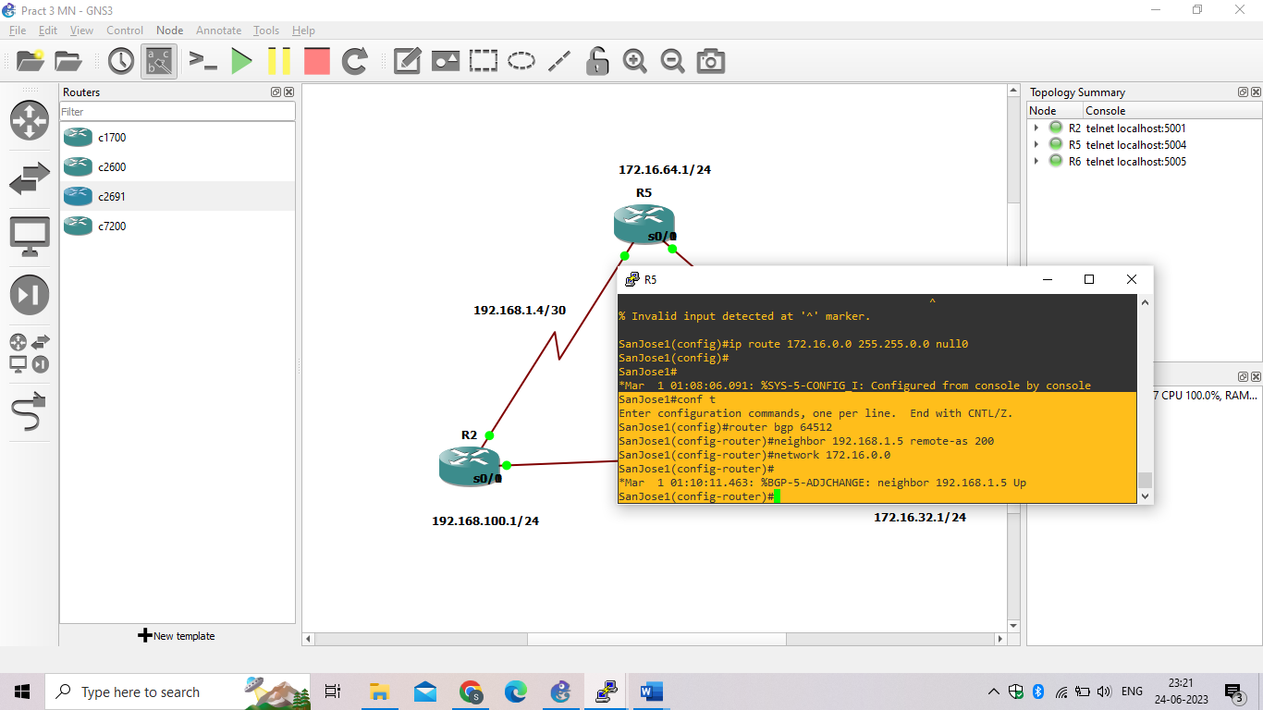
4. Use the **show ip bgp neighbors** command to verify that SanJose1 and ISP have reached the established state. Troubleshoot if necessary.

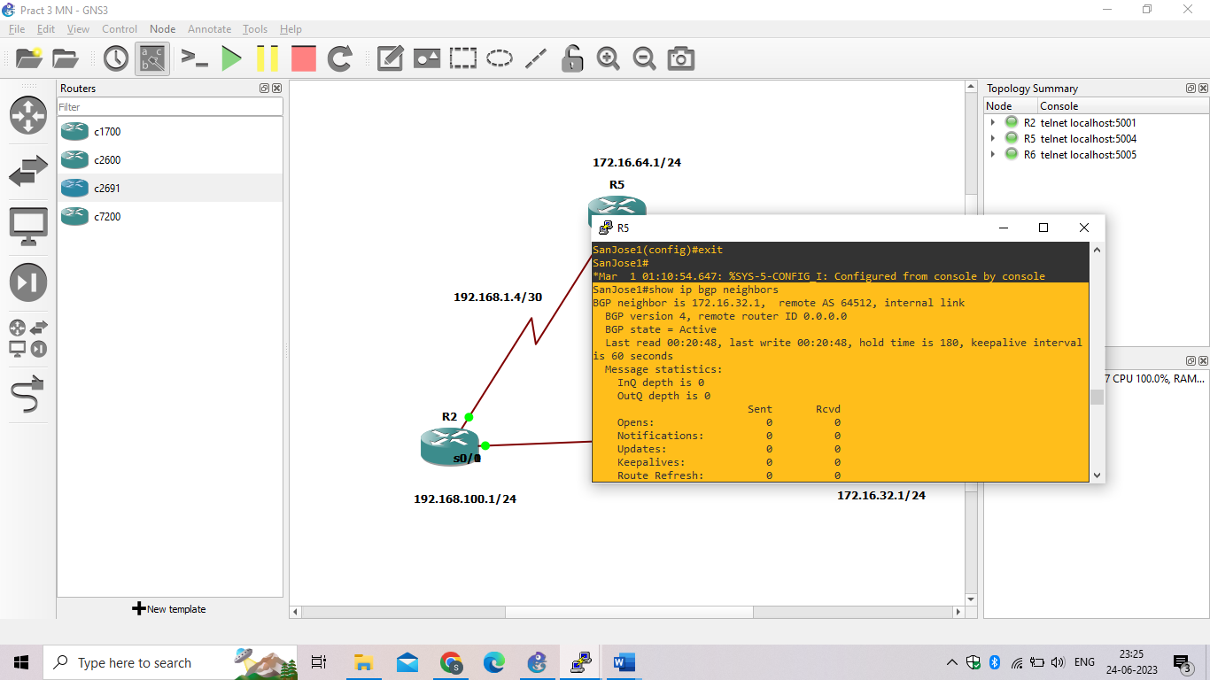

1. Configure a discard static route for 172.16.0.0/16 on SanJose2 and as an EBGP peer to ISP.

SanJose2(config)# **ip route 172.16.0.0 255.255.0.0 null0**

SanJose2(config)# **router bgp 64512**

SanJose2(config-router)# **neighbor 192.168.1.1 remote-as 200**

SanJose2(config-router)# **network 172.16.0.0**

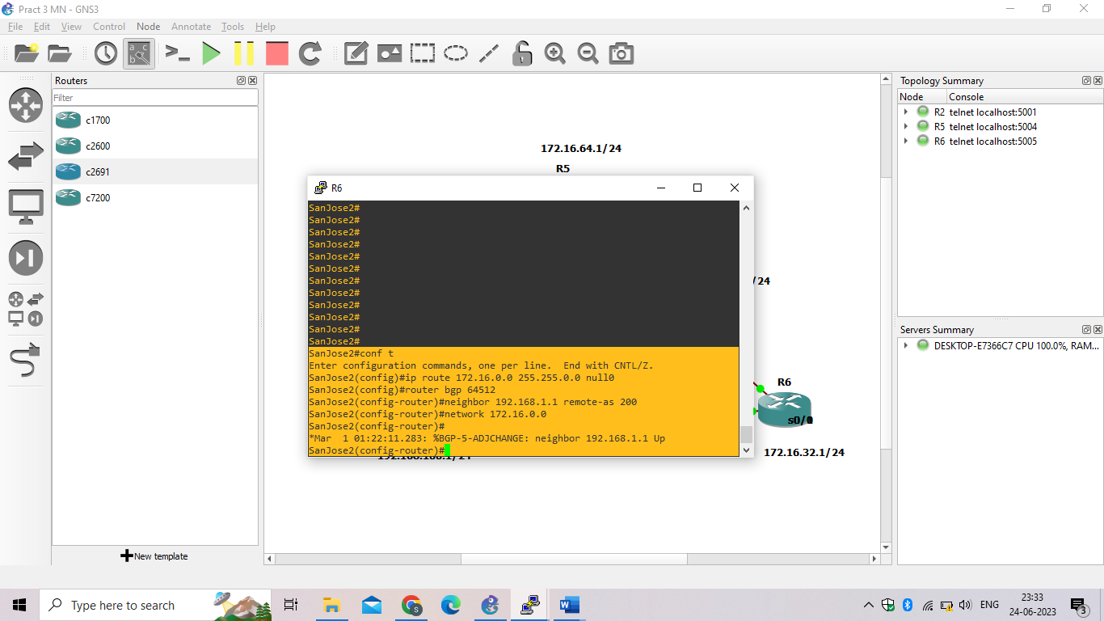

Step 5: View BGP summary output.

In Step 4, the show ip bgp neighborscommand was used to verify that SanJose1 and ISP had reached the established state. A useful alternative command is show ip bgp summary. The output should be similar to the

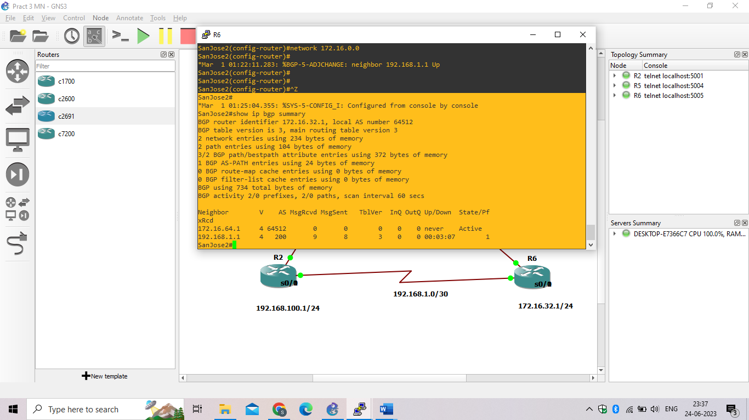

Step 6: Verify which path the traffic takes.

1. Clear the IP BGP conversation with the clear ip bgp * command on ISP. Wait for the conversations to reestablish with each SanJose router.

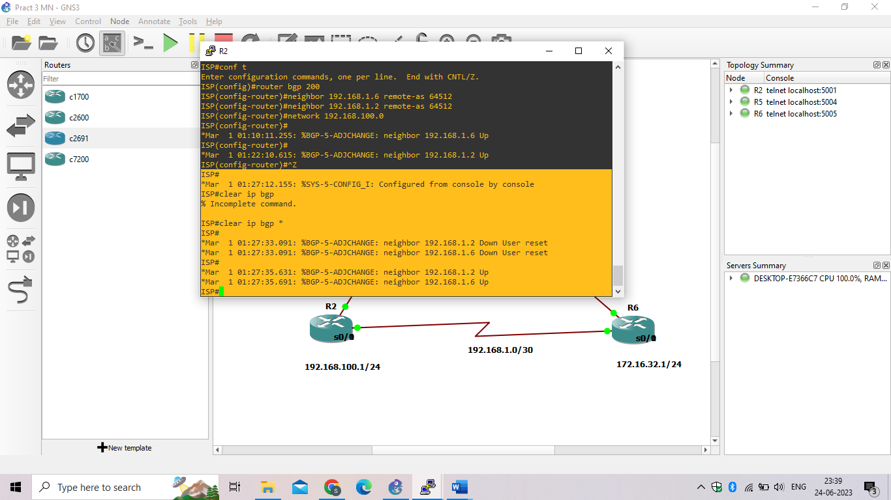

1. Test whether ISP can ping the loopback 0 address of 172.16.64.1 on SanJose1 and the serial link between SanJose1 and SanJose2, 172.16.1.1.

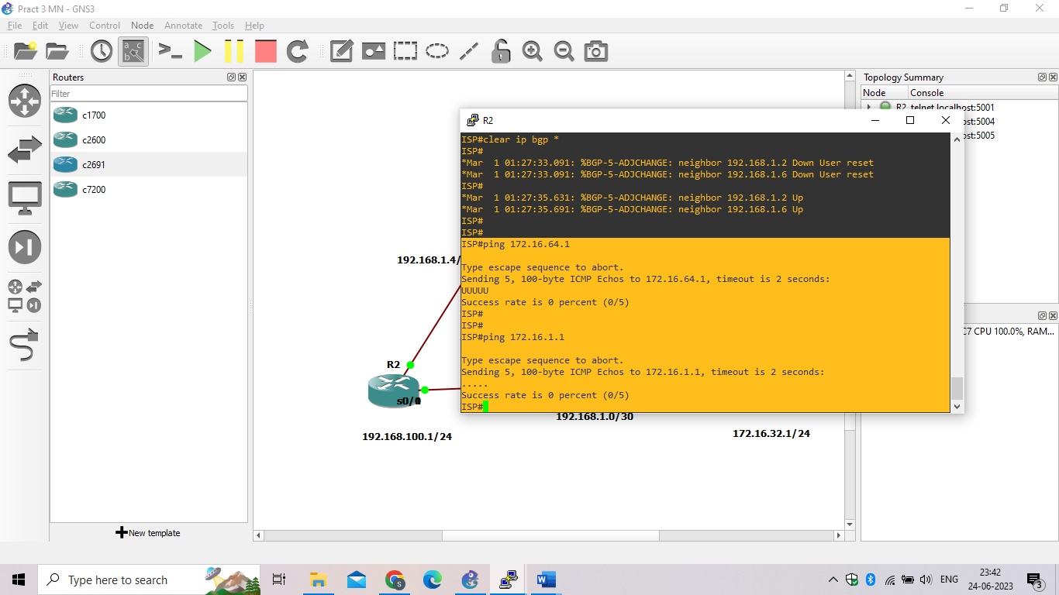

1. Now ping from ISP to the loopback 0 address of 172.16.32.1 on SanJose2 and the serial link between SanJose1 and SanJose2, 172.16.1.2.

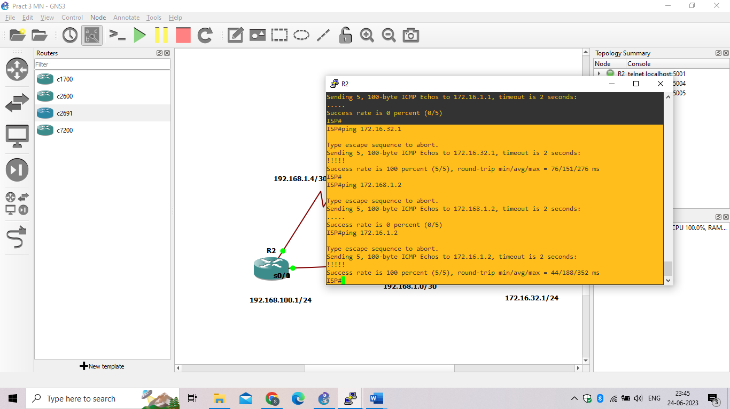

1. Issue the show ip bgpcommand on ISP to verify BGP routes and metrics.

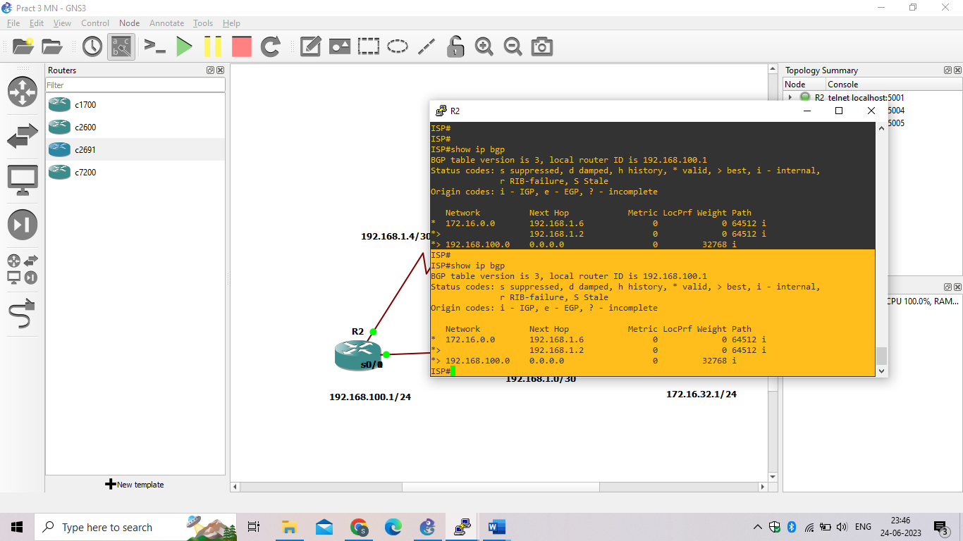

1. At this point, the ISP router should be able to get to each network connected to SanJose1 and SanJose2 from the loopback address 192.168.100.1. Use the extended **ping** command and specify the source address of ISP Lo0 to test.

ISP# **ping 172.16.1.1 source 192.168.100.1**

ISP# **ping 172.16.32.1 source 192.168.100.1**

ISP# **ping 172.16.1.2 source 192.168.100.1**

ISP# **ping 172.16.64.1 source 192.168.100.1**

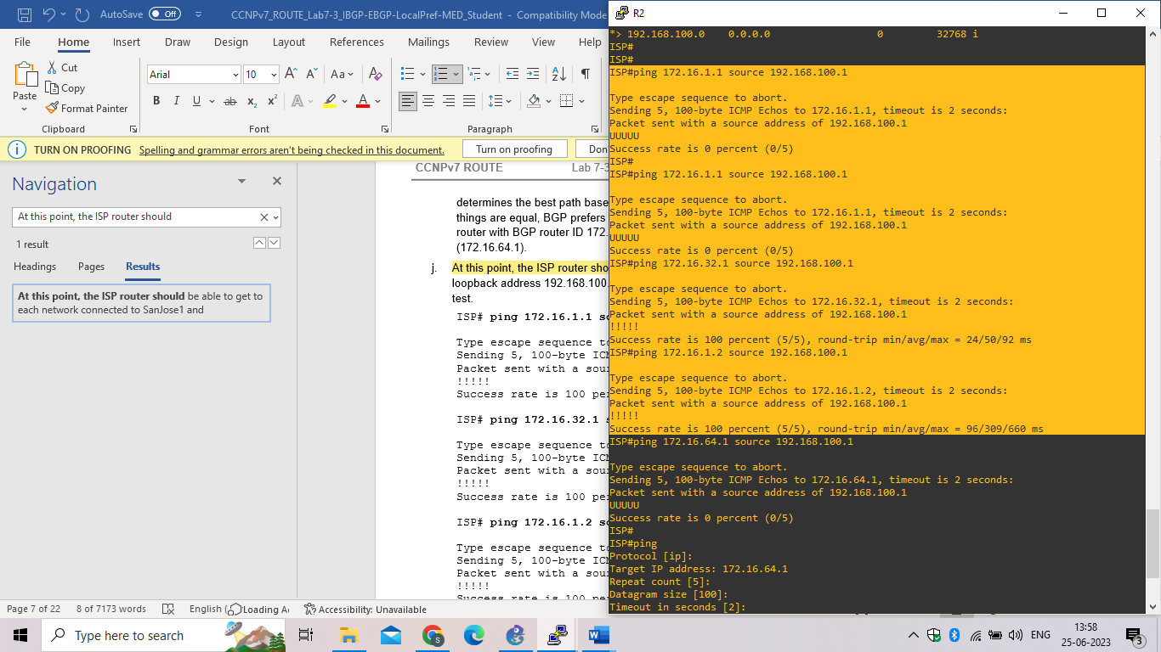

1. ISP# **ping**

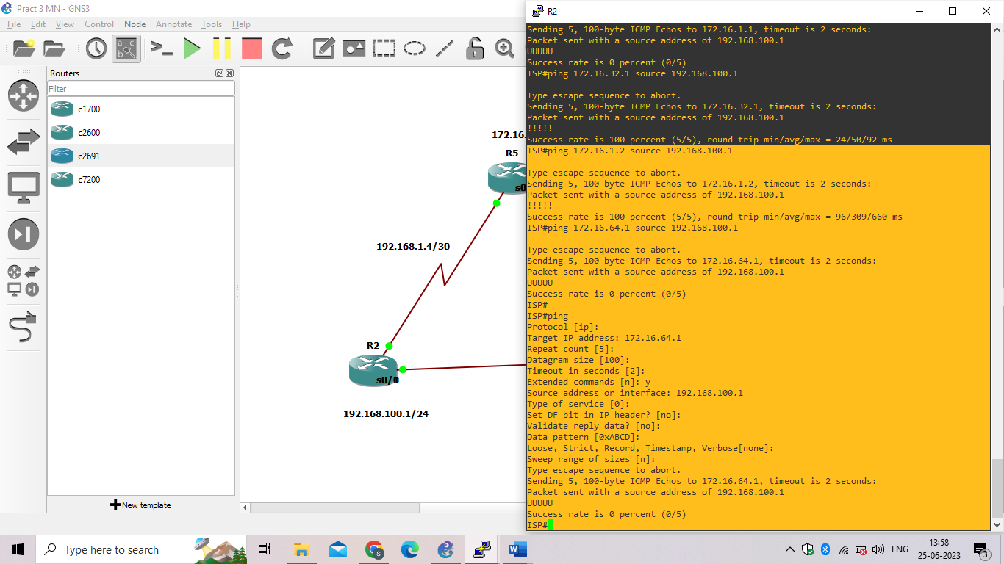

Step 7: Configure the BGP next-hop-self feature.

SanJose1 is unaware of the link between ISP and SanJose2, and SanJose2 is unaware of the link between ISP and SanJose1. Before ISP can successfully ping all the internal serial interfaces of AS 64512, these serial links should be advertised via BGP on the ISP router. This can also be resolved via EIGRP on each SanJose router. One method is for ISP to advertise these links.

a. Issue the following commands on the ISP router.

ISP(config)# **router bgp 200**

ISP(config-router)# **network 192.168.1.0 mask 255.255.255.252**

ISP(config-router)# **network 192.168.1.4 mask 255.255.255.252**

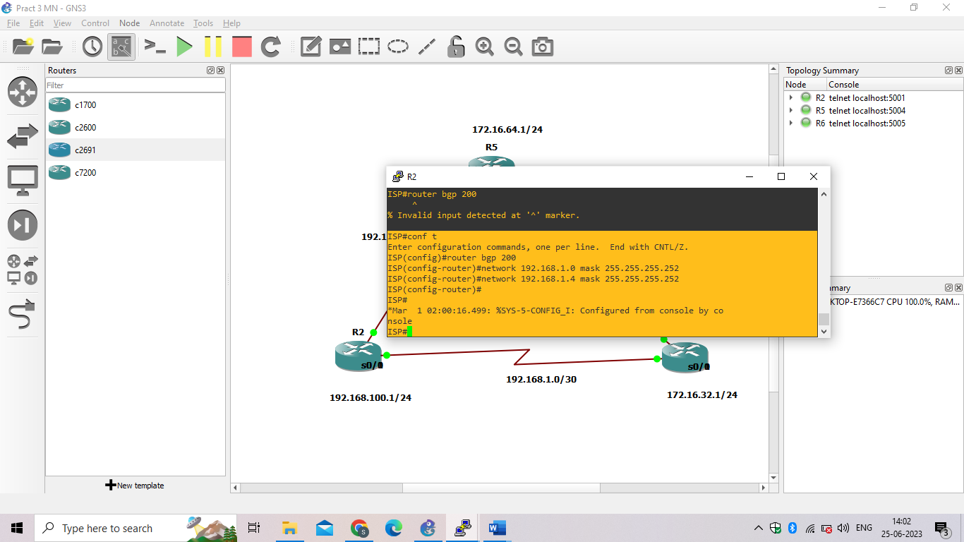

1. Issue the show ip bgp command to verify that the ISP is correctly injecting its own WAN links into BGP.

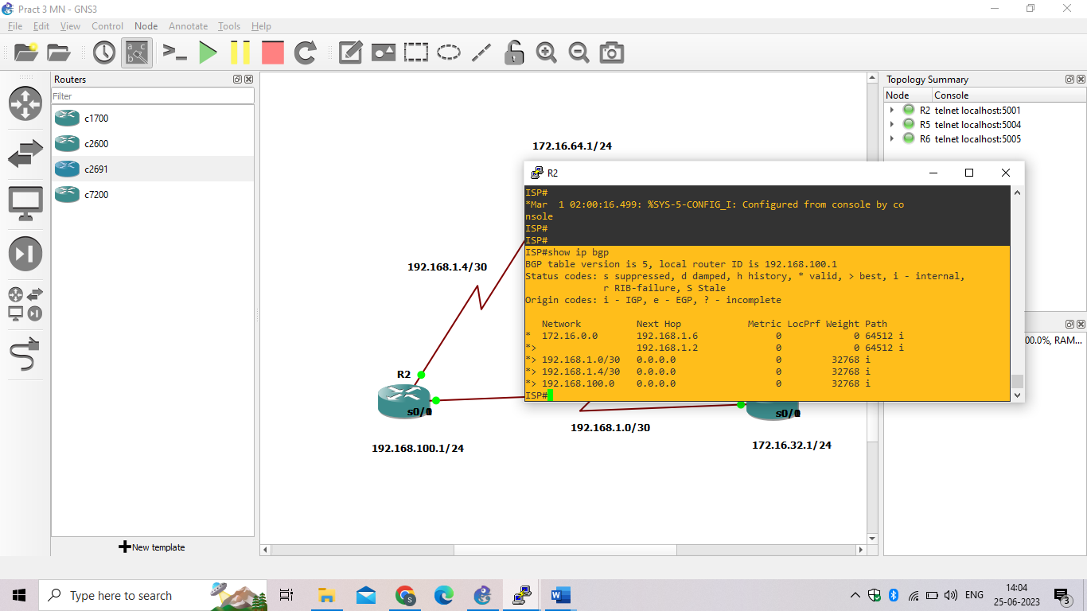

1. Verify on SanJose1 and SanJose2 that the opposite WAN link is included in the routing table. The output from SanJose2 is as follows.

SanJose2# **show ip route**

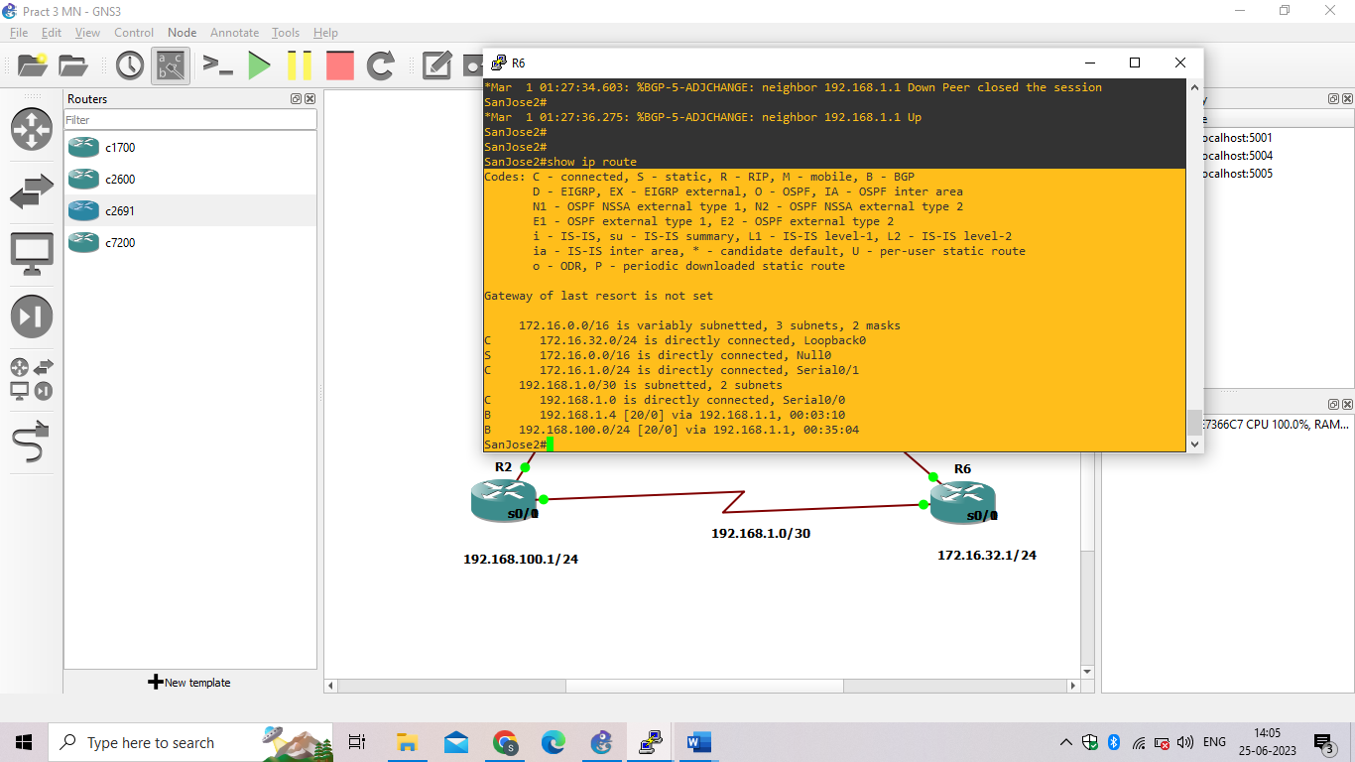

1. To better understand the next-hop-self command we will remove ISP advertising its two WAN links and shutdown the WAN link between ISP and SanJose2. The only possible path from SanJose2 to ISP’s 192.168.100.0/24 is through SanJose1.

ISP(config)# **router bgp 200**

ISP(config-router)# **nonetwork 192.168.1.0 mask 255.255.255.252**

ISP(config-router)# **nonetwork 192.168.1.4 mask 255.255.255.252**

ISP(config-router)# **exit**

ISP(config)# **interface serial 0/0/1**

ISP(config-if)# **shutdown**

ISP(config-if)#

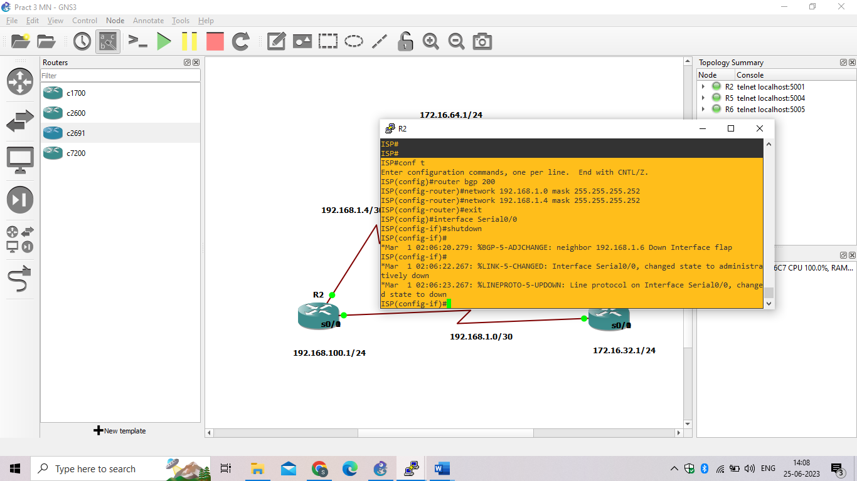

1. Display SanJose2’s BGP table using the **show ip bgp** command and the IPv4 routing table with **show ip route**.

SanJose2# **show ip bgp**

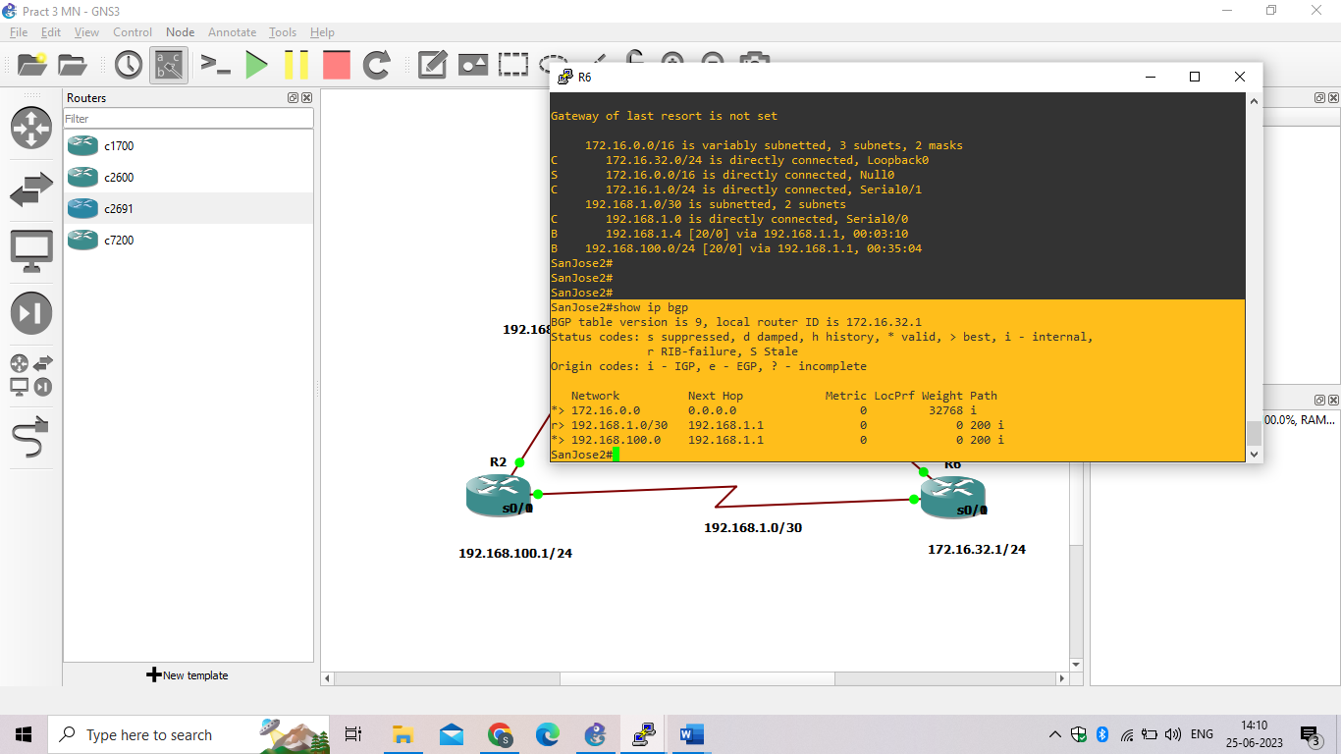

SanJose2# **show ip route**

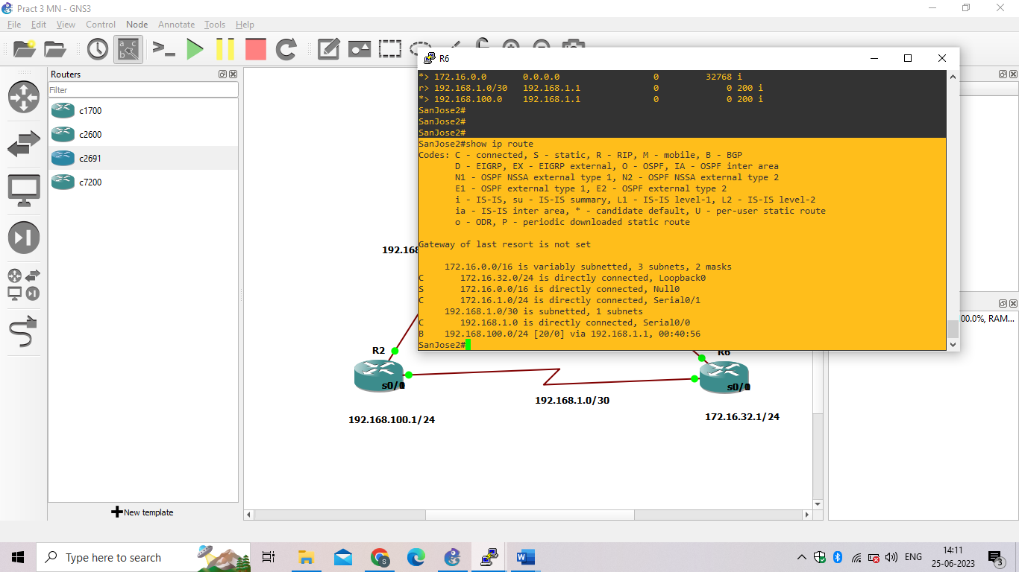

1. Issue the **next-hop-self** command on SanJose1 and SanJose2 to advertise themselves as the next hop to their IBGP peer.

SanJose1(config)# **router bgp 64512**

SanJose1(config-router)# **neighbor 172.16.32.1 next-hop-self**

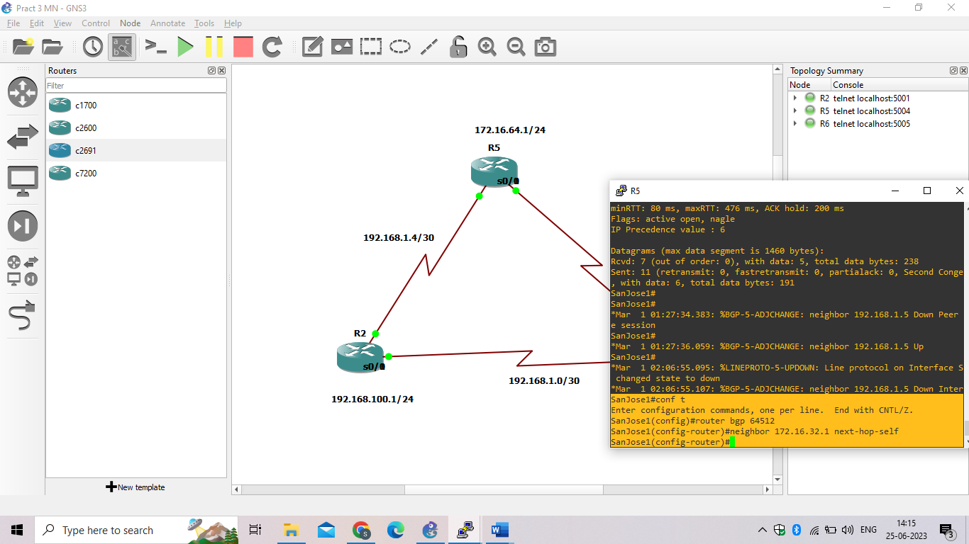

SanJose2(config)# **router bgp 64512**

SanJose2(config-router)# **neighbor 172.16.64.1 next-hop-self**

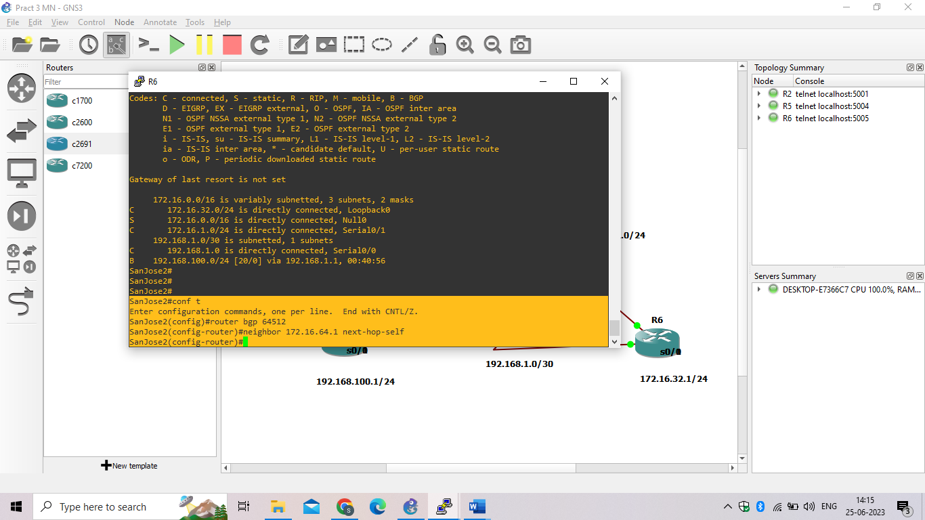

1. Reset BGP operation on either router with the clear ip bgp * command.

SanJose1# **clear ip bgp \***

SanJose1#

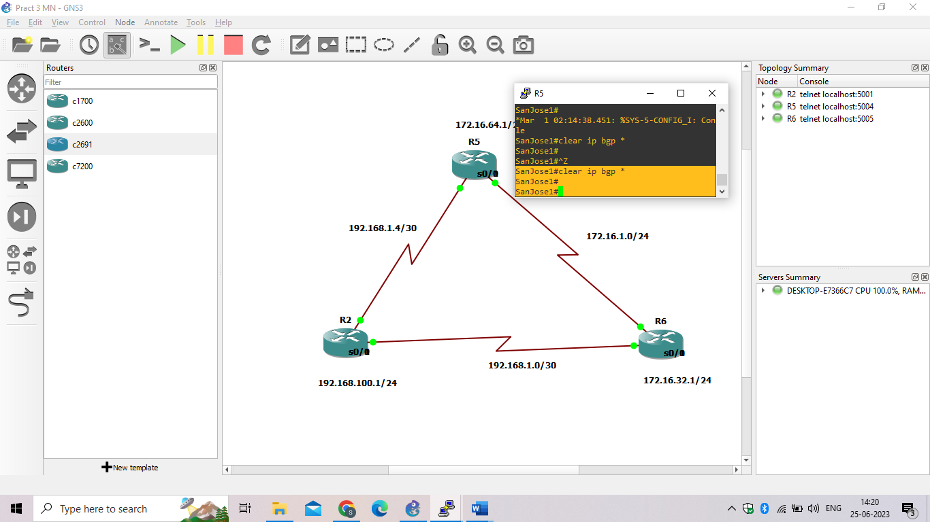

SanJose2# **clear ip bgp \***

SanJose2#

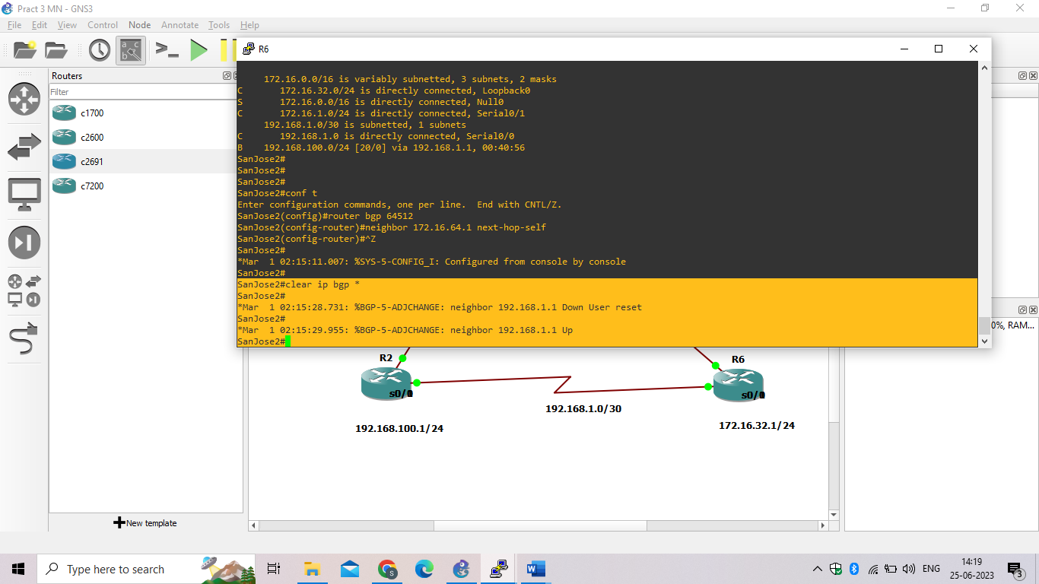

1. After the routers have returned to established BGP speakers, issue the **show ip bgp** command on SanJose2 and notice that the next hop is now SanJose1 instead of ISP.

SanJose2# **show ip bgp**

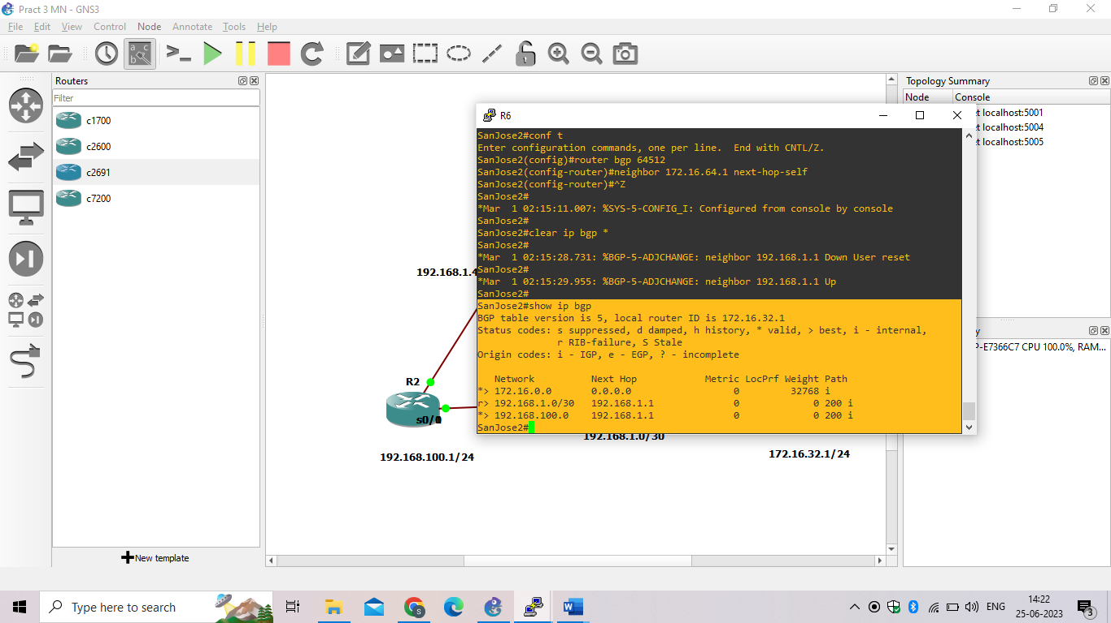

1. The **show ip route** command on SanJose2 now displays the 192.168.100.0/24 network because SanJose1 is the next hop, 172.16.64.1, which is reachable from SanJose2.

SanJose2# **show ip route**

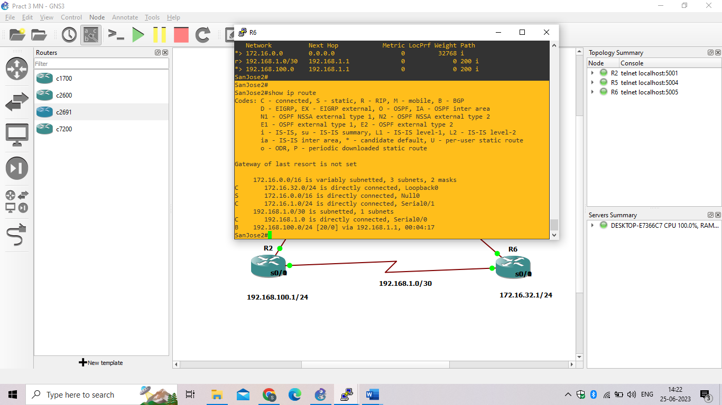

1. Before configuring the next BGP attribute, restore the WAN link between ISP and SanJose3. This will change the BGP table and routing table on both routers. For example, SanJose2’s routing table shows 192.168.100.0/24 will now have a better path through ISP.

ISP(config)# **interface serial 0/0/1**

ISP(config-if)# **noshutdown**

ISP(config-if)#

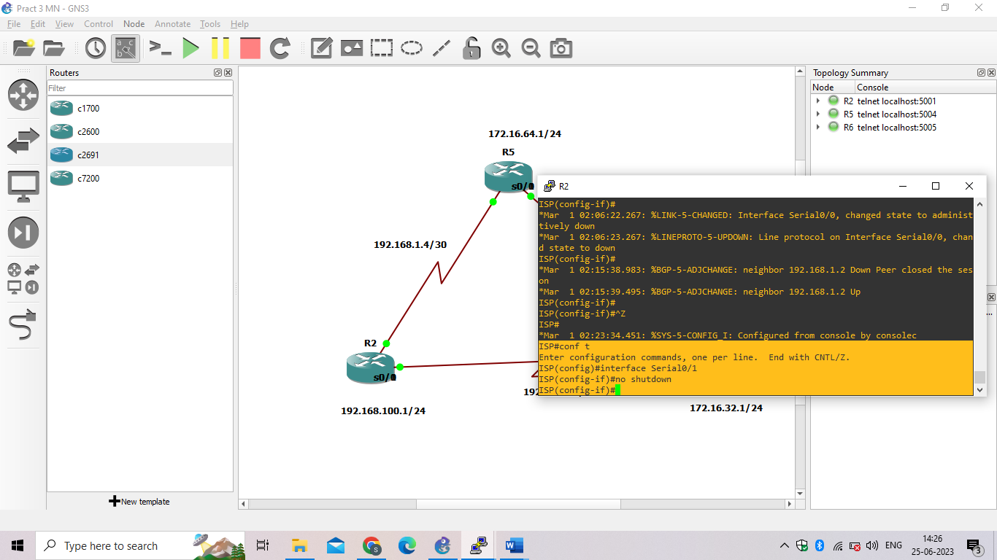

SanJose2# **show ip route**

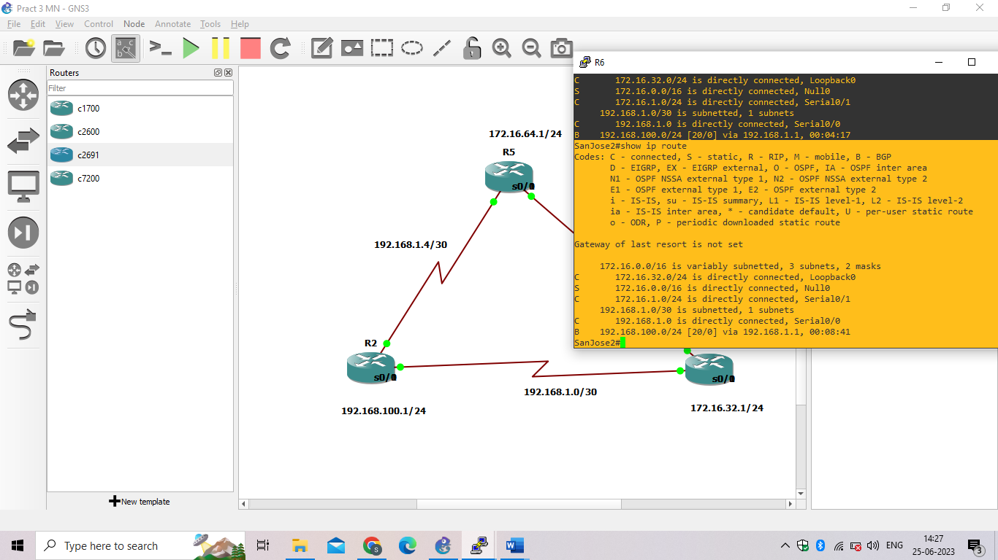

Step 8: Set BGP local preference.

At this point, everything looks good, with the exception of default routes, the outbound flow of data, and inbound packet flow.

1. Because the local preference value is shared between IBGP neighbors, configure a simple route map that references the local preference value on SanJose1 and SanJose2. This policy adjusts outbound traffic to prefer the link off the SanJose1 router instead of the metered T1 off SanJose2.

SanJose1(config)# **route-map PRIMARY_T1_IN permit 10**

SanJose1(config-route-map)# **set local-preference 150**

SanJose1(config-route-map)#**exit**

SanJose1(config)# **router bgp 64512**

SanJose1(config-router)# **neighbor 192.168.1.5 route-map PRIMARY_T1_IN in**

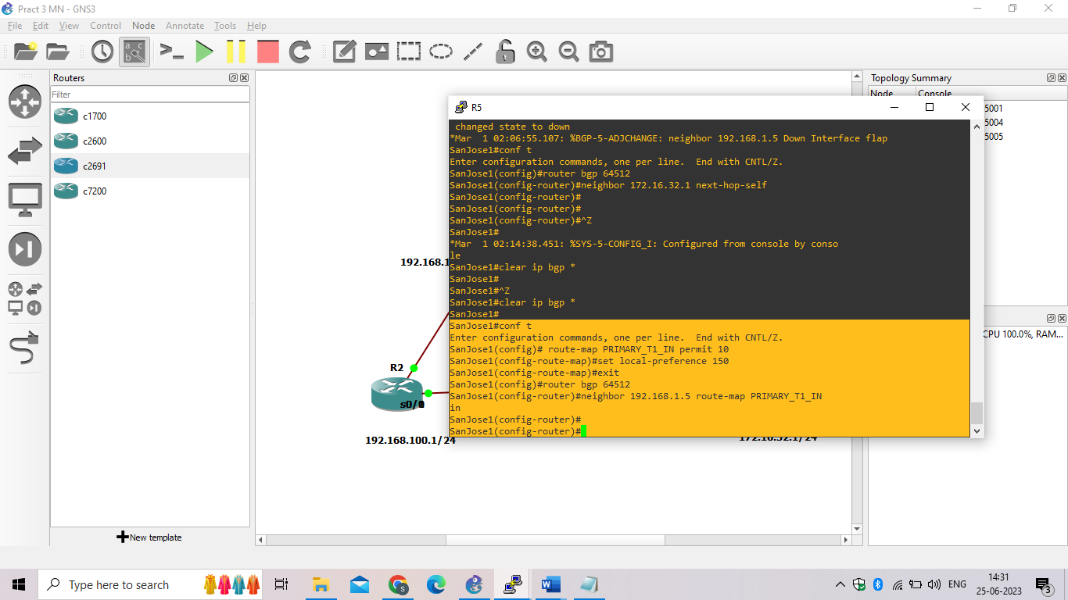

SanJose2(config)# **route-map SECONDARY_T1_IN permit 10**

SanJose2(config-route-map)# **set local-preference 125**

SanJose1(config-route-map)#**exit**

SanJose2(config)# **router bgp 64512**

SanJose2(config-router)# **neighbor 192.168.1.1 route-map SECONDARY_T1_IN in**

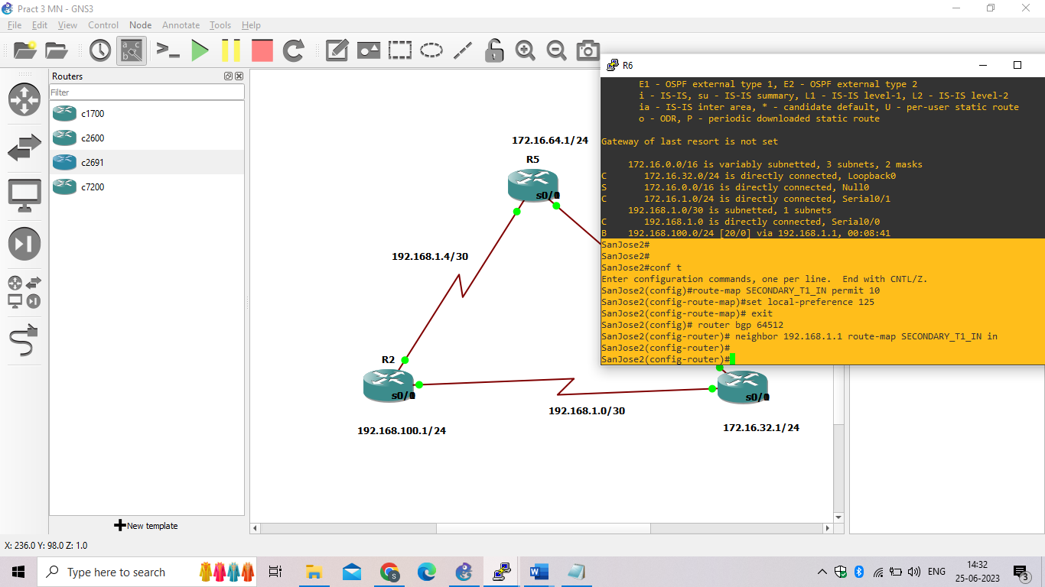

1. Use the clear ip bgp * soft command after configuring this new policy. When the conversations have been reestablished, issue the show ip bgp command on SanJose1 and SanJose2.

SanJose1# **clear ip bgp * soft**

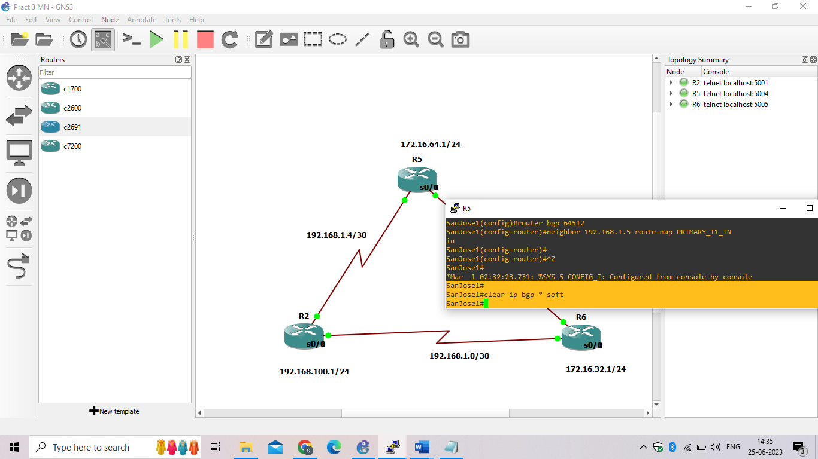

SanJose2# **clear ip bgp * soft**

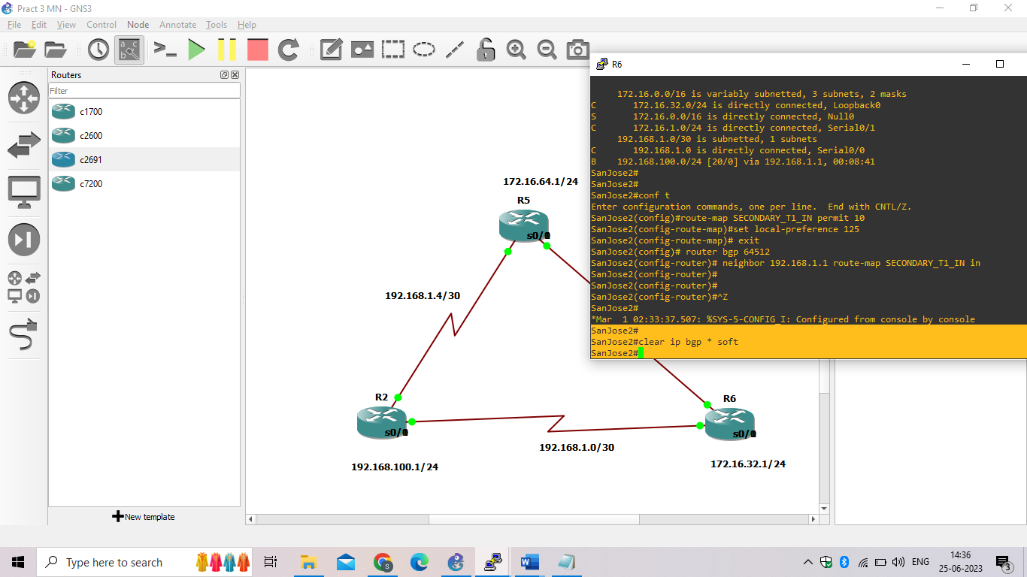

SanJose1# **show ip bgp**

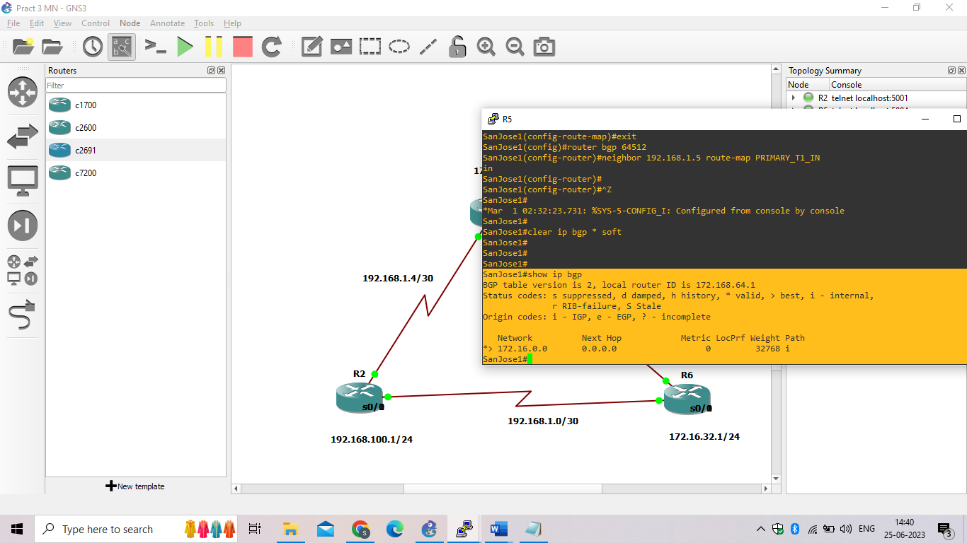

SanJose2# **show ip bgp**

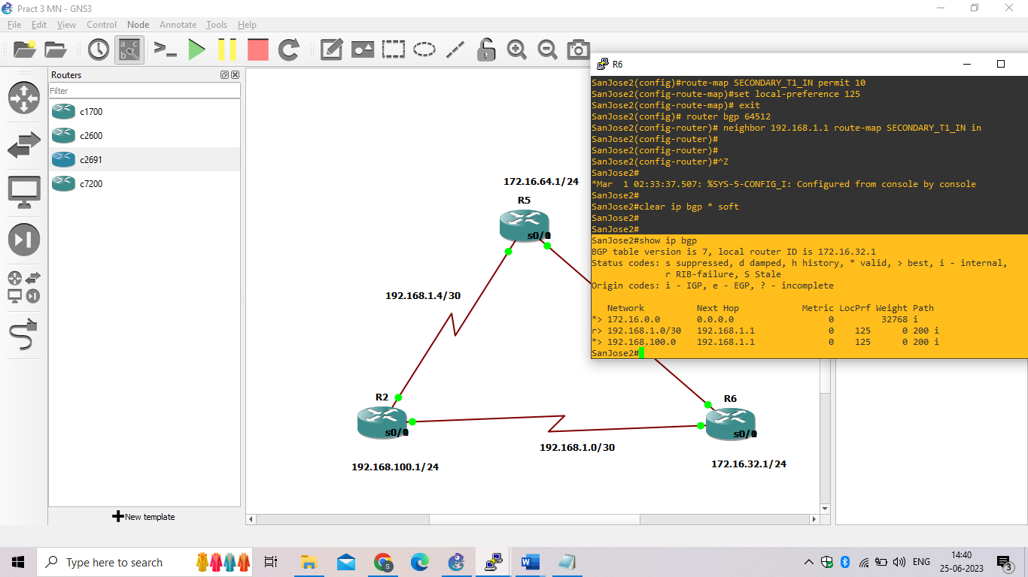

Step 9: Set BGP MED.

1. In the previous step we saw that SanJose1 and SanJose2 will route traffic for 192.168.100.0/24 using the link between SanJose1 and ISP. Examine what the return path ISP takes to reach AS 64512. Notice that the return path is different from the original path. This is known as asymmetric routing and is not necessarily an unwanted trait.

ISP# **show ip bgp**

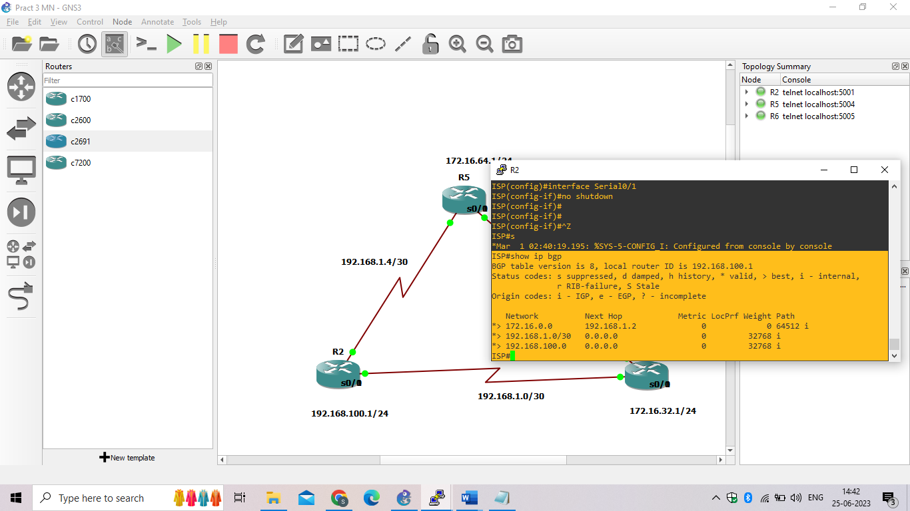

ISP# **show ip route**

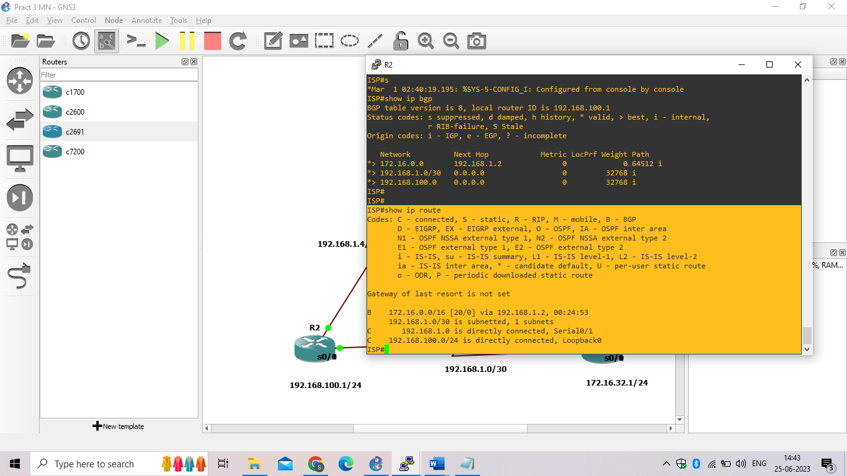

SanJose2# **ping**

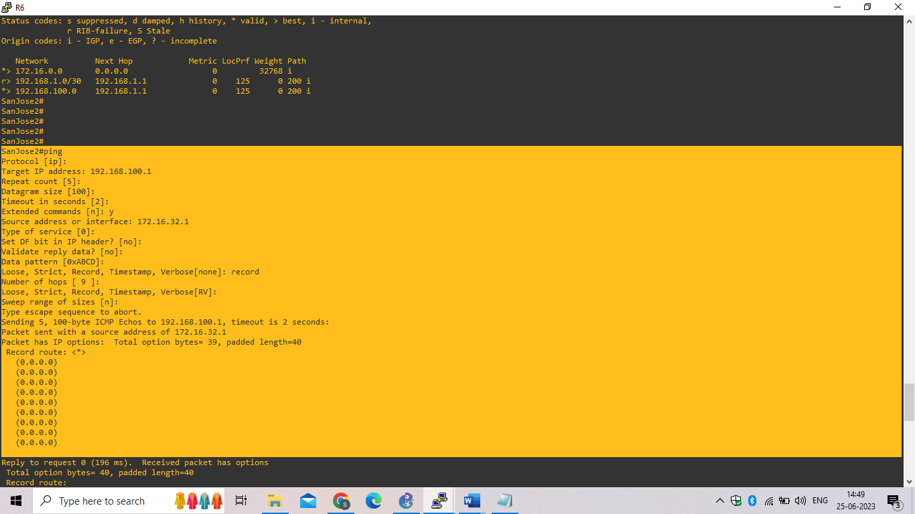

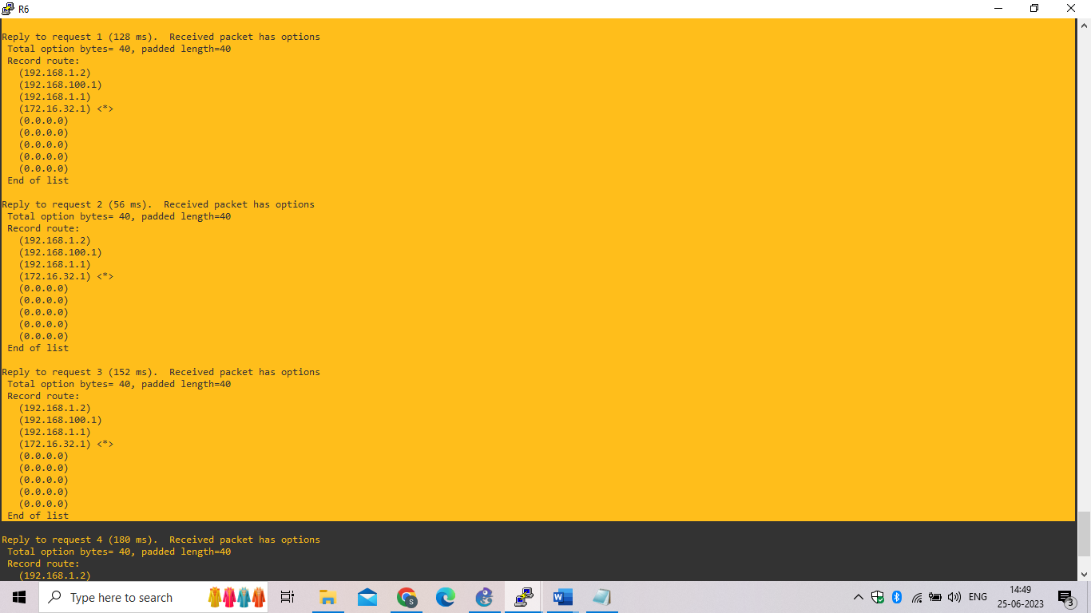

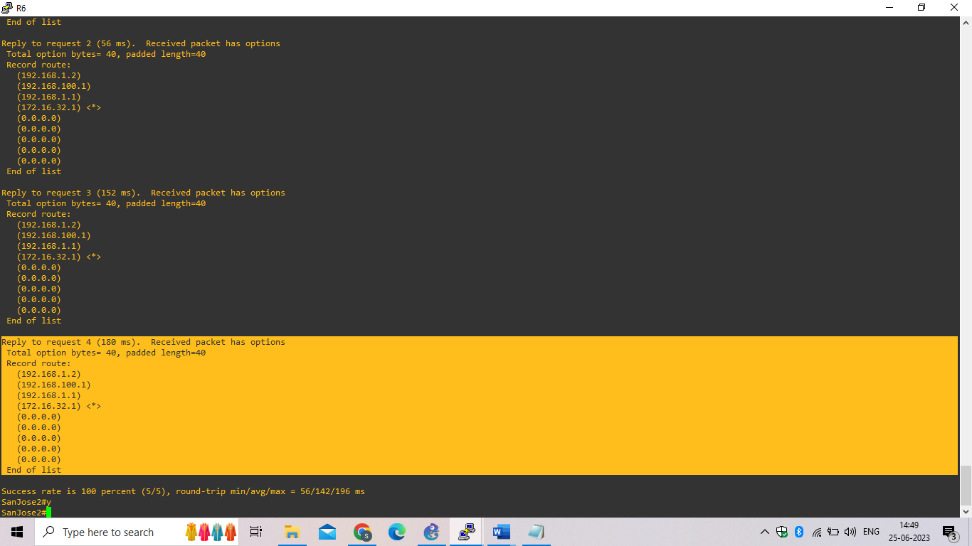

ISP# **show ip bgp**

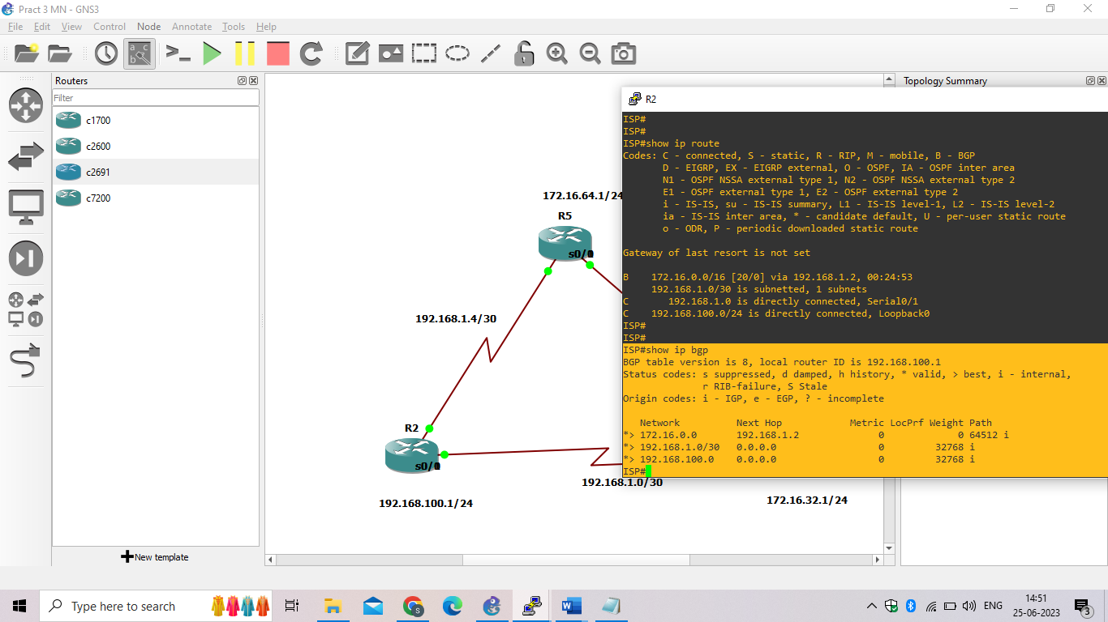

Step 10: Establish a default route.

The final step is to establish a default route that uses a policy statement that adjusts to changes in the network.

1. Configure ISP to inject a default route to both SanJose1 and SanJose2 using BGP using the **default-originate** command. This command does not require the presence of 0.0.0.0 in the ISP router. Configure the 10.0.0.0/8 network which will not be advertised using BGP. This network will be used to test the default route on SanJose1 and SanJose2.

ISP(config)# **router bgp 200**

ISP(config-router)# **neighbor 192.168.1.6 default-originate**

ISP(config-router)# **neighbor 192.168.1.2 default-originate**

ISP(config-router)# **exit**

ISP(config)# **interface loopback 10**

ISP(config-if)# **ip address 10.0.0.1 255.255.255.0**

ISP(config-if)#

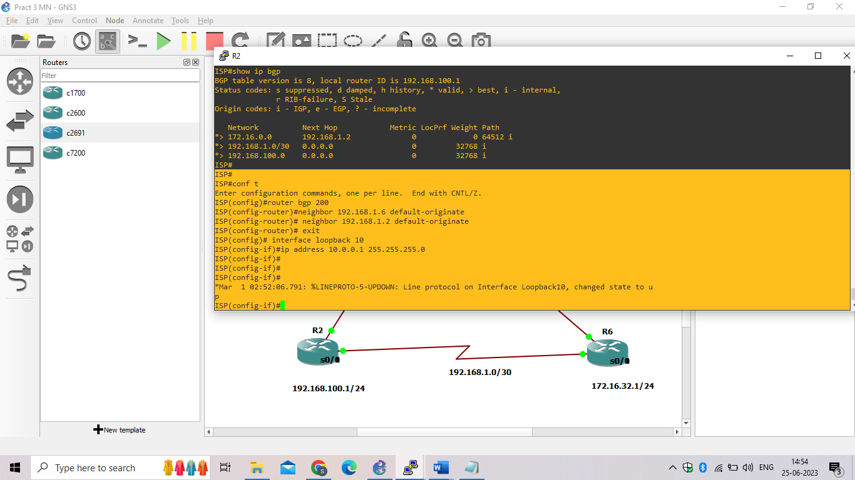

1. Verify that both routers have received the default route by examining the routing tables on SanJose1 and SanJose2. Notice that both routers prefer the route between SanJose1 and ISP

SanJose1# **show ip route**

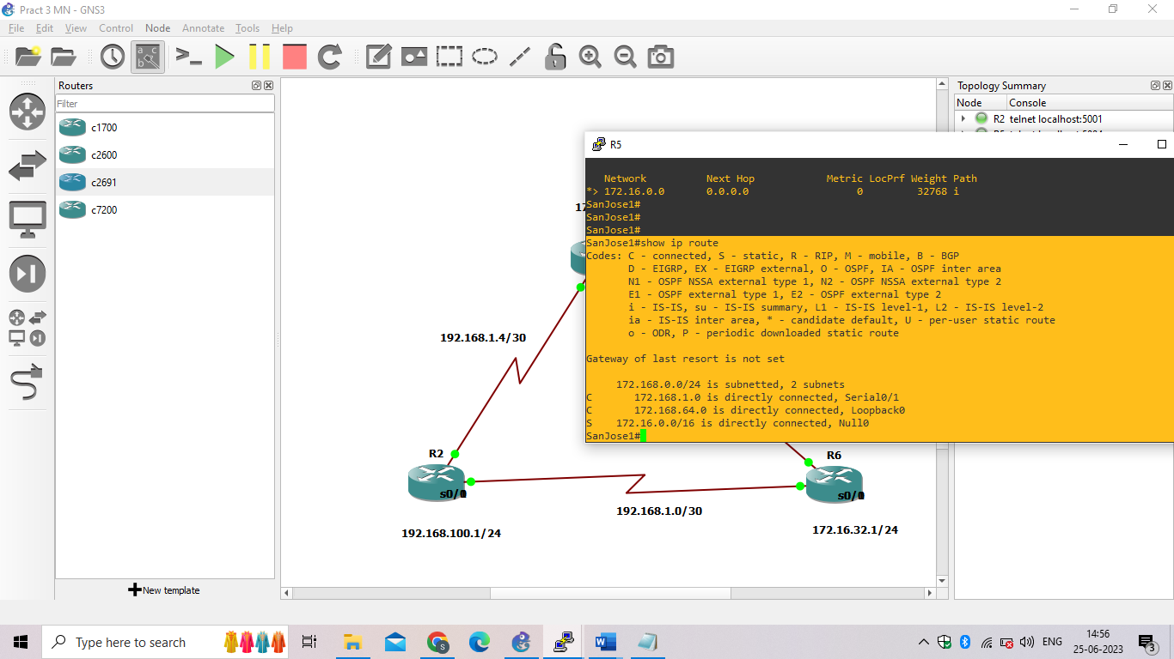

SanJose2# **show ip route**

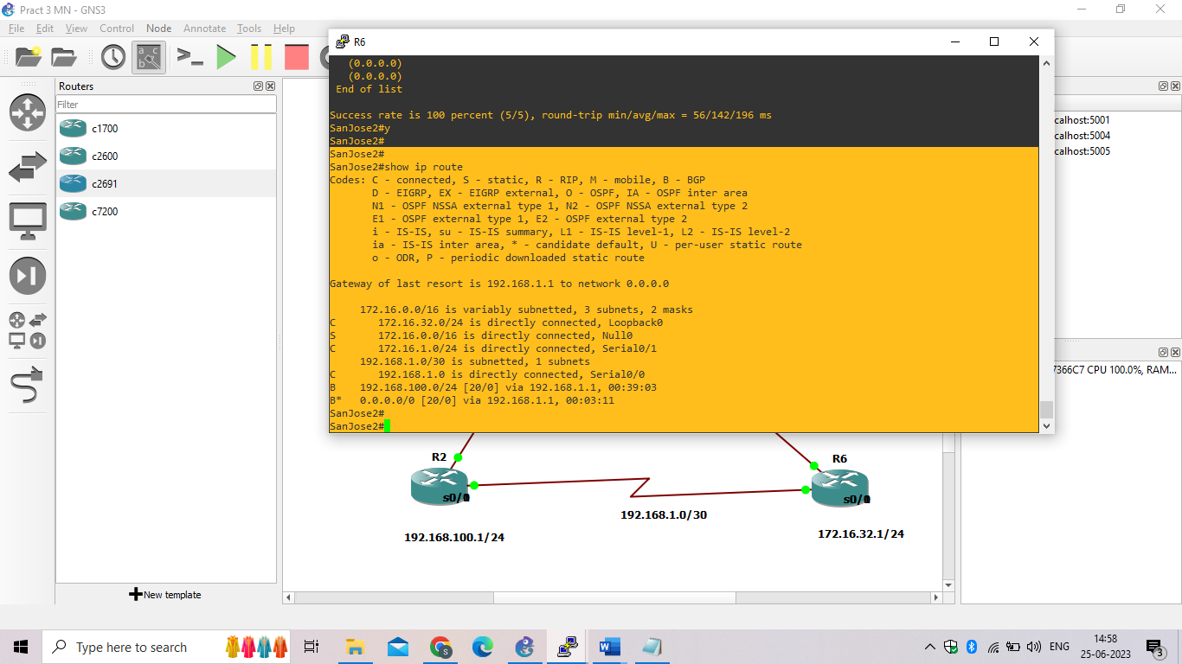

SanJose2# **show ip bgp**

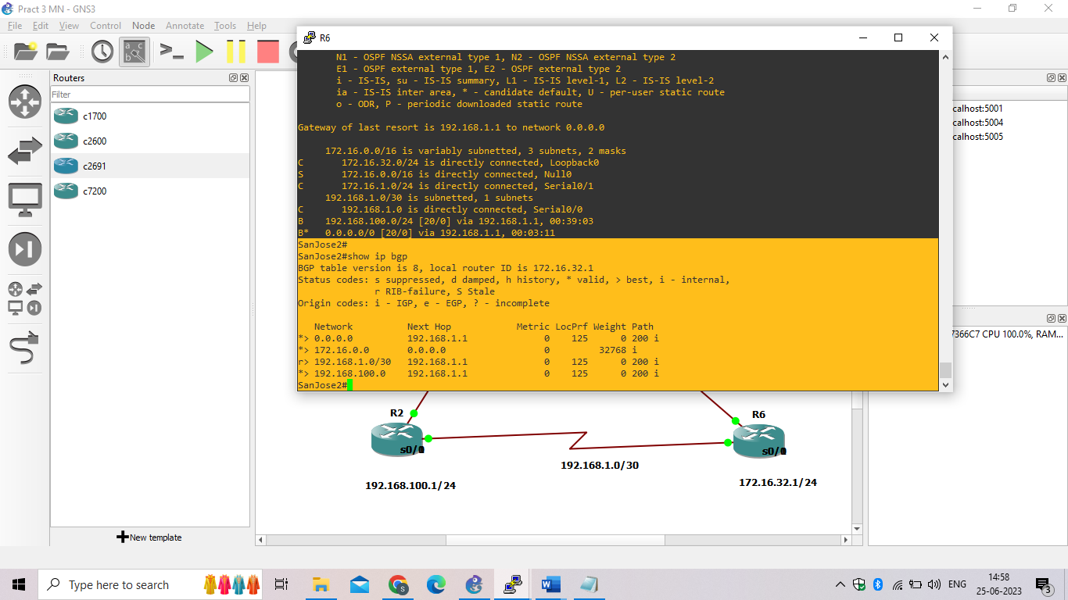

1. Using the traceroute command verify that packets to 10.0.0.1 is using the default route through SanJose1.

SanJose2# **traceroute 10.0.0.1**

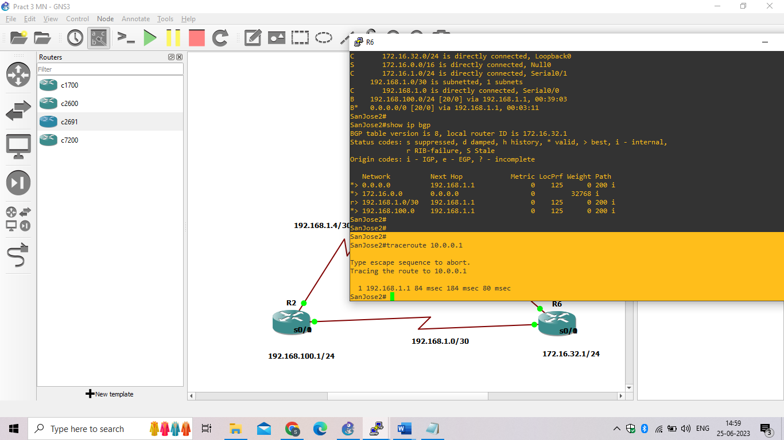

1. Next, test how BGP adapts to using a different default route when the path between SanJose1 and ISP goes down.

ISP(config)# **interface serial 0/0/0**

ISP(config-if)# **shutdown**

ISP(config-if)#

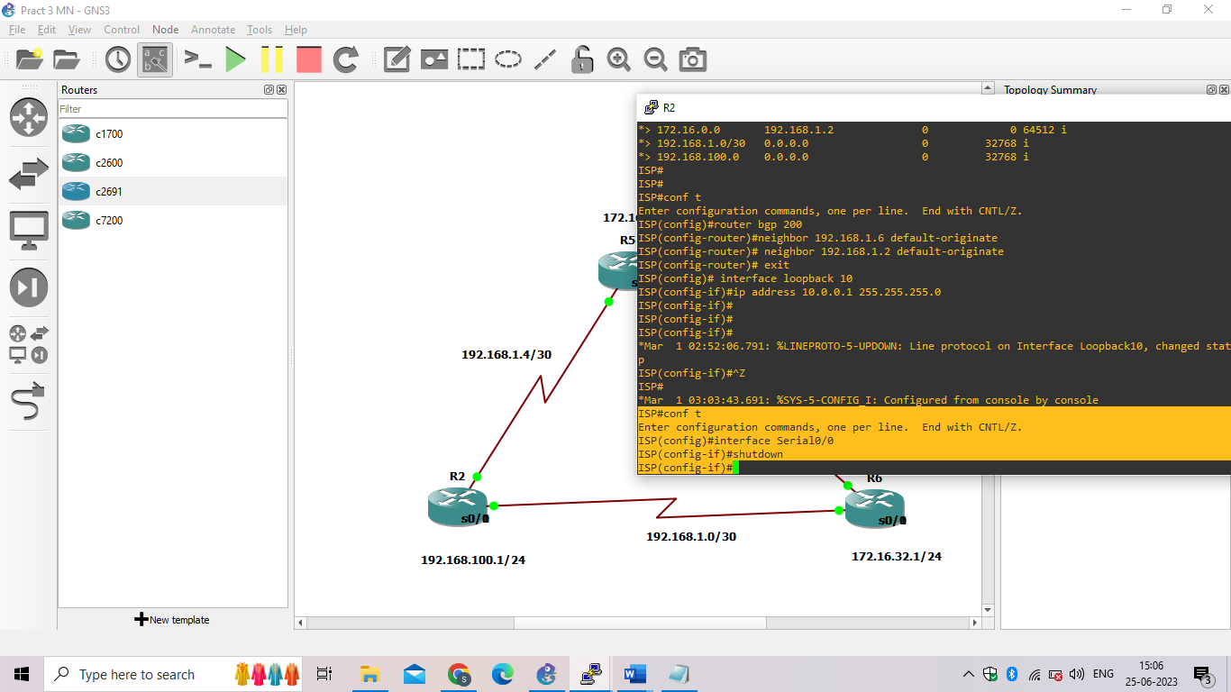

1. Verify that both routers are modified their routing tables with the default route using the path between SanJose2 and ISP.

SanJose1# **show ip route**

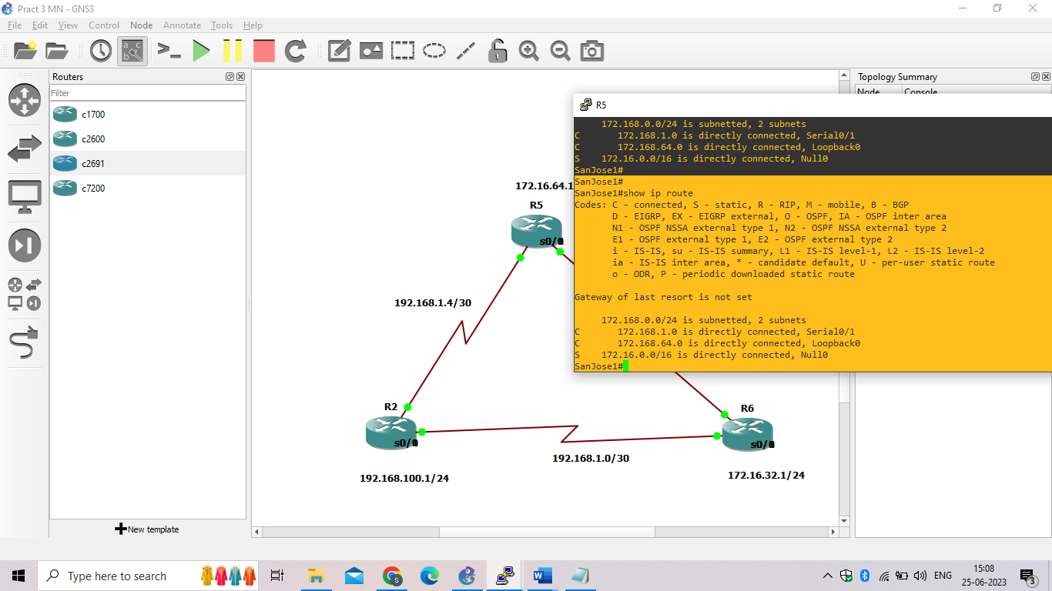

SanJose2# **show ip route**

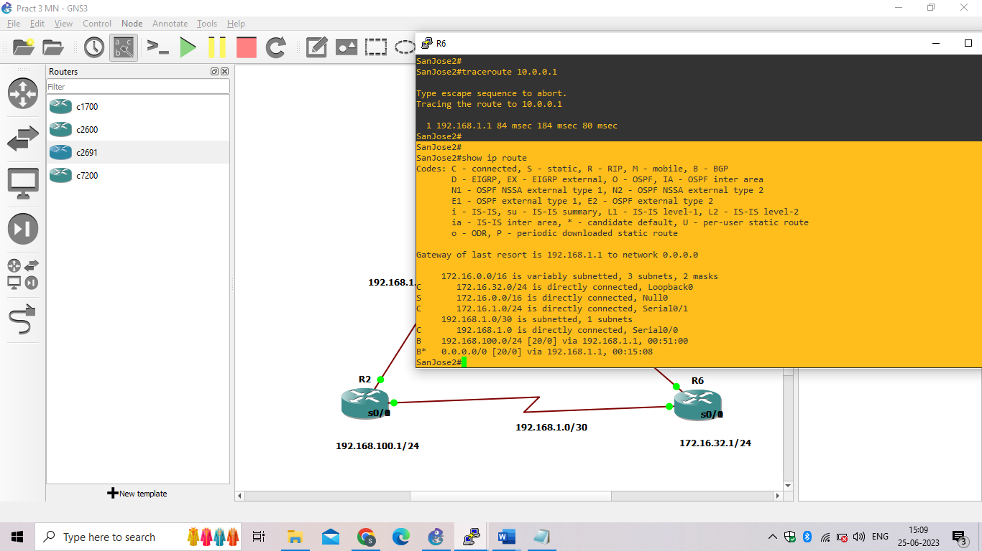

**PRACTICAL NO:- 4**

**Aim:- Secure the Management Plane**

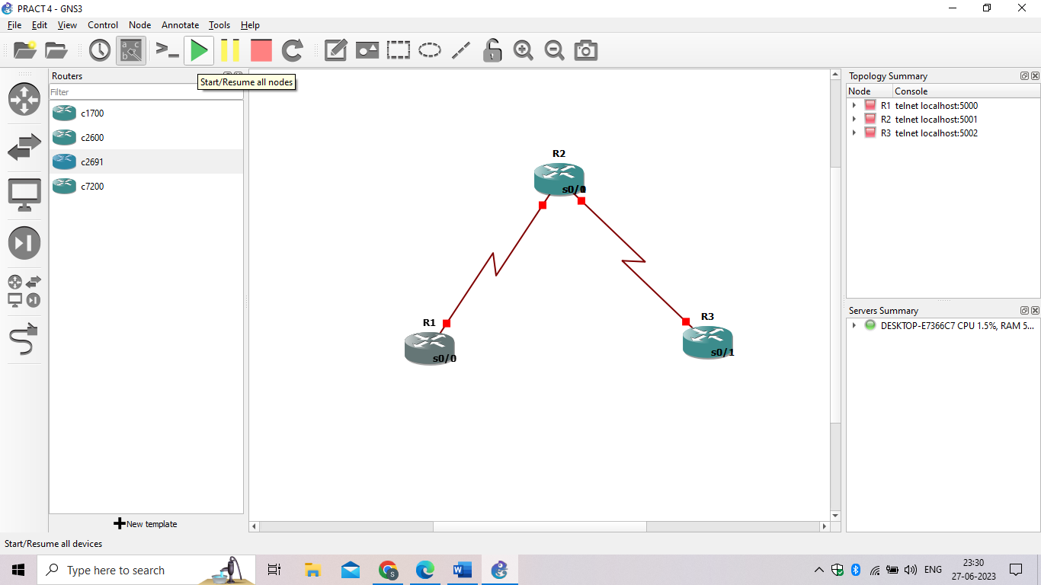

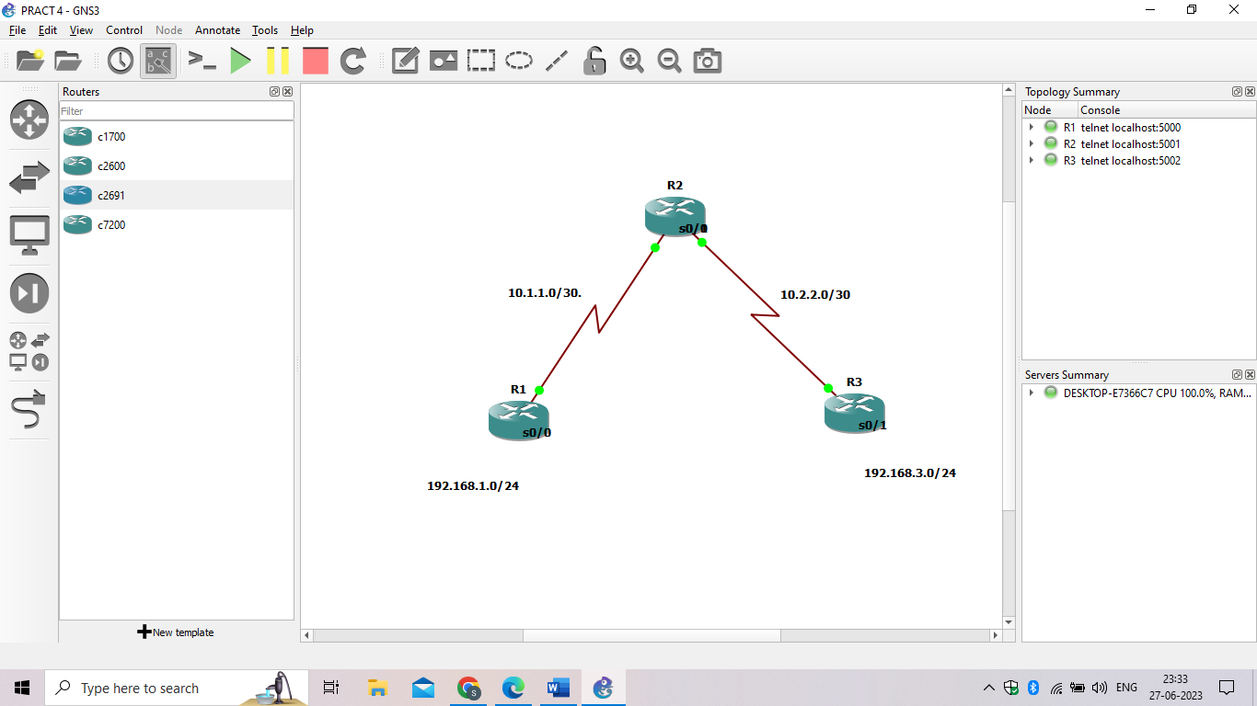

**Step 1: Configure loopbacks and assign addresses.**

**R1**

hostname R1

interface Loopback 0

 description R1 LAN

 ip address 192.168.1.1 255.255.255.0

exit

!

interface Serial0/0

 description R1 --> R2

 ip address 10.1.1.1 255.255.255.252

 clock rate 128000

 no shutdown

exit

!

End

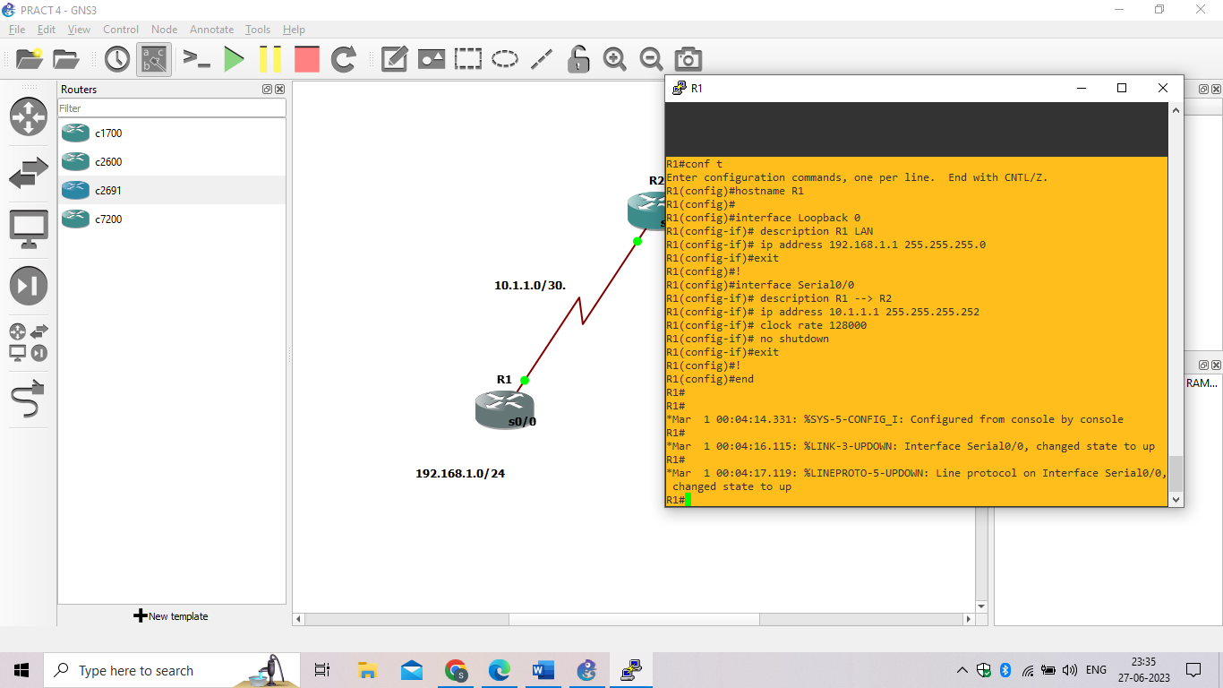

**R2**

hostname R2

!

interface Serial0/0

 description R2 --> R1

 ip address 10.1.1.2 255.255.255.252

 no shutdown

exit

interface Serial0/1

 description R2 --> R3

 ip address 10.2.2.1 255.255.255.252

 clock rate 128000

 no shutdown

exit

!

End

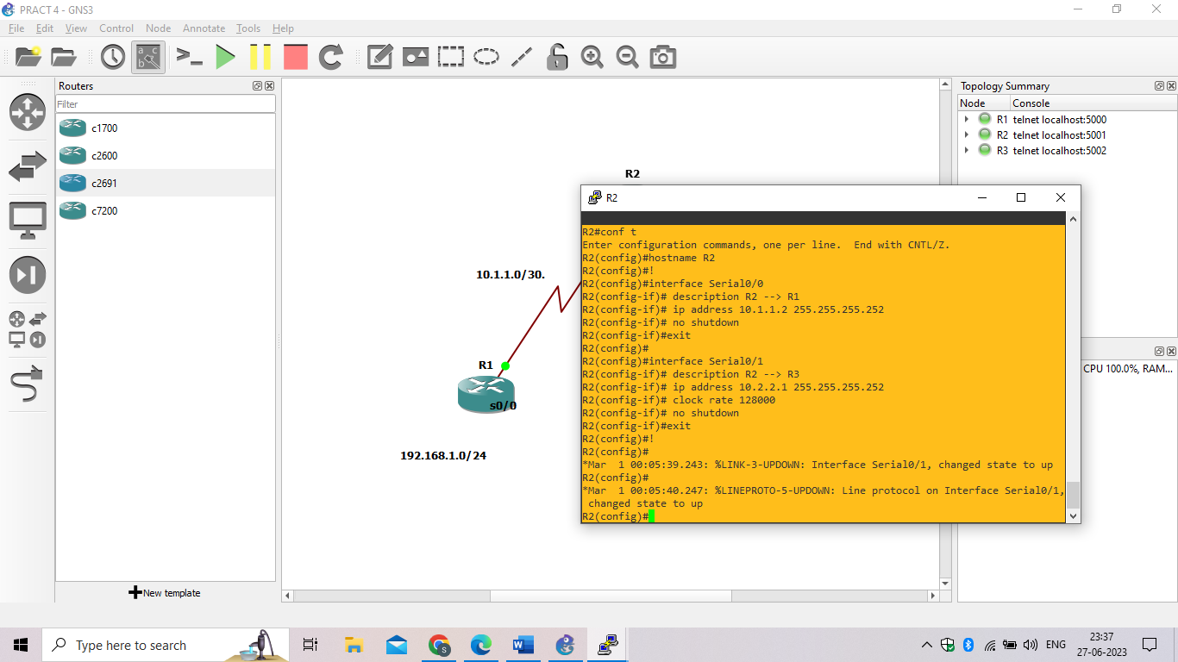

**R3**

hostname R3

!

interface Loopback0

 description R3 LAN

 ip address 192.168.3.1 255.255.255.0

exit

interface Serial0/1

 description R3 --> R2

 ip address 10.2.2.2 255.255.255.252

 no shutdown

exit

!

end

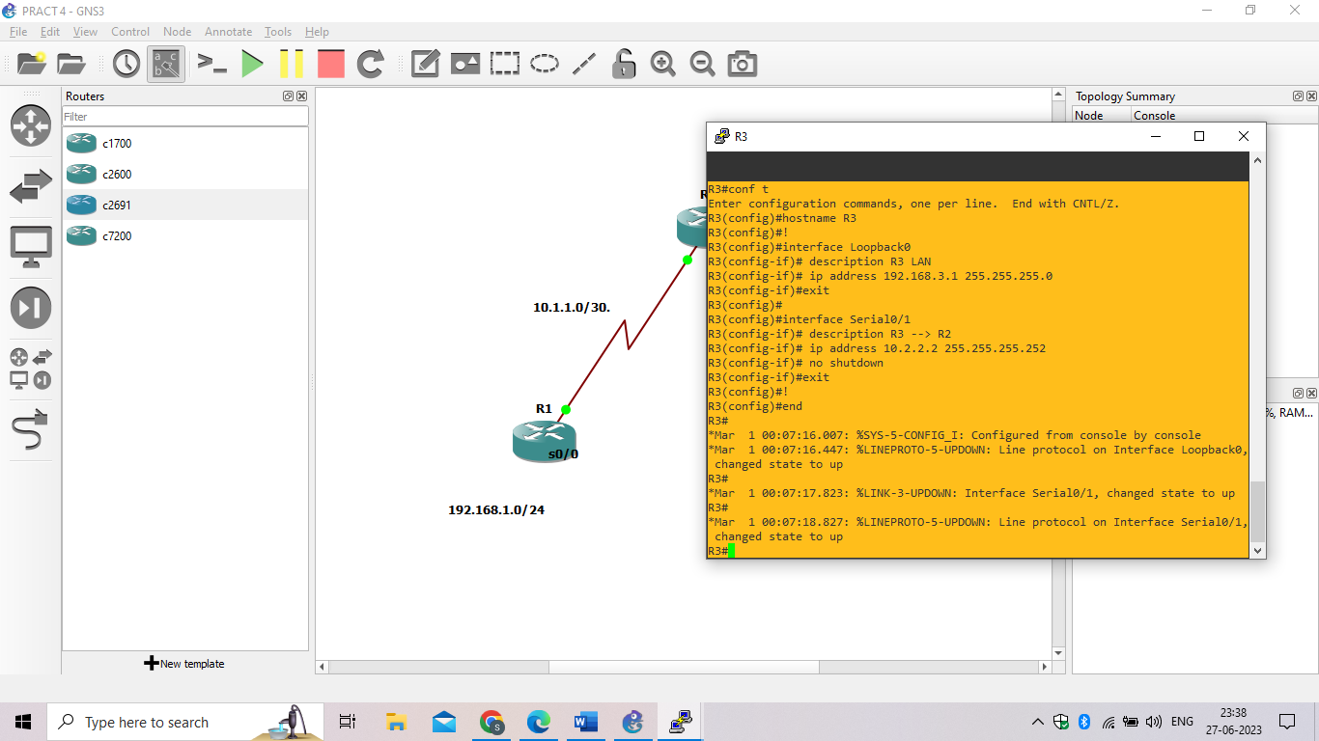

**Step 2: Configure static routes.**

1. On R1, configure a default static route to ISP.

R1(config)# **ip route 0.0.0.0 0.0.0.0 10.1.1.2**

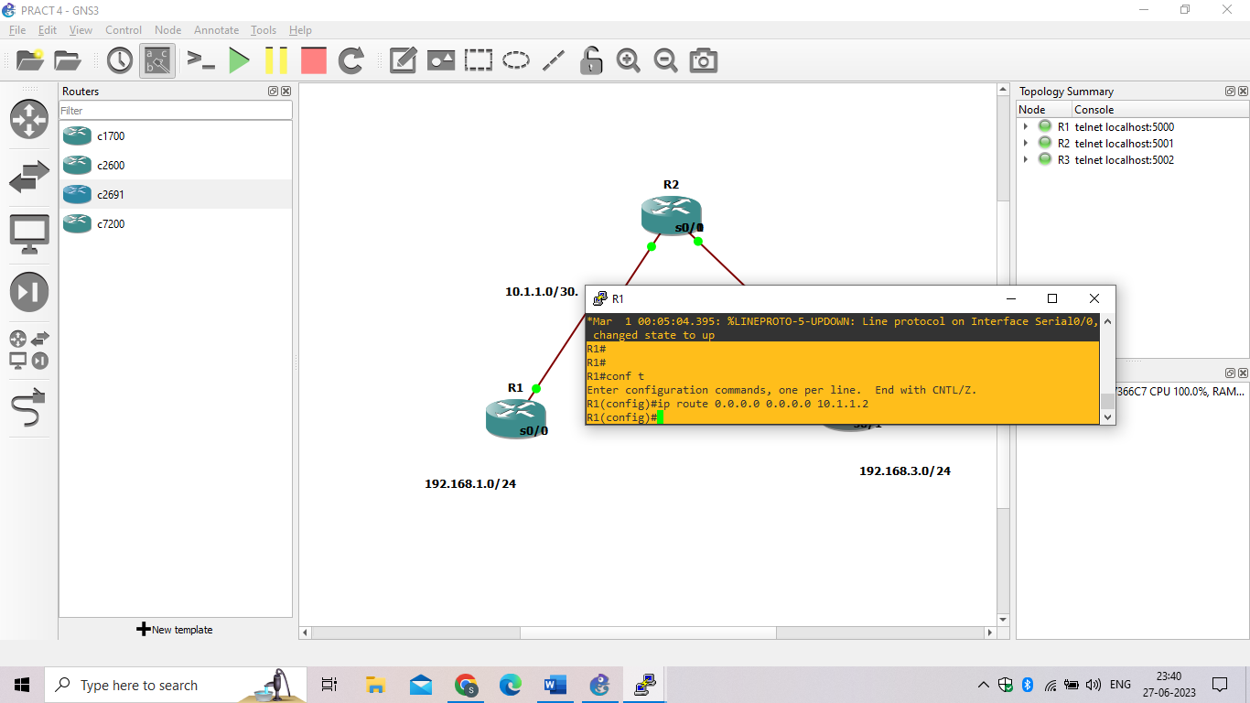

1. On R3, configure a default static route to ISP.

R3(config)# **ip route 0.0.0.0 0.0.0.0 10.2.2.1**

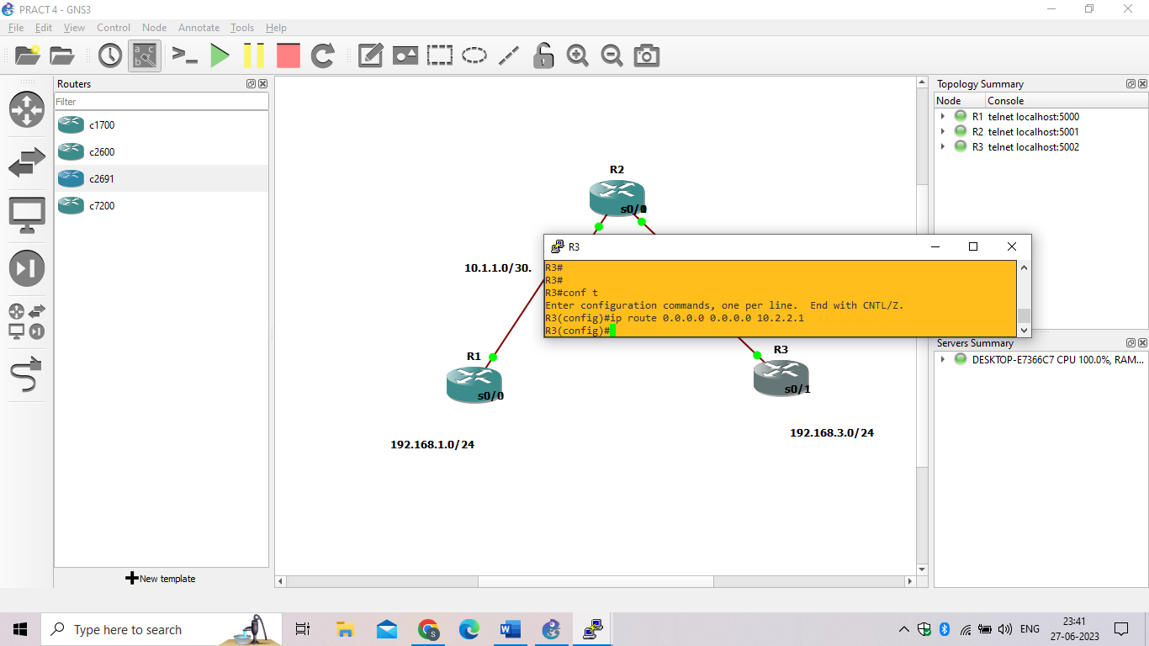

1. On R2, configure two static routes.

R2(config)# **ip route 192.168.1.0 255.255.255.0 10.1.1.1**

R2(config)# **ip route 192.168.3.0 255.255.255.0 10.2.2.2**

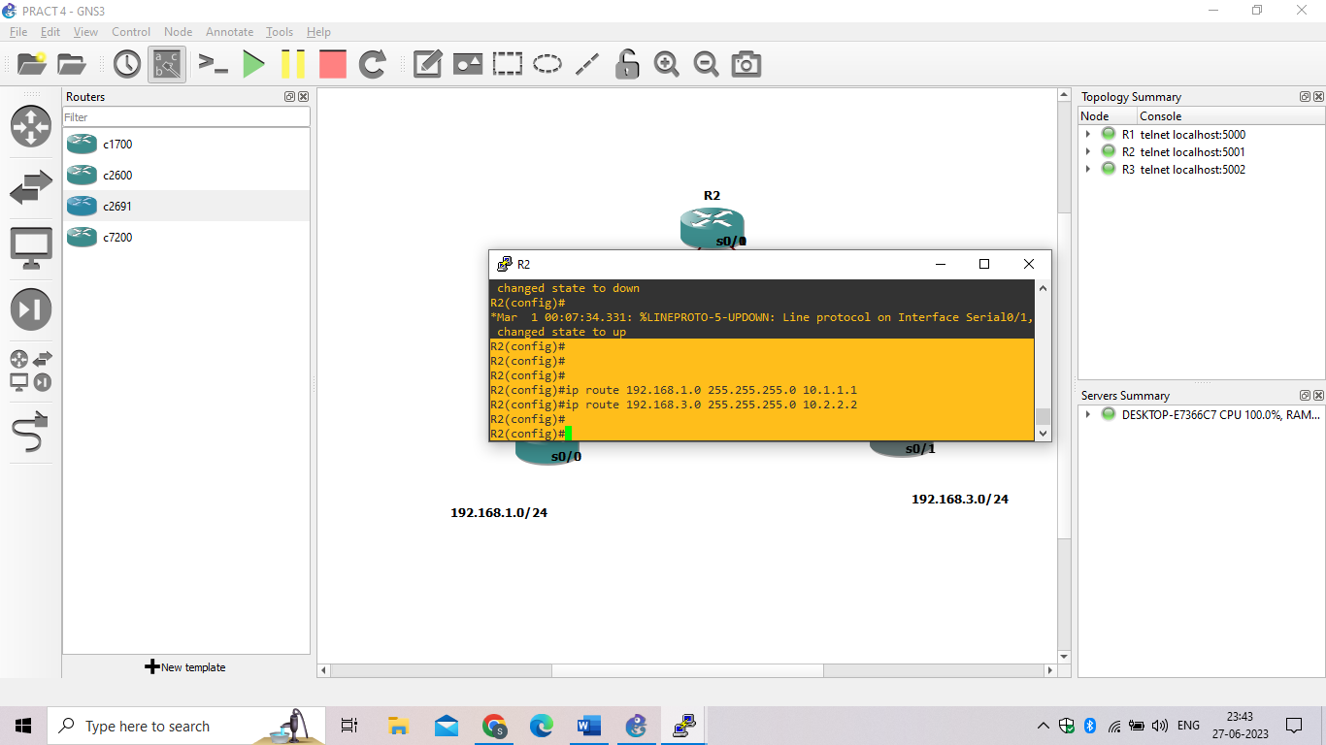

1. From the R1 router, run the following Tcl script to verify connectivity.

**foreach address {**

**192.168.1.1**

**10.1.1.1**

**10.1.1.2**

**10.2.2.1**

**10.2.2.2**

**192.168.3.1**

**} { ping $address }**

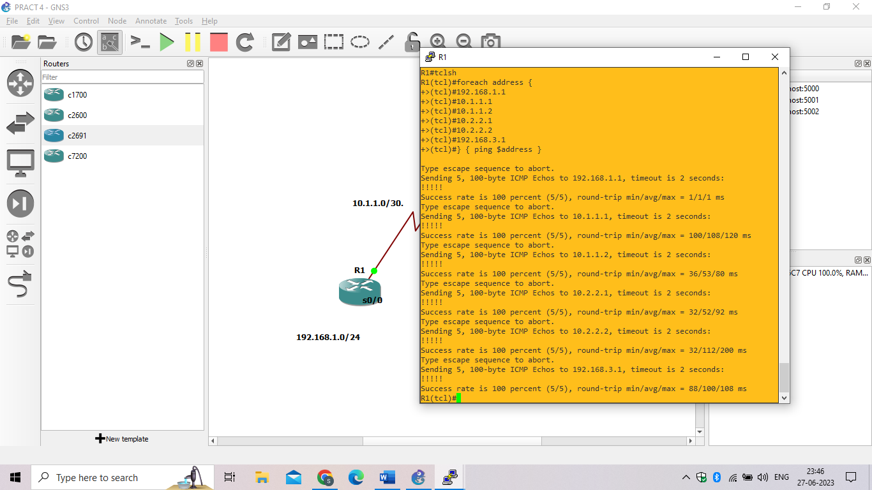

### Step 3: Secure management access.

1. On R1, use the **security passwords** command to set a minimum password length of 10 characters.

R1(config)# **security passwords min-length 10**

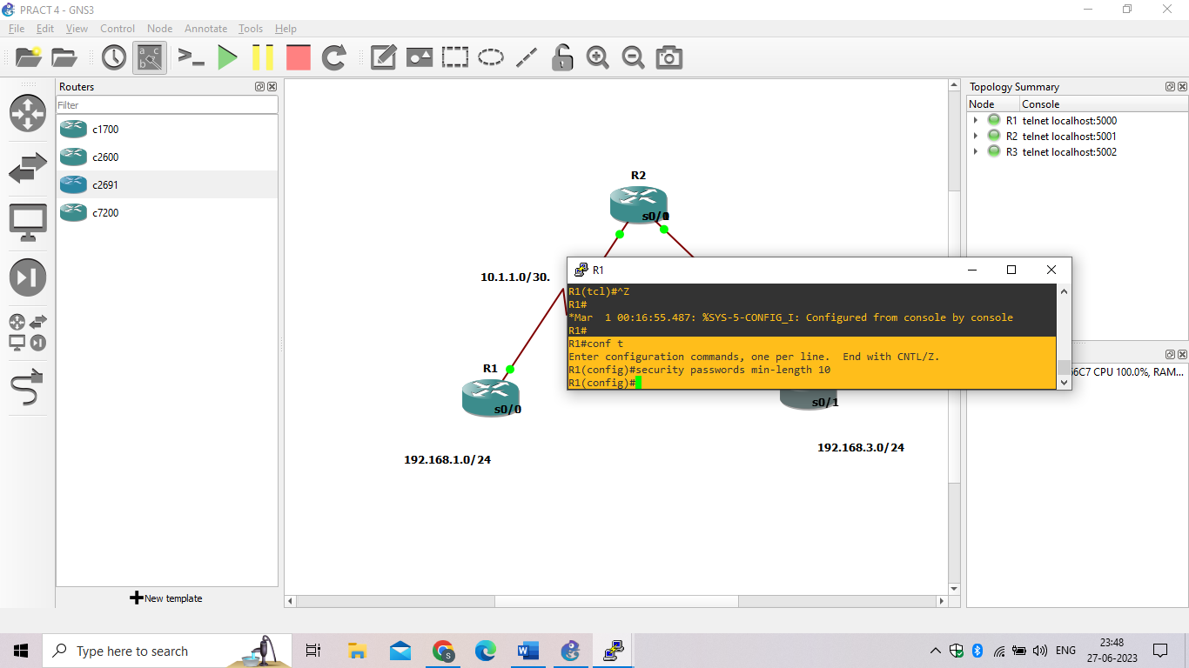

1. Configure the enable secret encrypted password on both routers.

R1(config)# **enable secret class12345**

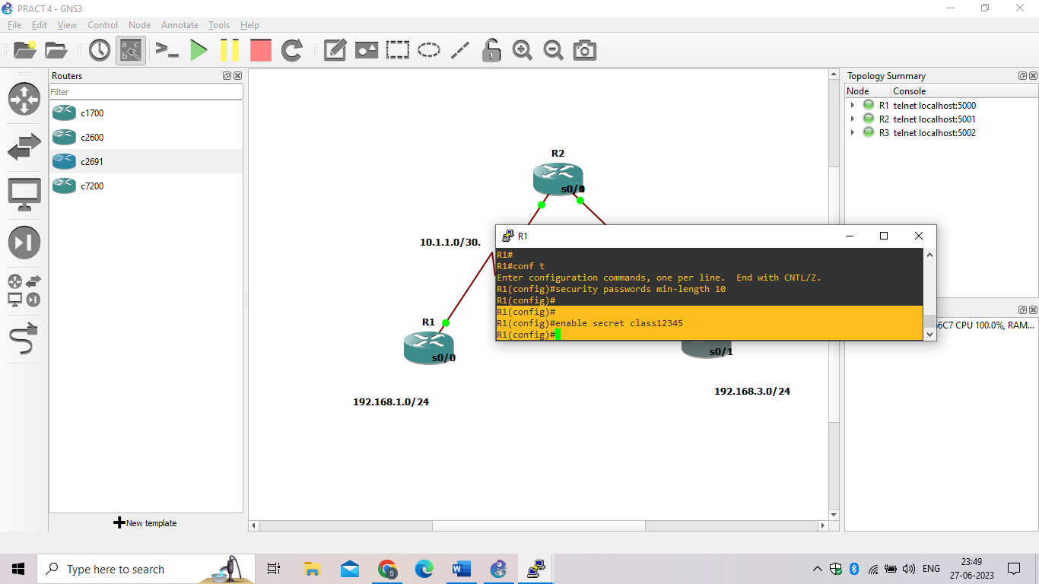

1. Configure a console password and enable login for routers. For additional security, the **exec-timeout** command causes the line to log out after 5 minutes of inactivity. The **logging synchronous** command prevents console messages from interrupting command entry.

R1(config)# **line console 0**

R1(config-line)# **password ciscoconpass**

R1(config-line)# **exec-timeout 5 0**

R1(config-line)# **login**

R1(config-line)# **logging synchronous**

R1(config-line)# **exit**

R1(config)#

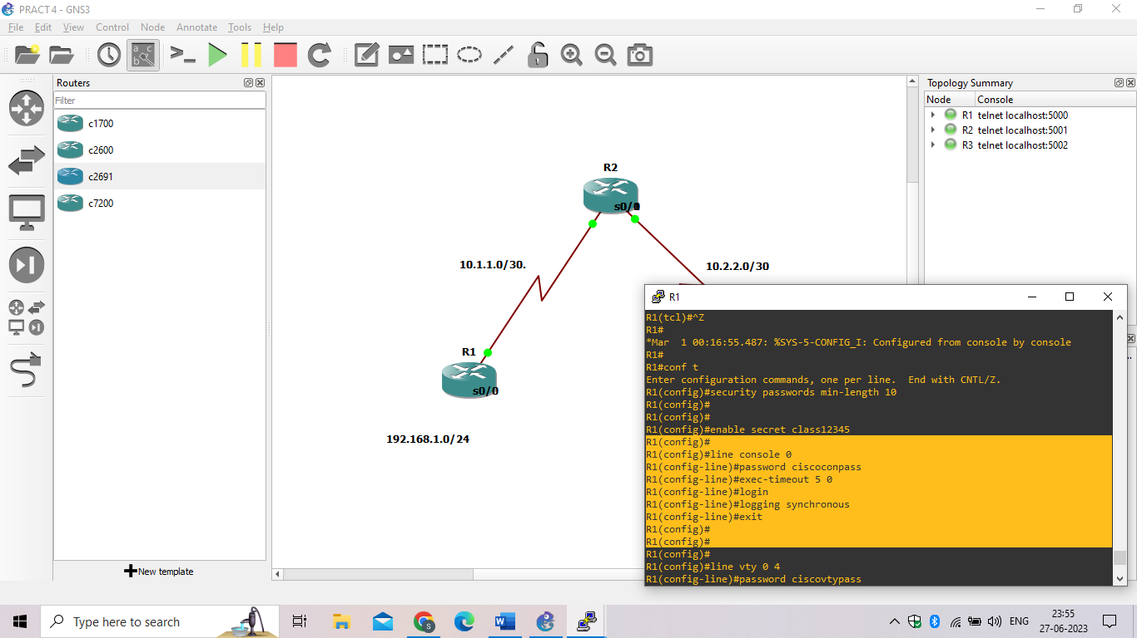

1. Configure the password on the vty lines for router R1.

R1(config)# **line vty 0 4**

R1(config-line)# **password ciscovtypass**

R1(config-line)# **exec-timeout 5 0**

R1(config-line)# **login**

R1(config-line)# **exit**

R1(config)#

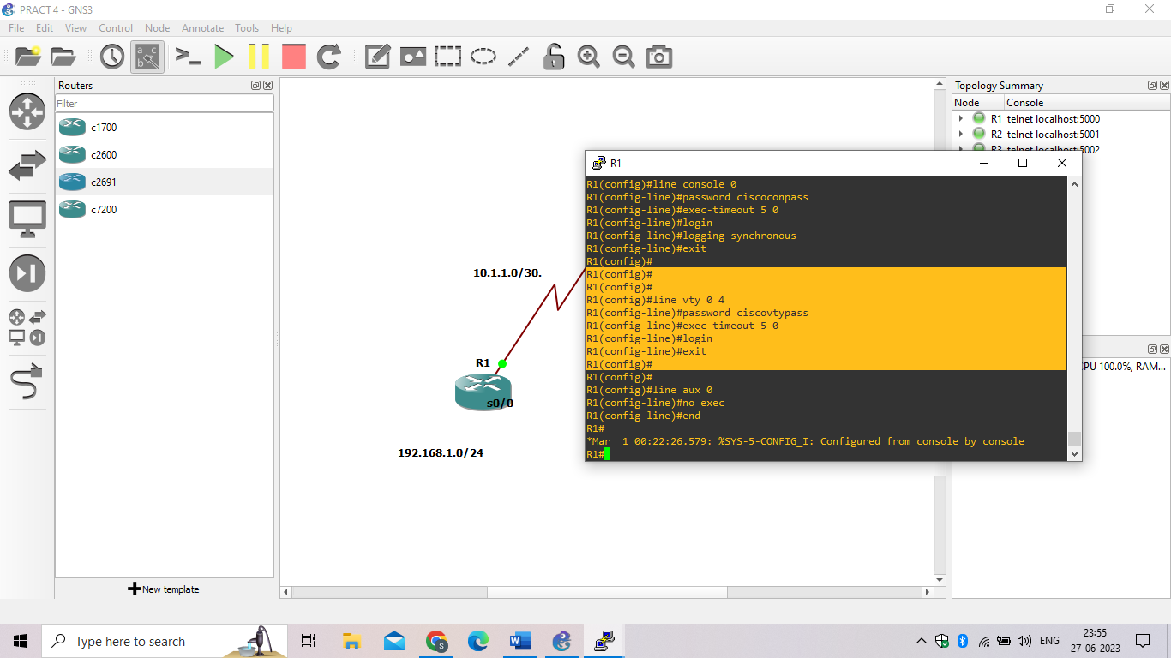

1. The aux port is a legacy port used to manage a router remotely using a modem and is hardly ever used. Therefore, disable the aux port.

R1(config)# **line aux 0**

R1(config-line)# **no exec**

R1(config-line)# **end**

R1#

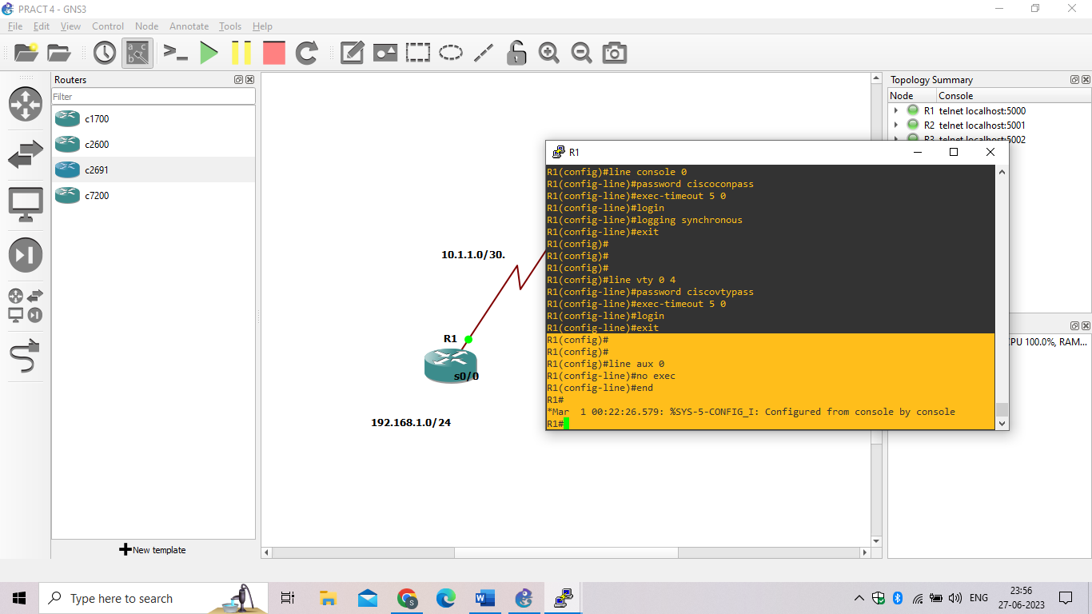

1. Use the **service password-encryption** command to encrypt the line console and vty passwords.

R1(config)# **service password-encryption**

R1(config)#

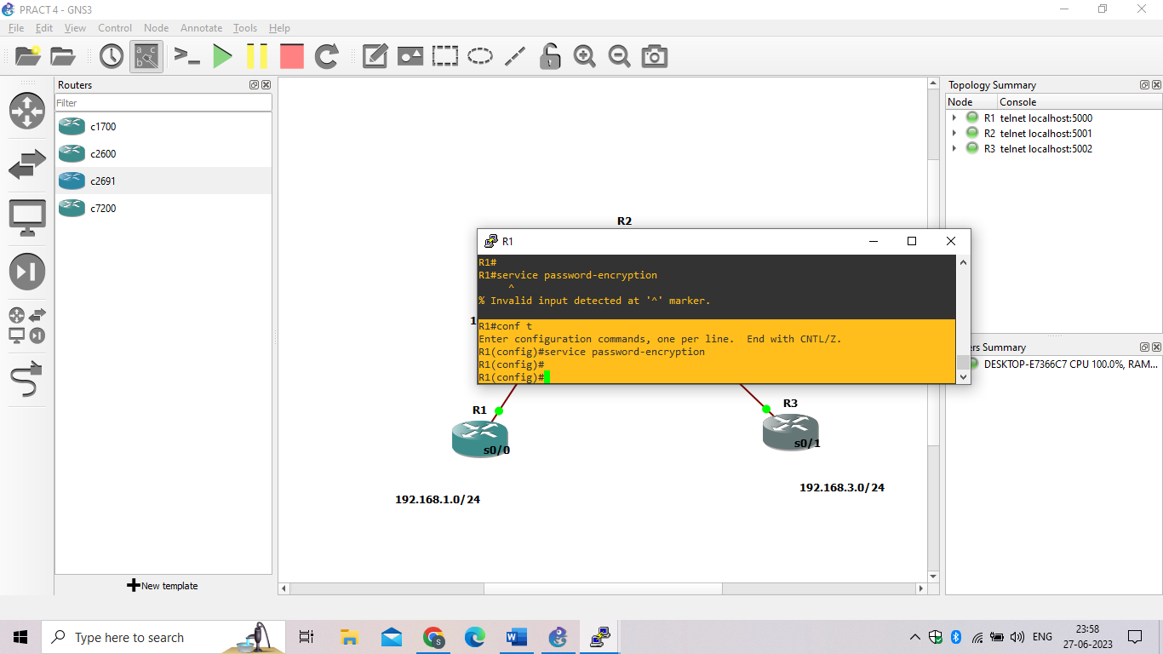

1. Configure a warning to unauthorized users with a message-of-the-day (MOTD) banner using the **banner motd** command. When a user connects to one of the routers, the MOTD banner appears before the login prompt. In this example, the dollar sign ($) is used to start and end the message.

R1(config)# **banner motd $Unauthorized access strictly prohibited!$**

R1(config)# **exit**

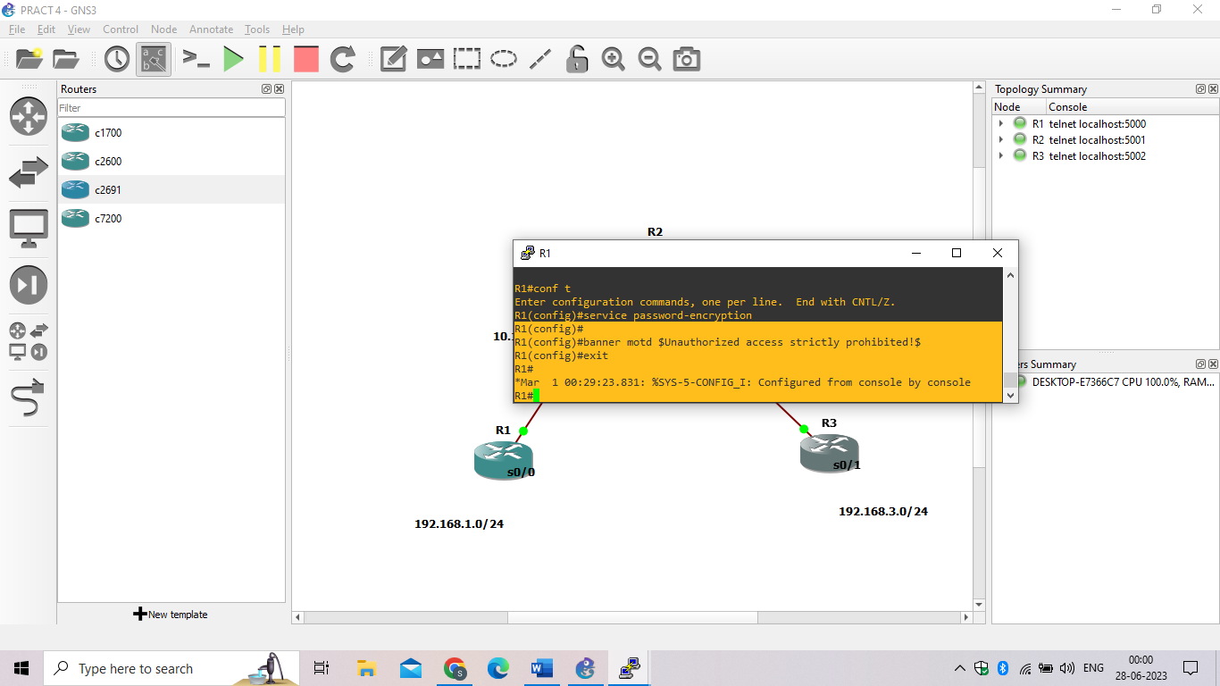

### Step 4: Configure enhanced username password security.

1. To create local database entry encrypted to level 4 (SHA256), use the **username***name***secret***password* global configuration command. In global configuration mode, enter the following command:

R1(config)# **username JR-ADMIN secret class12345**

R1(config)# **username ADMIN secret class54321**

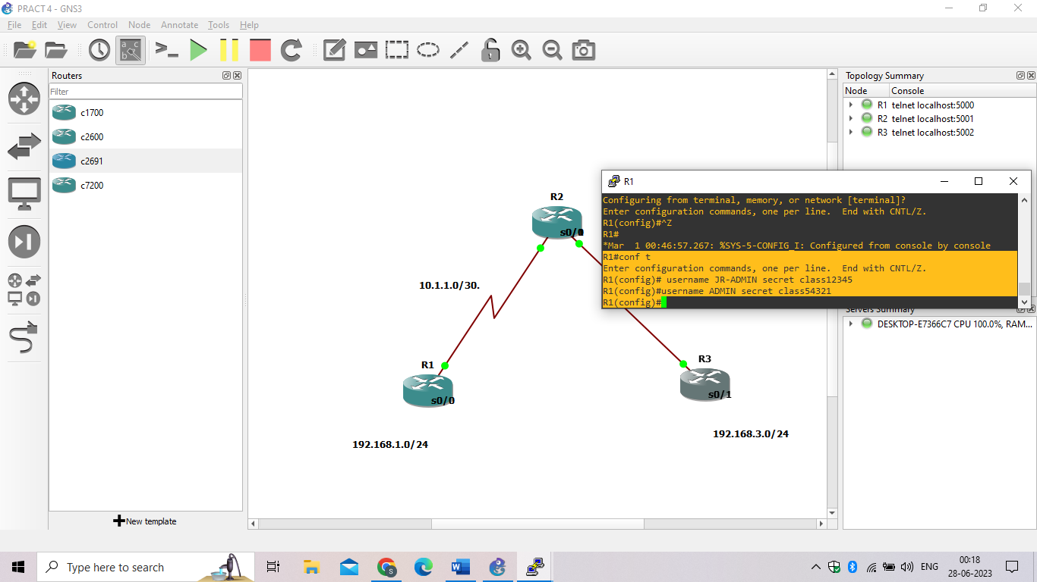

1. Set the console line to use the locally defined login accounts.

R1(config)# **line console 0**

R1(config-line)# **login local**

R1(config-line)# **exit**

R1(config)#

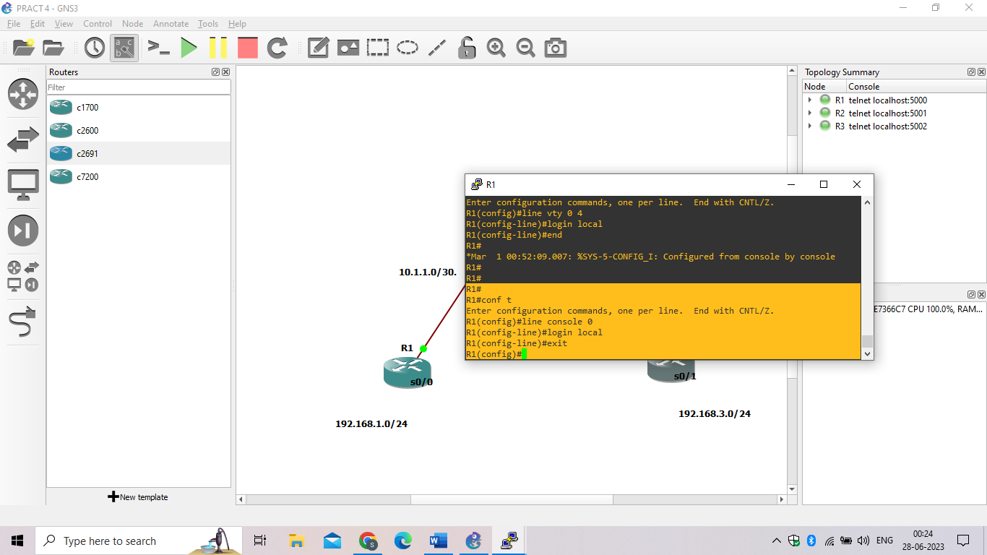

1. Set the vty lines to use the locally defined login accounts.

R1(config)# **line vty 0 4**

R1(config-line)# **login local**

R1(config-line)# **end**

R1(config)#

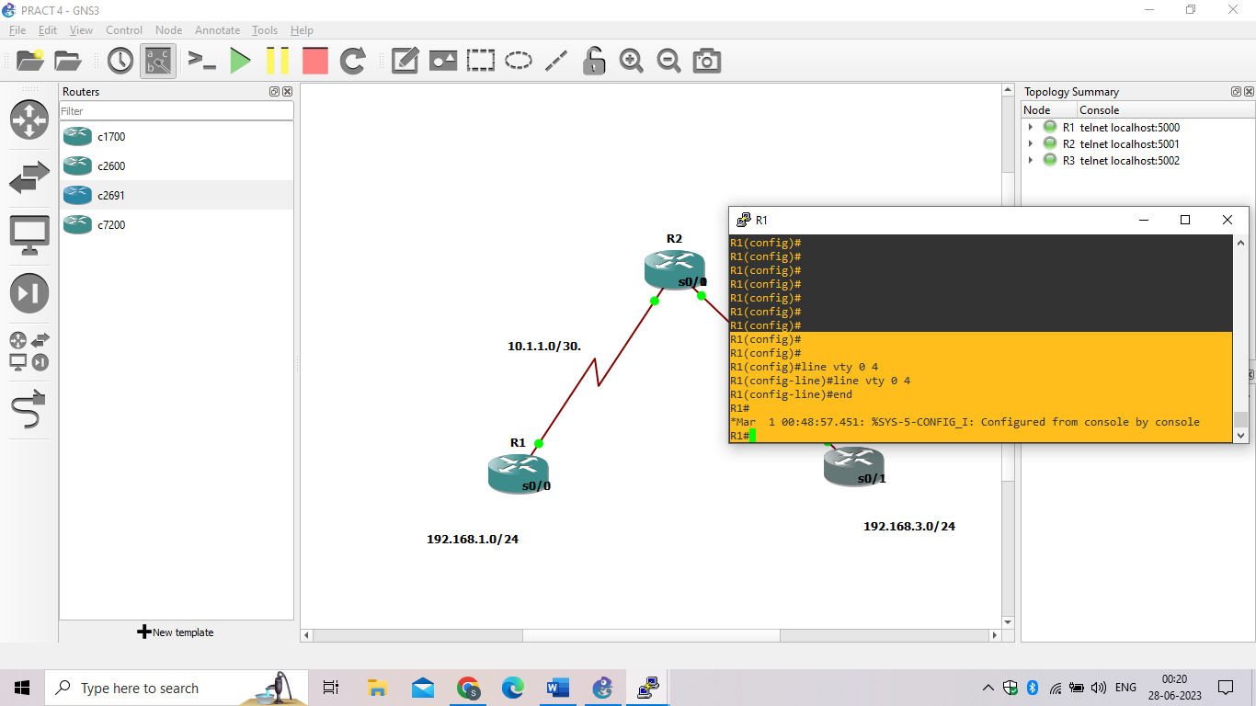

* Repeat the steps 4a to 4c on R3.

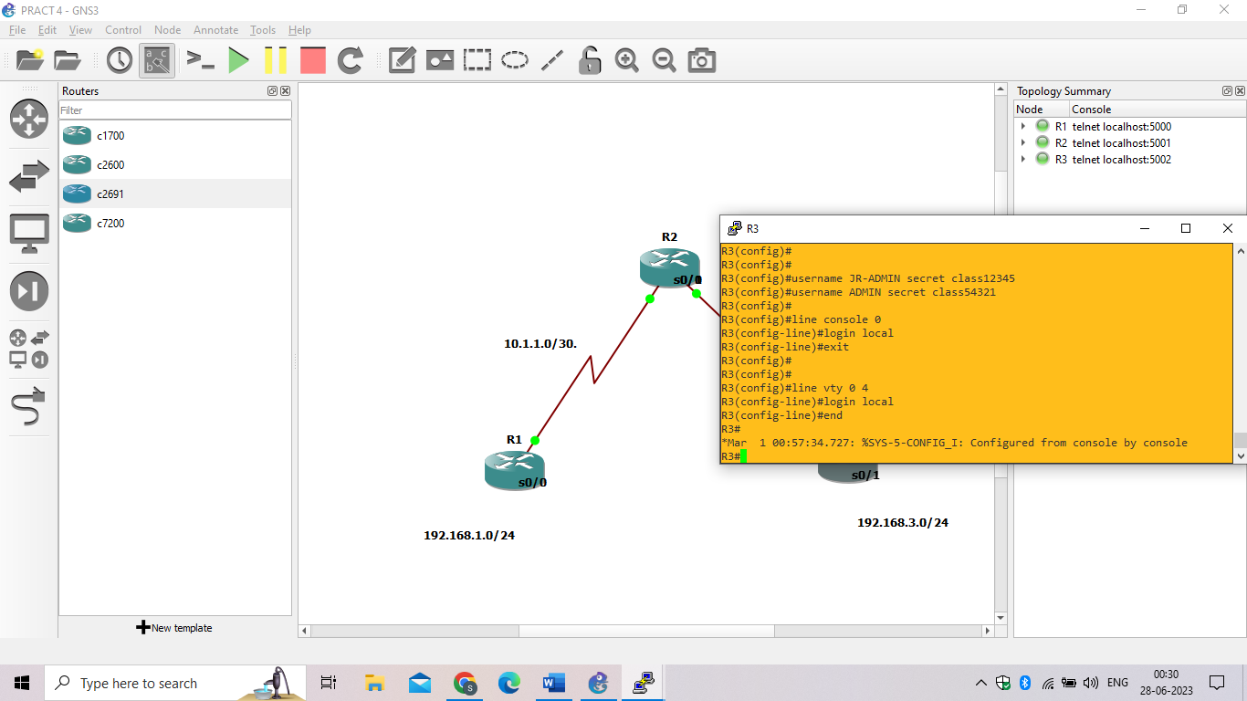

1. To verify the configuration, telnet to R3 from R1 and login using the ADMIN local database account.

R1# **telnet 10.2.2.2**

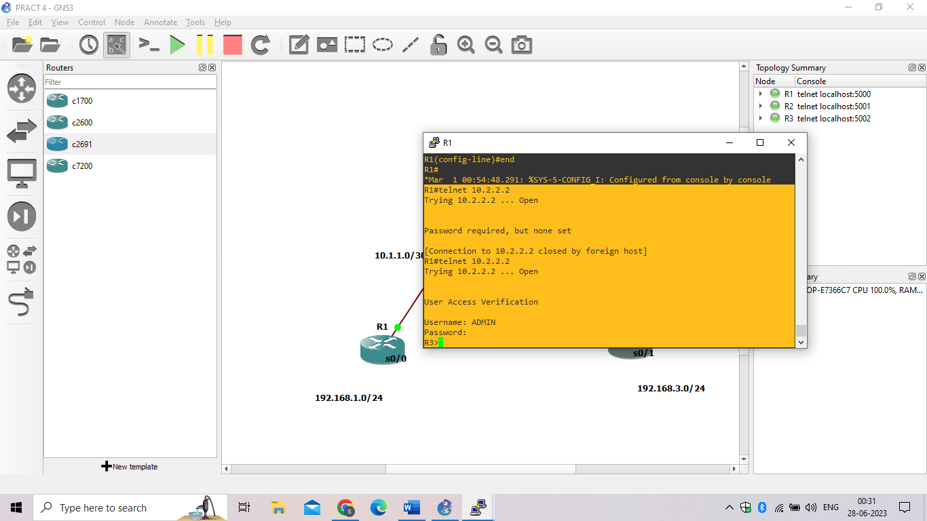

### Step 5: Enabling AAA RADIUS Authentication with Local User for Backup.

1. Always have local database accounts created before enabling AAA. Since we created two local database accounts in the previous step, then we can proceed and enable AAA on R1.

R1(config)# **aaa new-model**

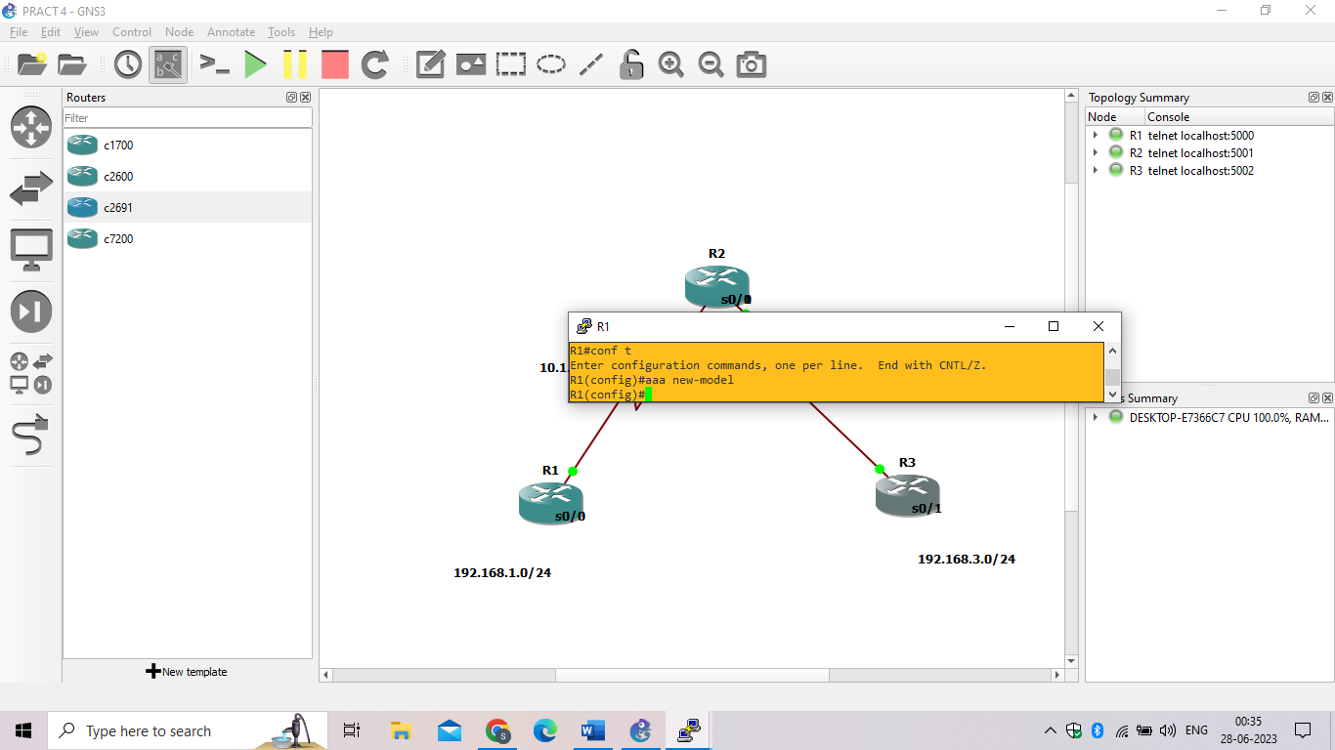

**PRACTICAL NO: 5**

**Aim: Configure and Verify Path Control Using PBR**

Step 1: Configure loopbacks and assign addresses

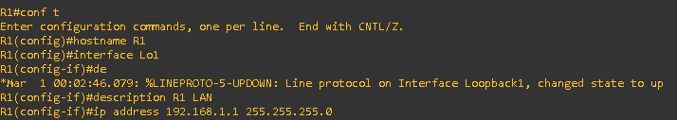

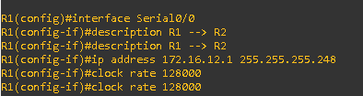

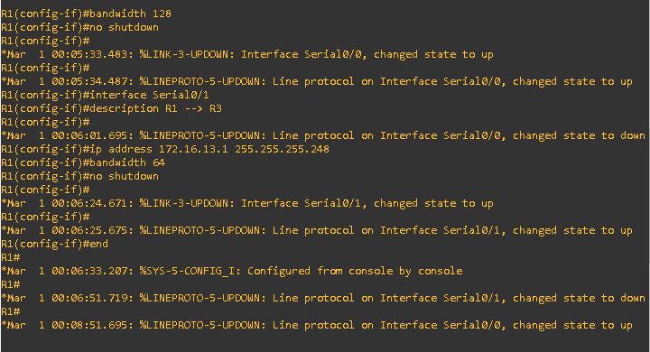

Router R2

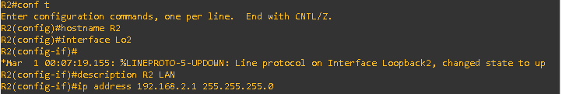

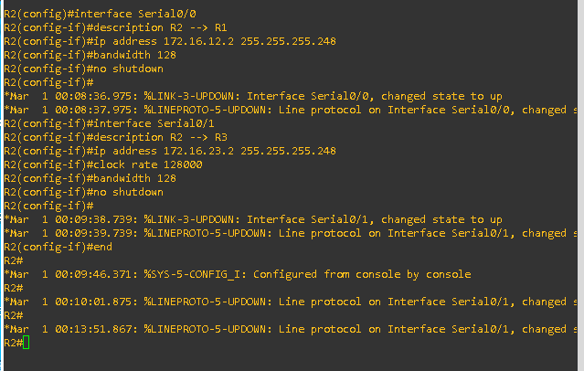

Router 3

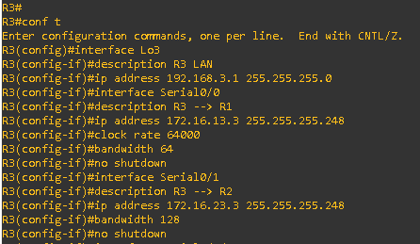

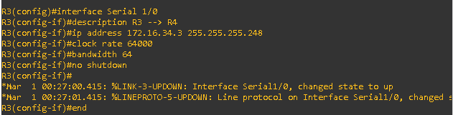

Router 4

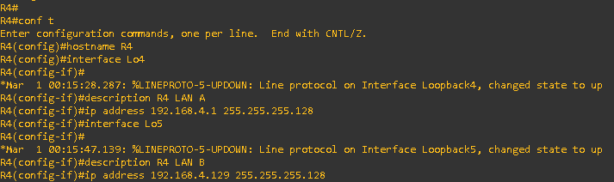

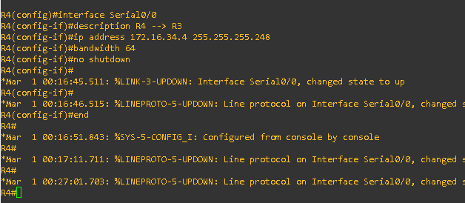

Verify the configuration with the show ip interface brief, show protocols, and show interfaces description commands. The output from router R3 is shown here as an example.

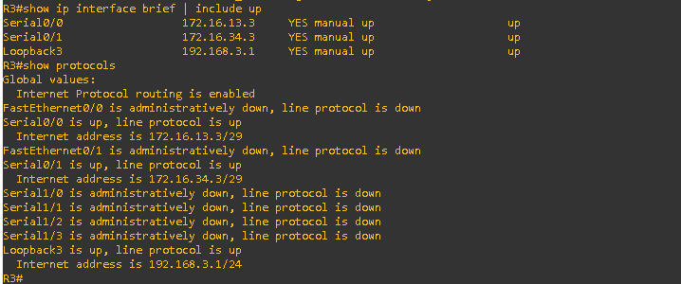

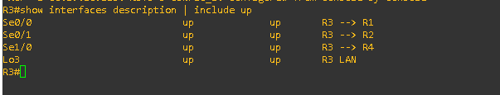

Step 2 : Configure basic EIGRP.

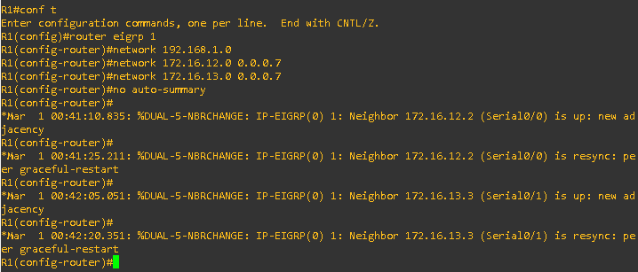

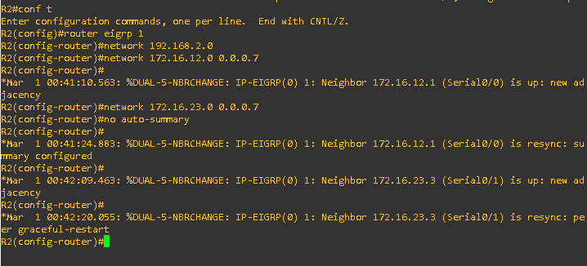

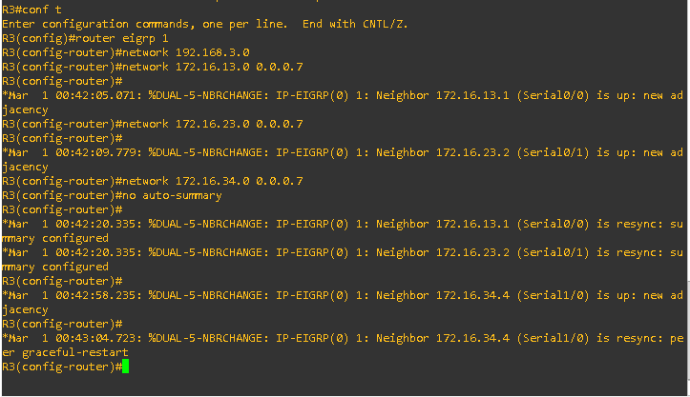

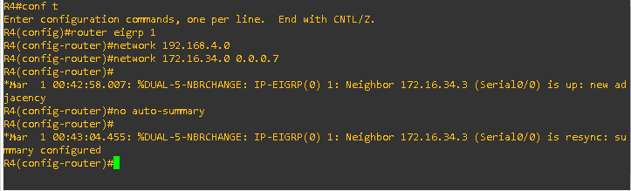

Step3 : Verify EIGRP connectivity

zz. Verify the configuration by using the show ipeigrpneighbors command to check which routers have EIGRP adjacencies.

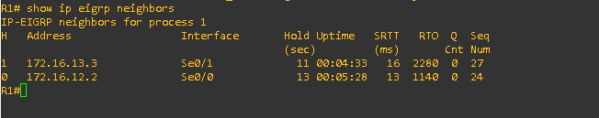

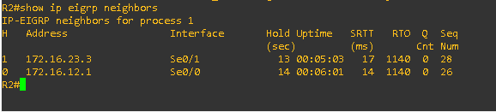

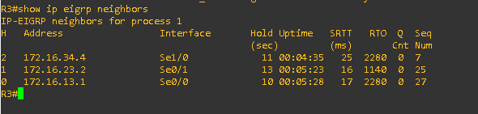

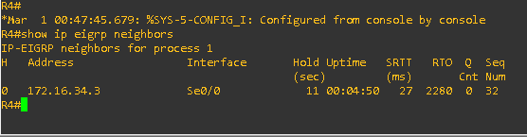

Run the following Tcl script on all routers to verify full connectivity.



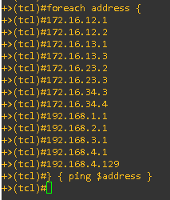

Step 4 : Verify the current path.

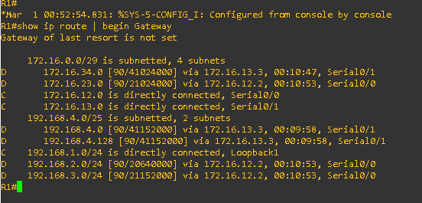

ccc.On R4, use the traceroute command to the R1 LAN address and source the ICMP packet from R4 LAN A and LAN B.

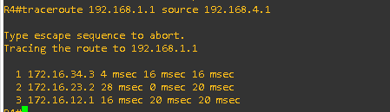

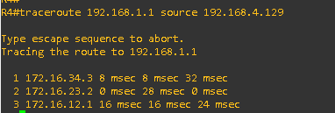

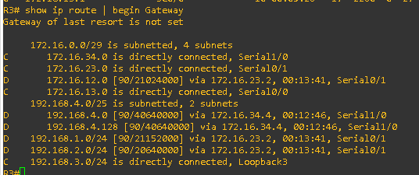

On R3, use the show interfaces serial 0/0/0 and show interfaces s0/0/1 commands.

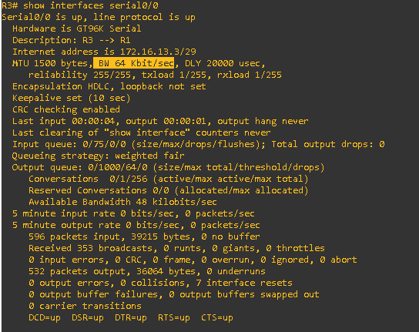

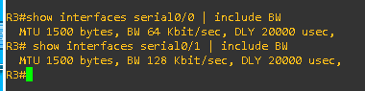

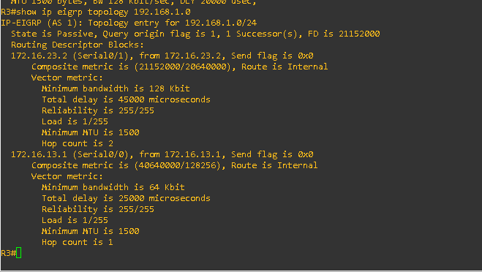

Step 5 : Configure PBR to provide path control.

On router R3, create a standard access list called PBR-ACL to identify the R4 LAN B network

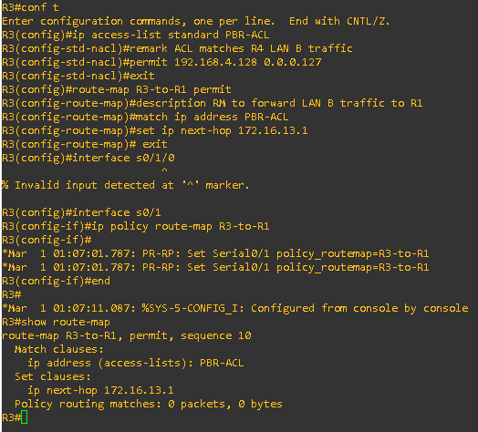

Step 6: Test the policy.

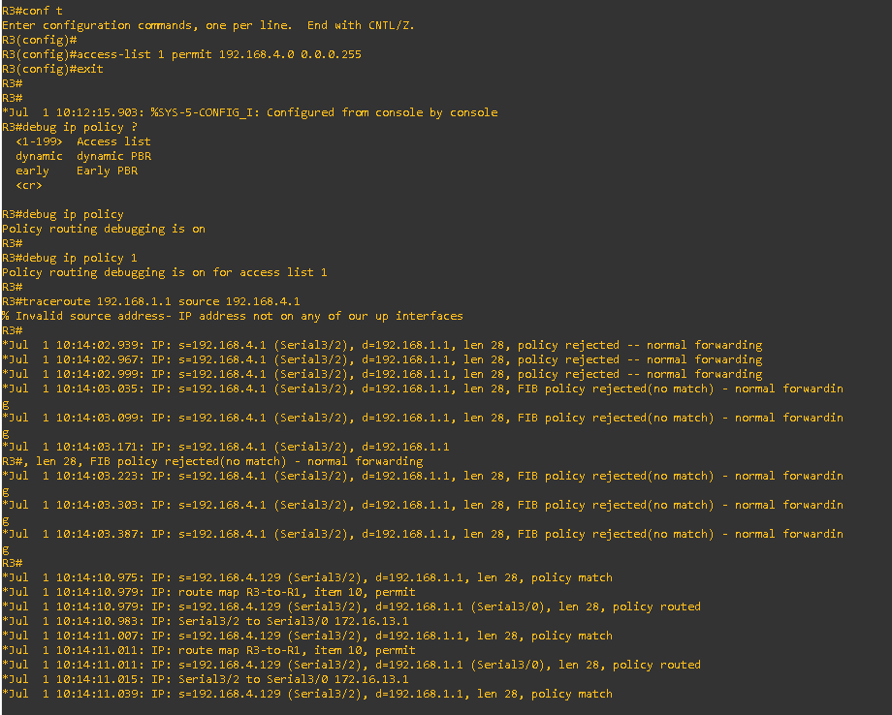

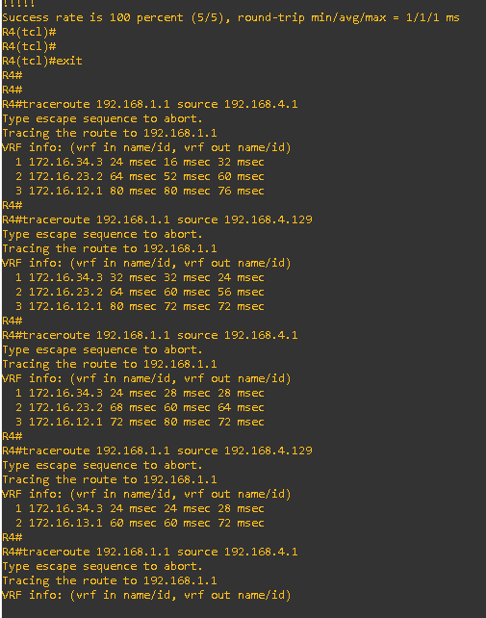

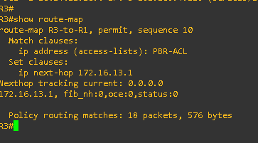

**PRACTICAL NO: 6**

**Aim:- IP Service Level Agreements and Remote SPAN in a Campus Environment**

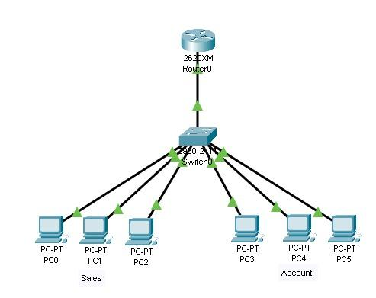

* Prepare the network as shown in the topology diagram above using the following components:

1. **Switch (2960-24TT)**
2. **PCs (PC0 to PC5)**
3. **Router (2620XM)**

* Connect PC0, PC1 and PC2 with the FastEthernet 0/1, 0/2 and 0/3 respectively of switch.
* Connect PC3, PC4 and PC5 with the FastEthernet 0/4, 0/5 and 0/6 respectively of switch.
* Assign IP address to PCs as:

**PC0: 10.0.0.1**

**PC1: 10.0.0.2**

**PC3: 10.0.0.3**

**PC4: 20.0.0.1**

**PC5: 20.0.0.2**

**PC6: 20.0.0.3**

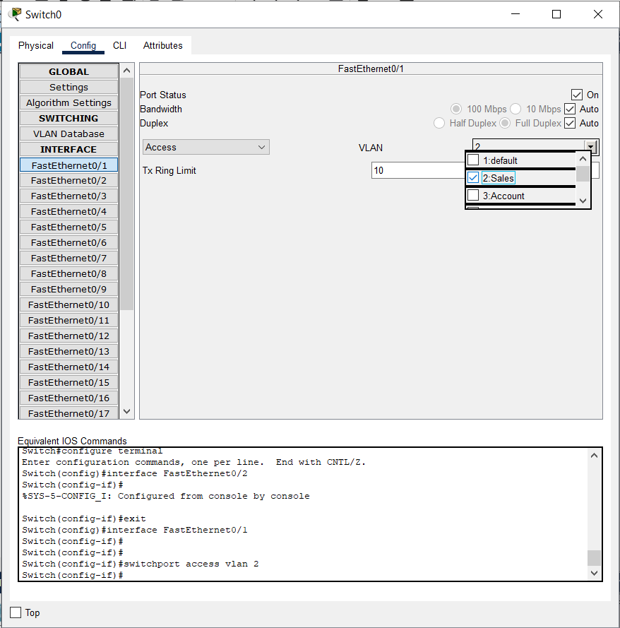

* PC 0,1,and 2 are added in the **SALES VLAN** as shown above.

Switch#**conf t**

Switch(config)#**interface FastEthernet0/0**

Switch(config-if)#**switchport access vlan 2**

Switch(config-if)#**exit**

Switch(config)#**interface FastEthernet0/1**

Switch(config-if)#**switchport access vlan 2**

Switch(config-if)#**exit**

Switch(config)#**interface FastEthernet0/2**

Switch(config-if)#**switchport access vlan 2**

Switch(config-if)#**exit**

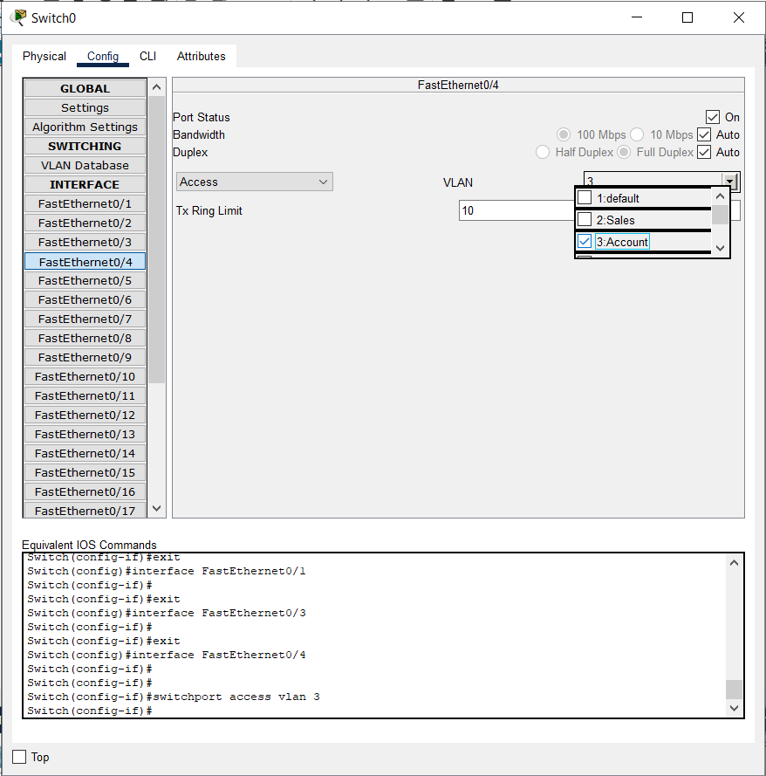

* PC 3,4,and 5 are added in the **ACCOUNTS VLAN** as shown above.

Switch#**conf t**

Switch(config)#**interface FastEthernet0/3**

Switch(config-if)#**switchport access vlan 3**

Switch(config-if)#**exit**

Switch(config)#**interface FastEthernet0/4**

Switch(config-if)#**switchport access vlan 3**

Switch(config-if)#**exit**

Switch(config)#**interface FastEthernet0/5**

Switch(config-if)#**switchport access vlan 3**

Switch(config-if)#**exit**

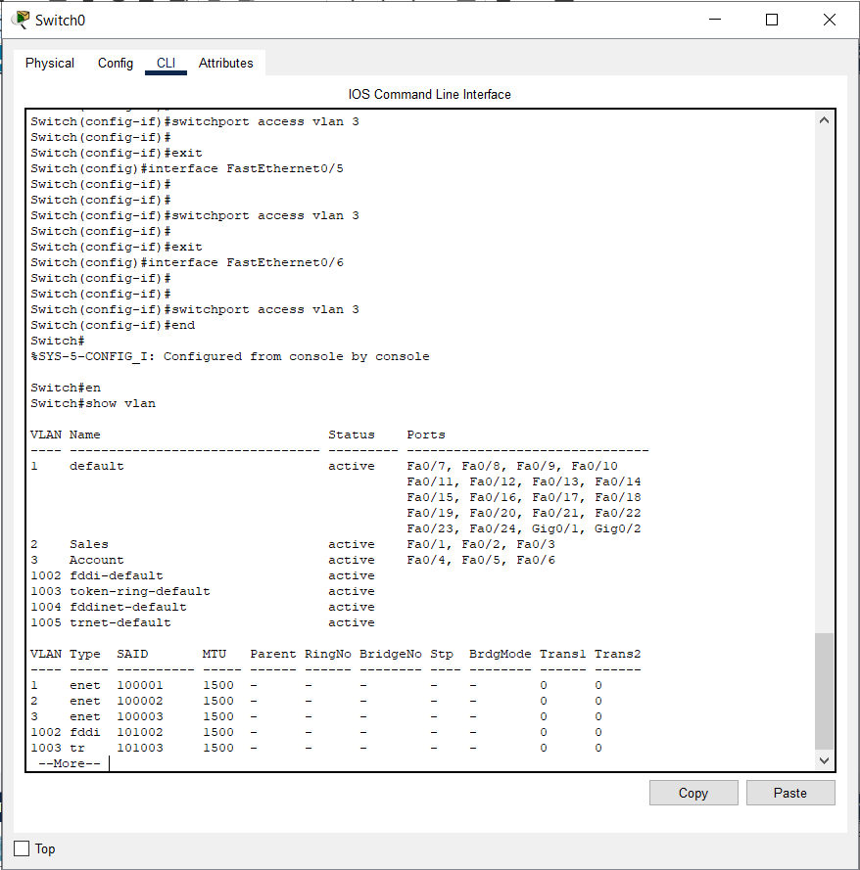

* Open the config of Switch

Switch#**en**

Switch#**show vlan**

* Connect a router to switch at FastEthernet 0/24 as shown in the topology diagram.

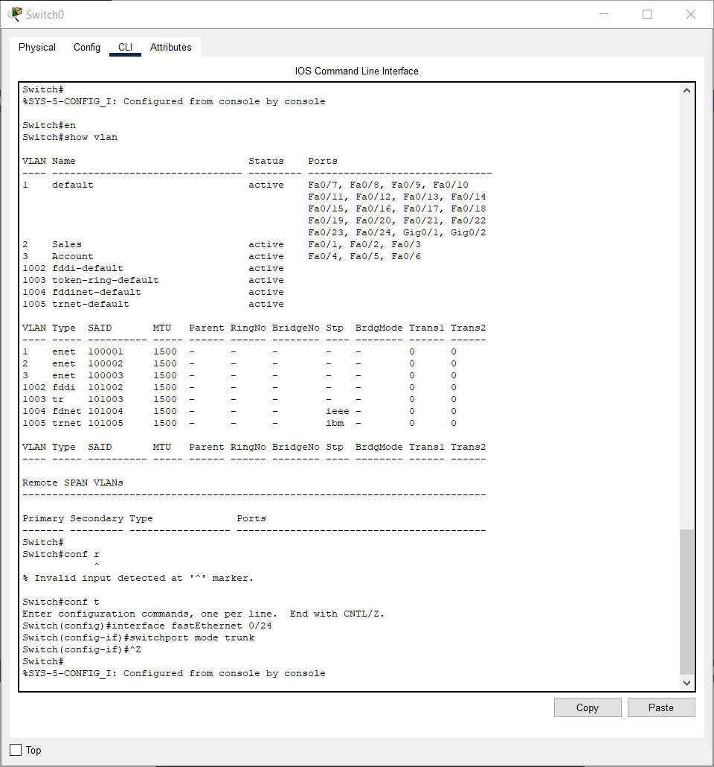

* Configure trunking ports

Switch#**conf t**

Switch(config)#**interface fastEthernet 0/24**

Switch(config-if)#**switchport mode trunk**

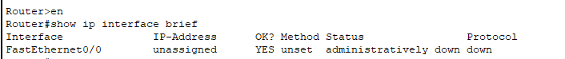

* Open Router CLI to check the status of the fastEthernet 0/0 port

Router>**en**

Router#**show ip interface brief**

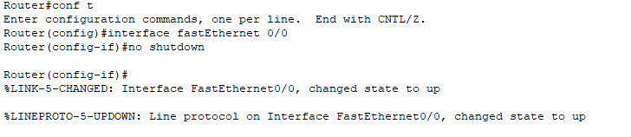

* To UP the status of fastEthernet 0/0

Router#**conf t**

Router(config)#**interface fastEthernet 0/0**

Router(config-if)#**no shutdown**

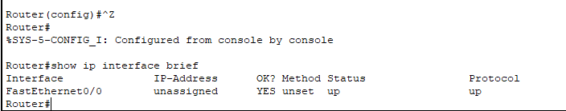

* To check if the status of ports are UP

Router#**show ip interface brief**

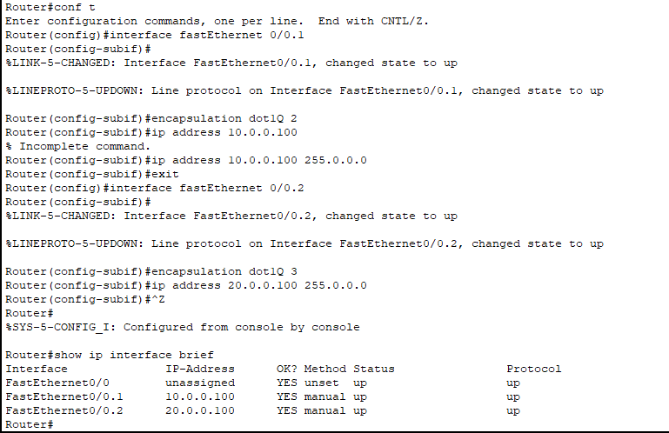

* To create sub interfaces on Router

Router#**conf t**

Router(config)#**interface fastEthernet 0/0.1**

Router(config-subif)#**encapsulation dot1Q 2**

Router(config-subif)#**ip address 10.0.0.100 255.0.0.0**

Router(config-subif)#**exit**

Router(config)#**interface fastEthernet 0/0.2**

Router(config-subif)#**encapsulation dot1Q 3**

Router(config-subif)#**ip address 20.0.0.100 255.0.0.0**

Router(config-subif)#**^z**

Router#**show ip interface brief**

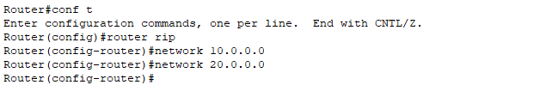

* To provide route for communicating between PCs and Router.

Router#**conf t**

Router(config)#**router rip**

Router(config-router)#**network 10.0.0.0**

Router(config-router)#**network 20.0.0.0**

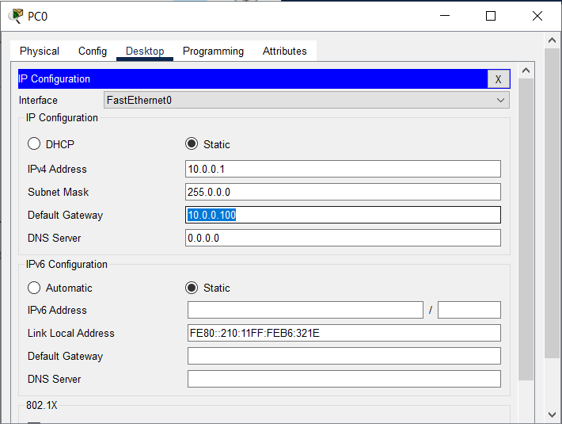

* Assign Default Gateway to PC 0, 1 and 2 as **10.0.0.100.**

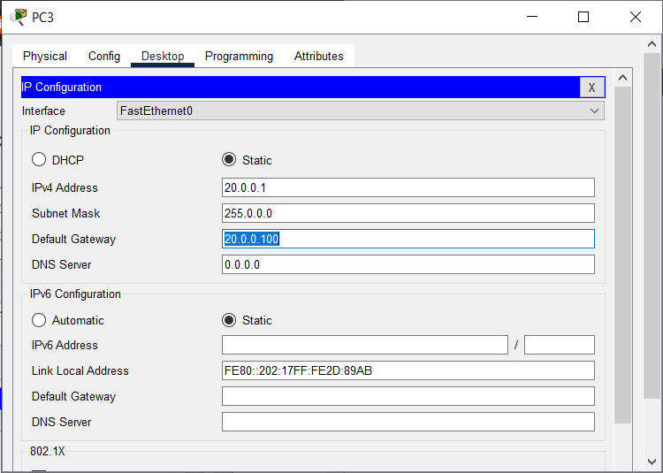

* Assign Default Gateway to PC 3, 4 and 5 as **20.0.0.100.**

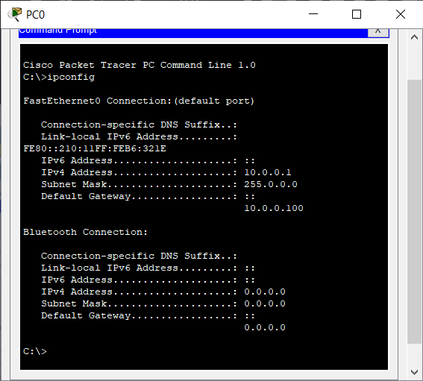

* Open Command Prompt of PC0 and check the ip addresses by the command **ipconfig.**
* Repeat the same step for other PCs also.
* Now using the **ping** command check if the connection is correct and the messages are sent properly without any error.
* Use the **ping** command as shown below to check the connection between PCs themselves and with the Router.

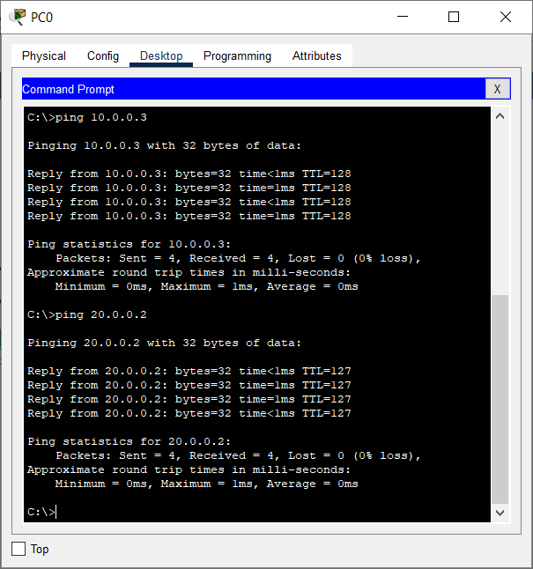

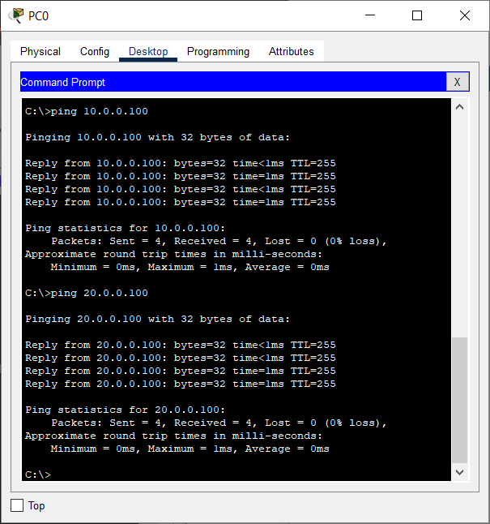

**PRACTICAL NO:- 7**

**Aim:- Cisco MPLS Configuration**

**Step 1 : IP addressing of MPLS Core and OSPF**

First bring 3 routers into your topology R1, R2, R3 position them as below. We are going to address the routers and configure ospf to ensure loopback to loopback connectivity between R1 and R3

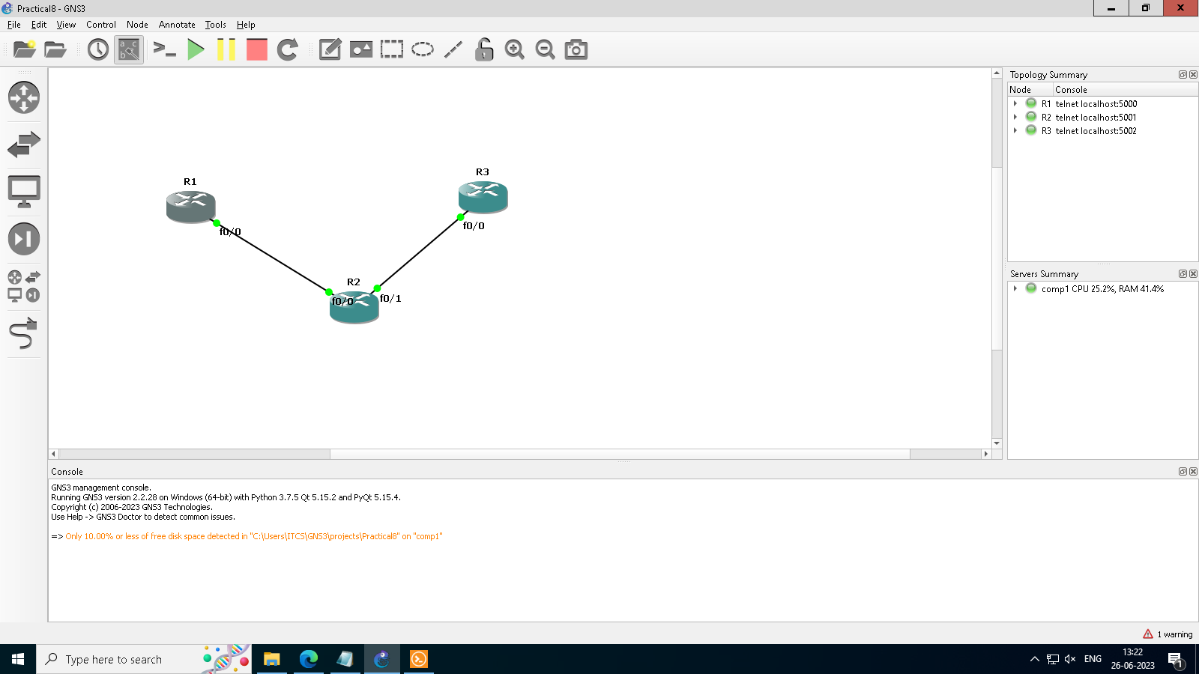

R1

hostname R1

int lo0

ip add 1.1.1.1 255.255.255.255

ipospf 1 area 0

int f0/0

ip add 10.0.0.1 255.255.255.0

no shut

ipospf 1 area 0

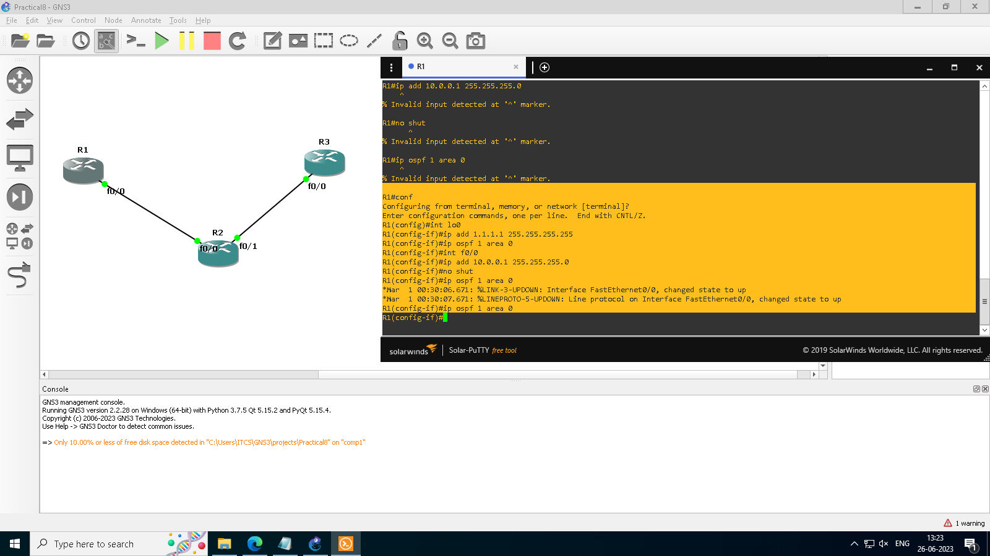

R2

hostname R2

int lo0

ip add 2.2.2.2 255.255.255.255

ipospf 1 are 0

int f0/0

ip add 10.0.0.2 255.255.255.0

no shut

ipospf 1 area 0

int f0/1

ip add 10.0.1.2 255.255.255.0

no shut

ipospf 1 area 0

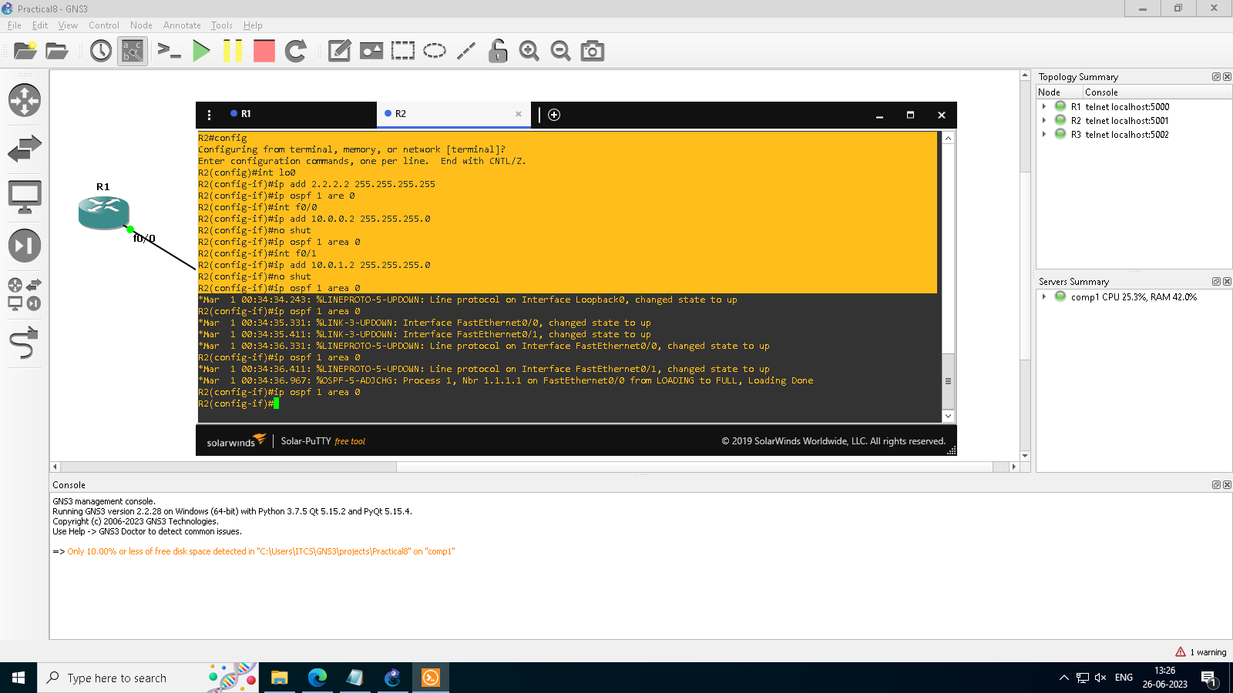

R3

hostname R3

int lo0

ip add 3.3.3.3 255.255.255.255

ipospf 1 are 0

int f0/0

ip add 10.0.1.3 255.255.255.0

no shut

ipospf 1 area 0

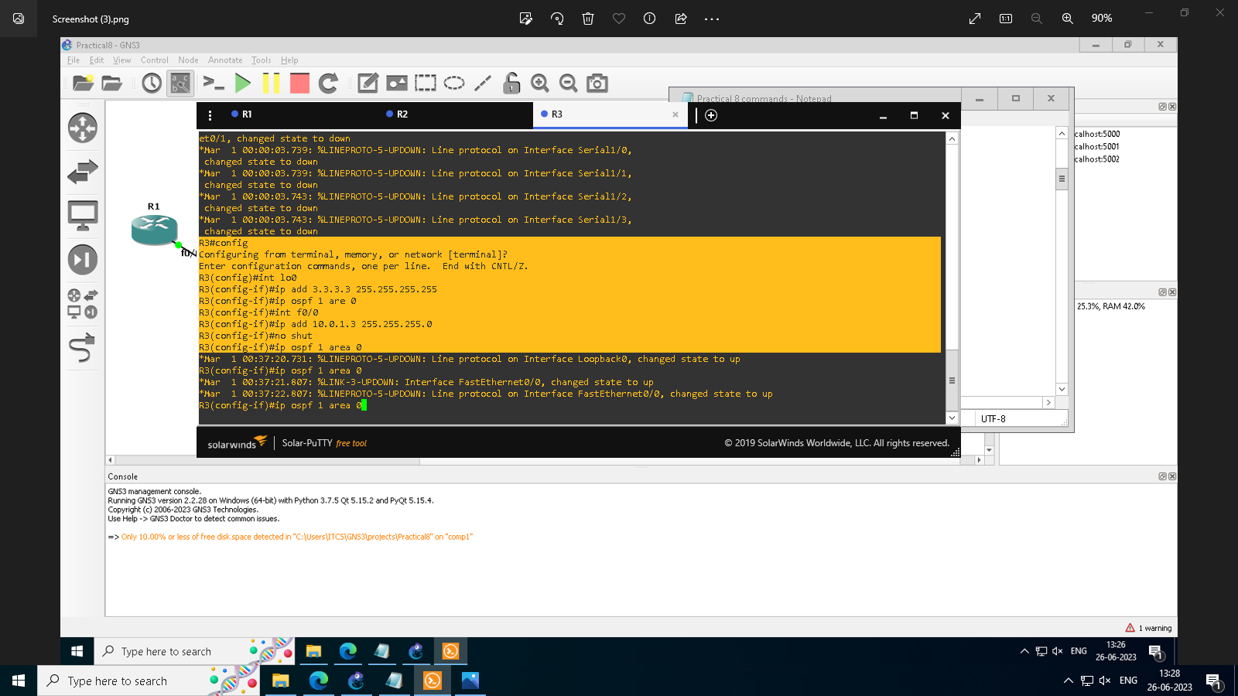

You should now have full ip connectivity between R1, R2, R3 to verify this we need to see if we can ping between the loopbacks of R1 and R3

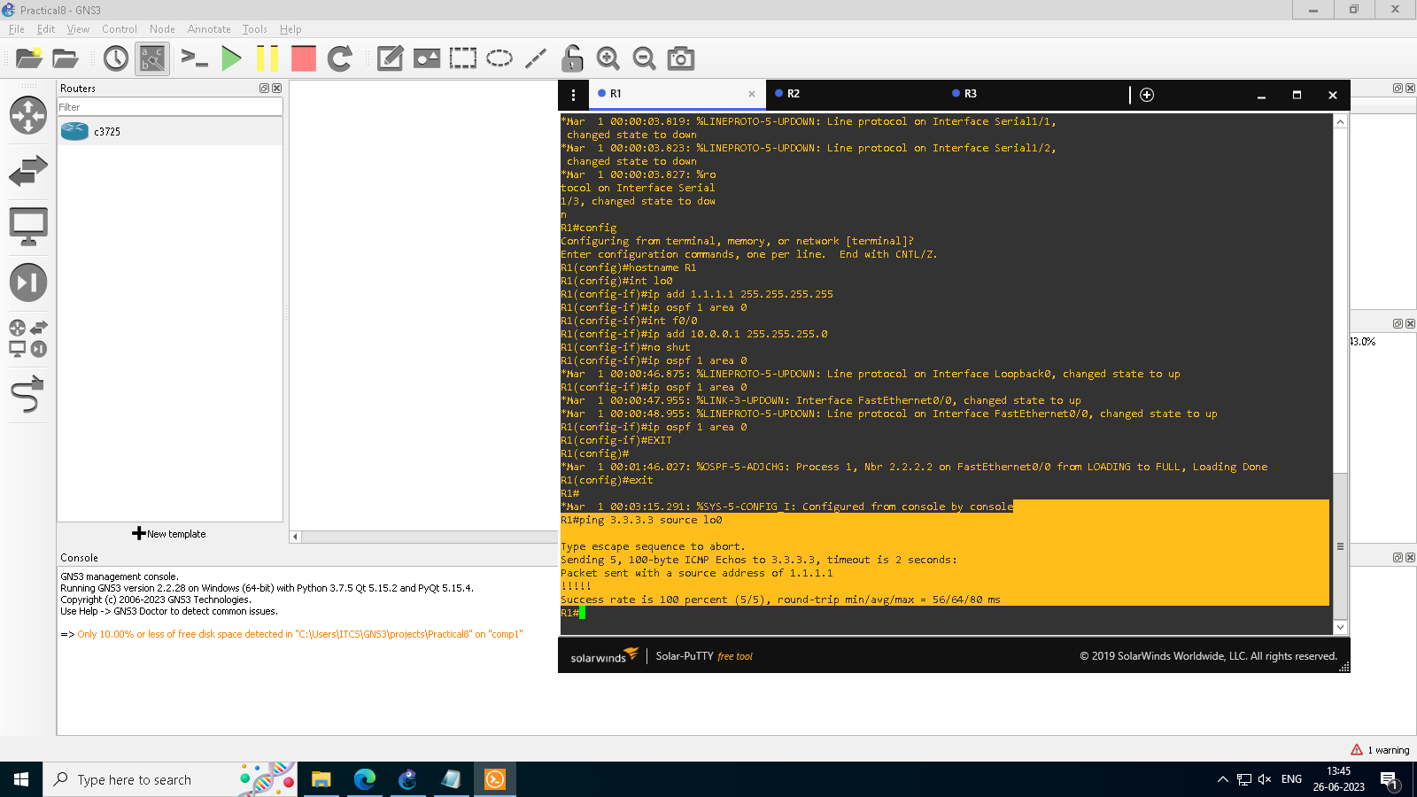

**Step 2 : Configure LDP on all the interfaces in the MPLS Core**

In order to run MPLS you need to enable it, there are two ways to do this

• At each interface enter the mplsip command

• Under the ospf process use the mplsldpautoconfig command

For this tutorial we will be using the second option, so go int the ospf process and enter mplsldpautoconfig – this will enable mpls label distribution protocol on every interface running ospf under that specific process.

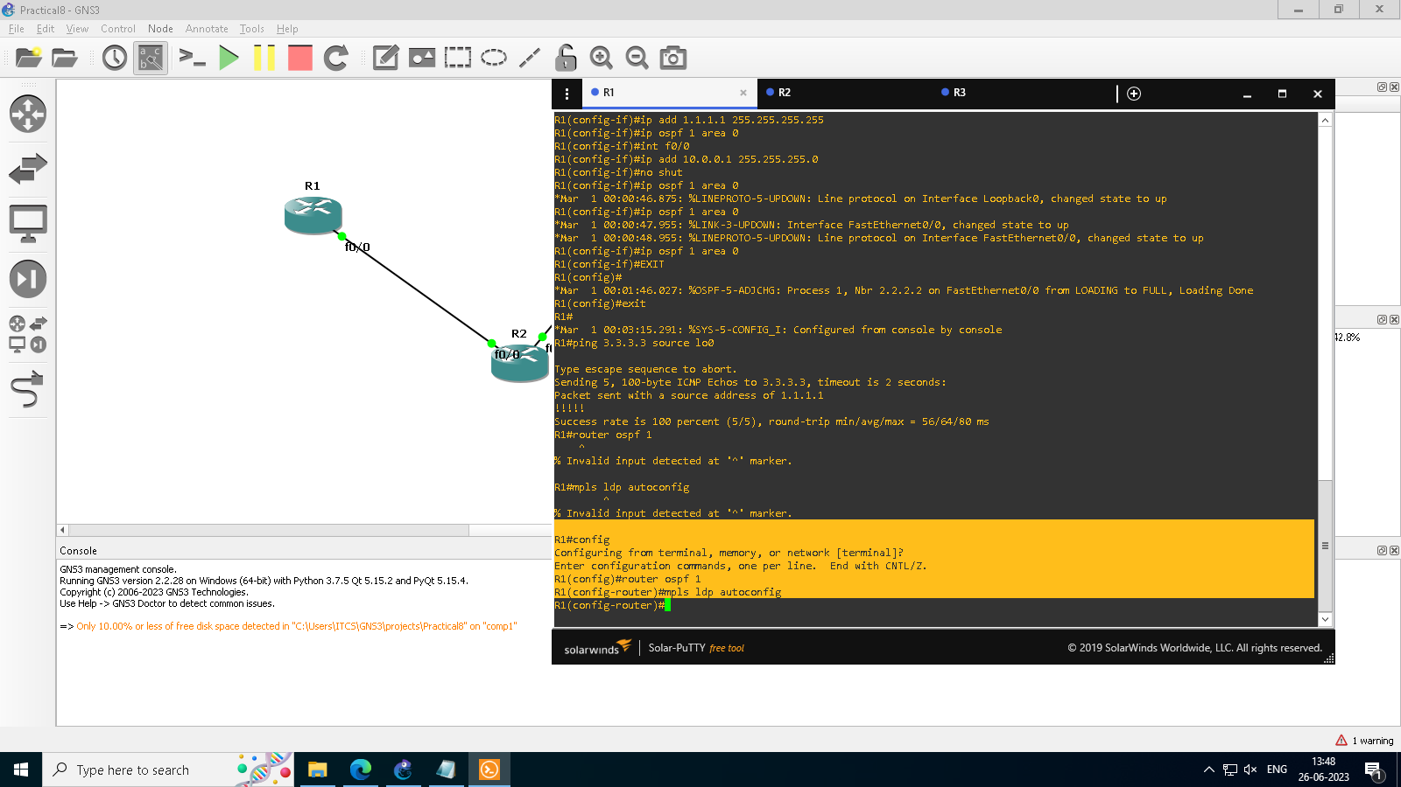

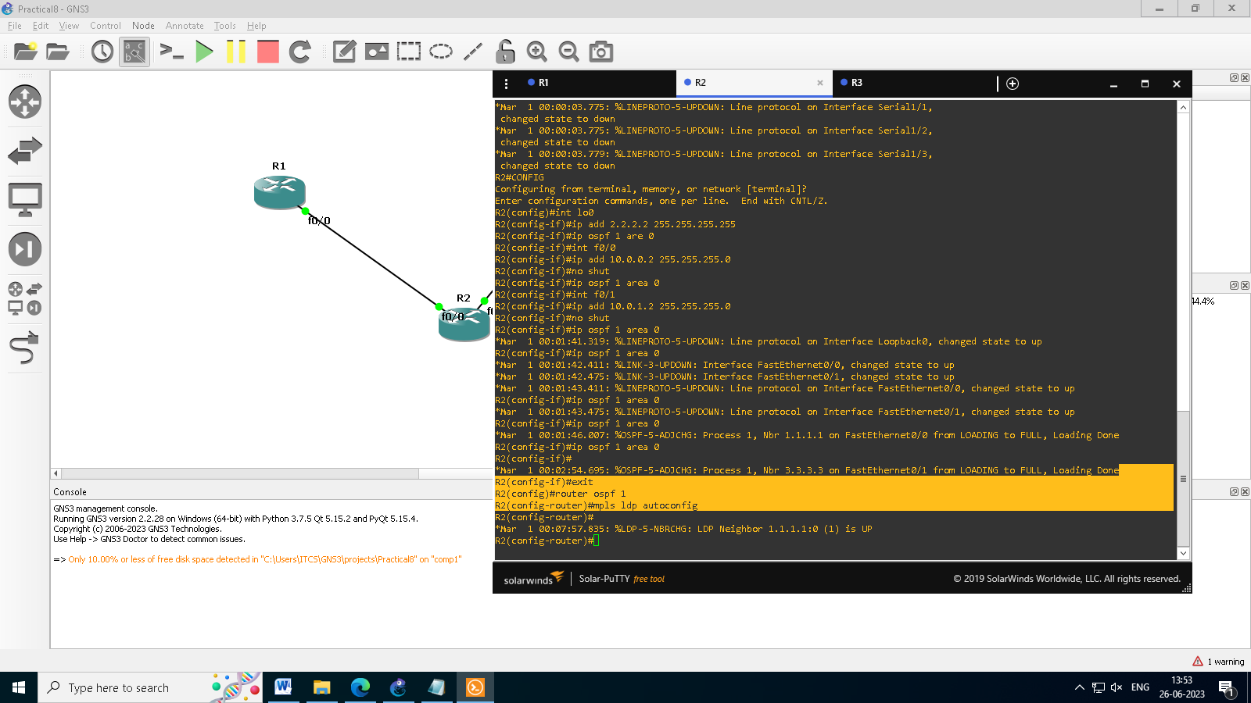

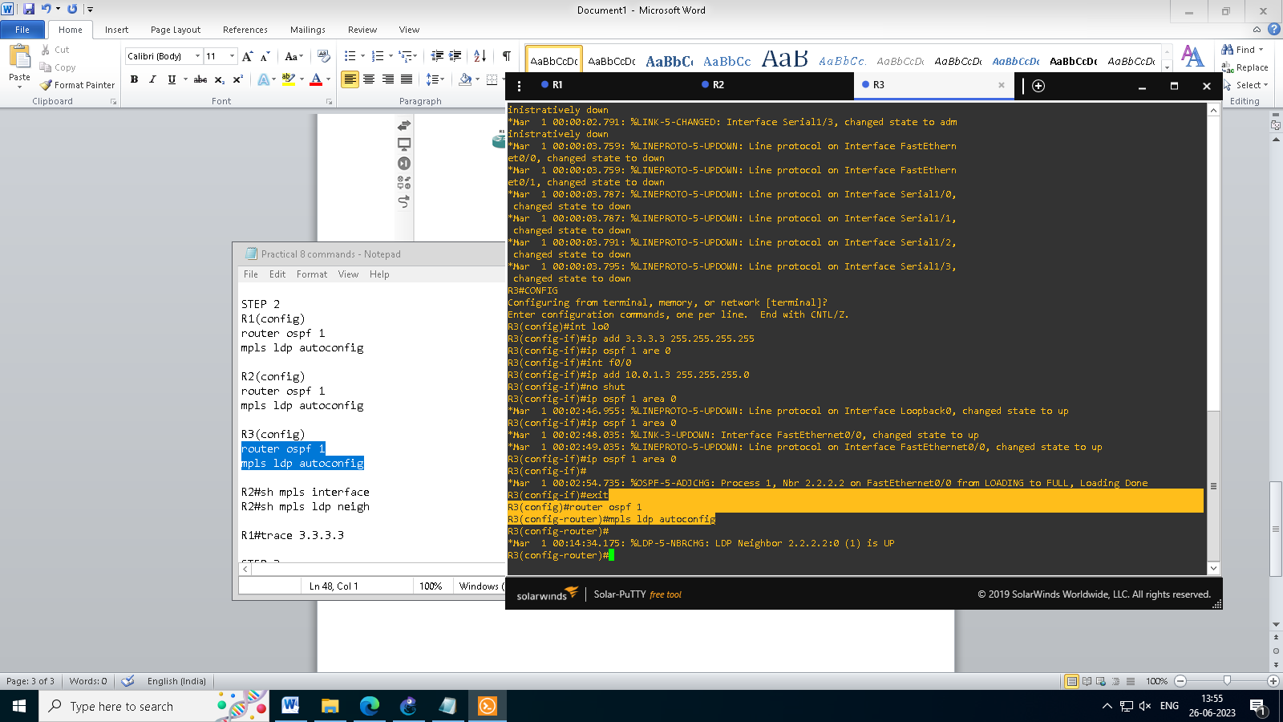

To verify the mpls interfaces the command is very simple – shmpls interface This is done on R2 and you can see that both interfaces are running mpls and using LDP

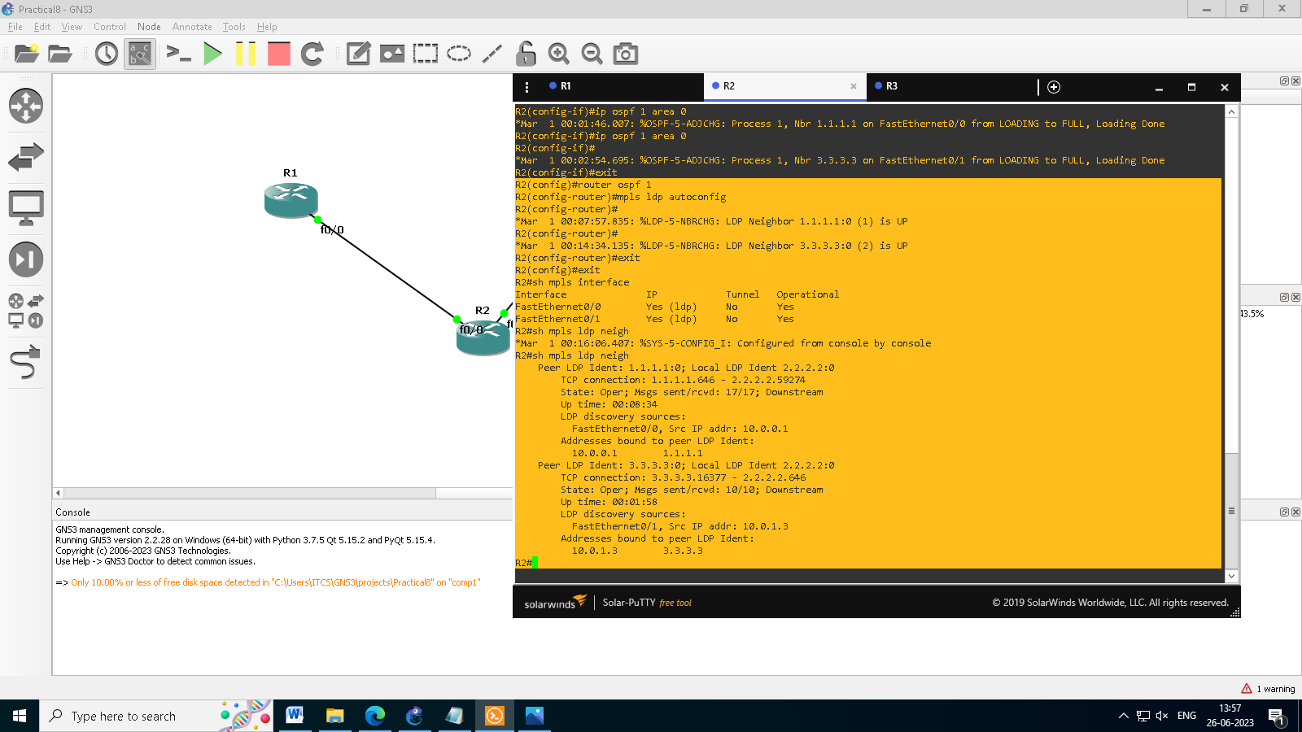

One more verification to confirm LDP is running ok is to do a trace between R1 and R3 and verify if you get MPLS Labels show up in the trace.

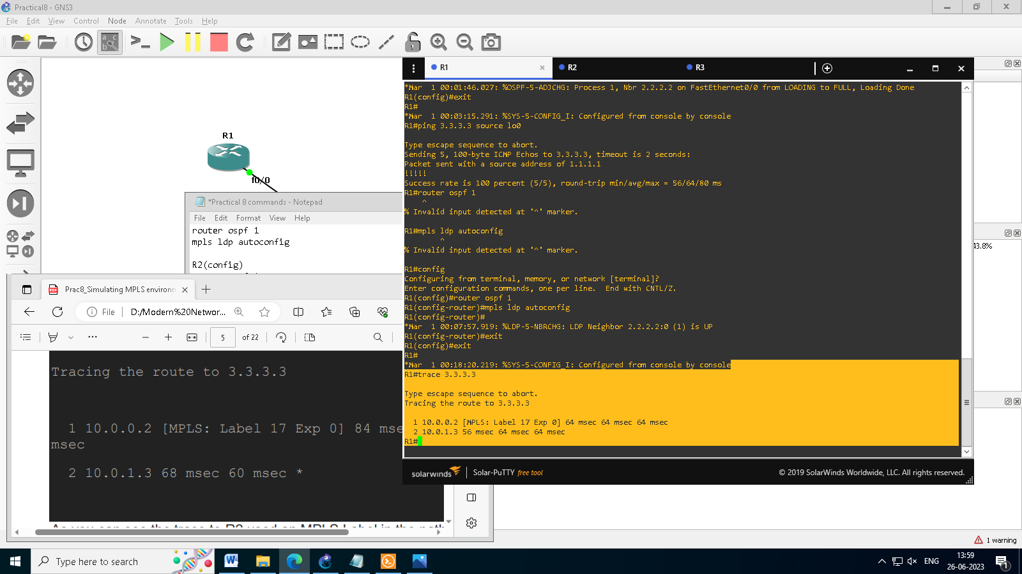

So to review we have now configured IP addresses on the MPLS core, enabled OSPF and full IP connectivity between all routers and finally enabled mpls on all the interfaces in the core and have established ldpneighbors between all routers.

The next step is to configure MP-BGP between R1 and R3

This is when you start to see the layer 3 vpn configuration come to life

**Step 3 : MPLS BGP Configuration between R1 and R3**

We need to establish a Multi Protocol BGP session between R1 and R3 this is done by configuring the vpnv4 address family as below

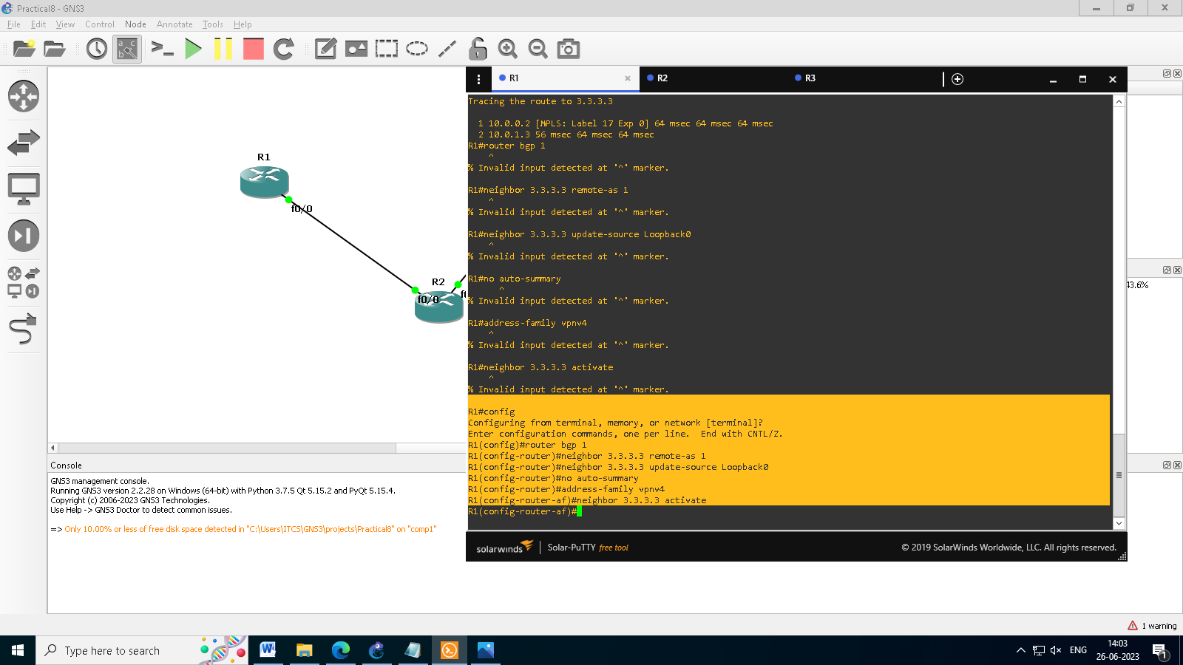

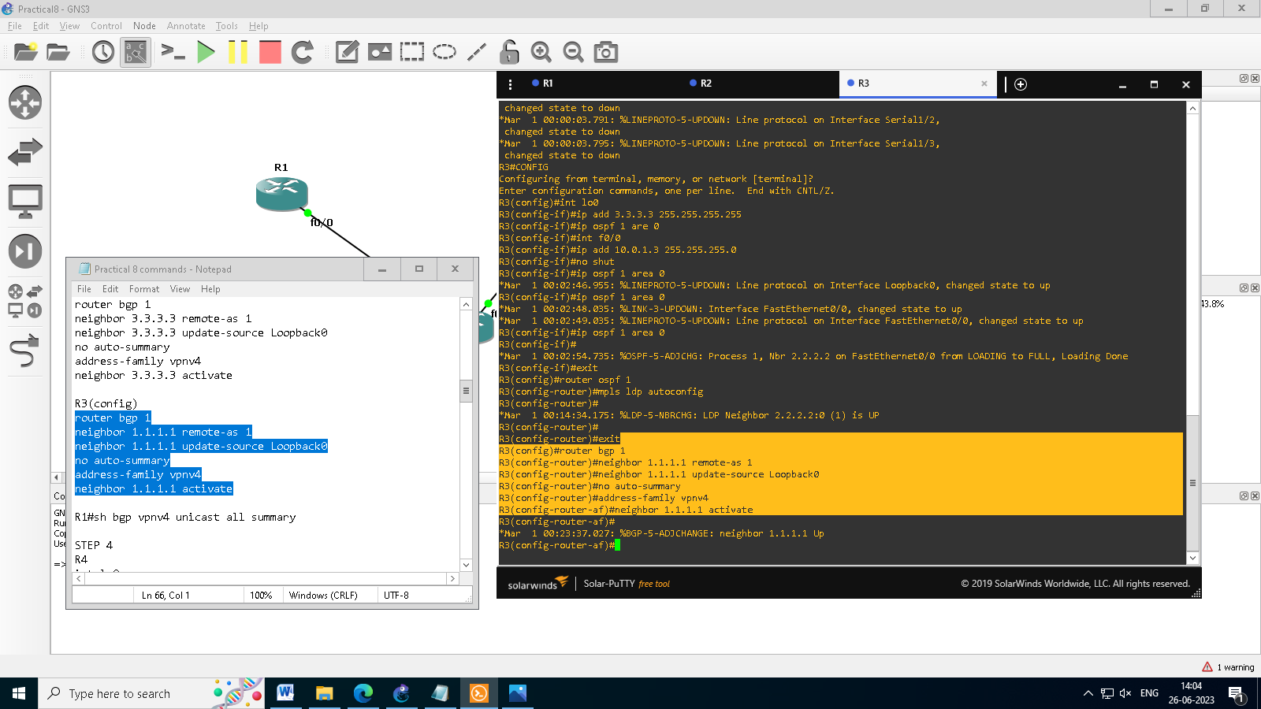

You should see log messages showing the BGP sessions coming up.

To verify the BGP session between R1 and R3 issue the command shbgp vpnv4 unicast all summary

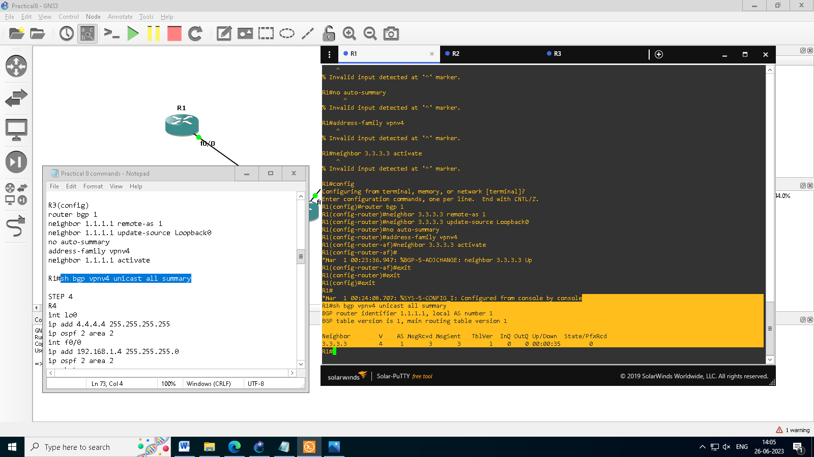

You can see here that we do have a bgp vpnv4 peering to R3 – looking at the PfxRcd you can see it says 0 this is because we have not got any routes in BGP. We are now going to add two more routers to the topology. These will be the customer sites connected to R1 and R3. We will then create a VRF on each router and put the interfaces connected to each site router into that VRF.

**PRACTICAL NO :- 8**

**Aim:- Simulating VRF**

We will add two more routers into the topology so it now looks like the final topology.

Router 4 will peer OSPF using process number 2 to a VRF configured on R1. It will use the local site addressing of 192.168.1.0/24.

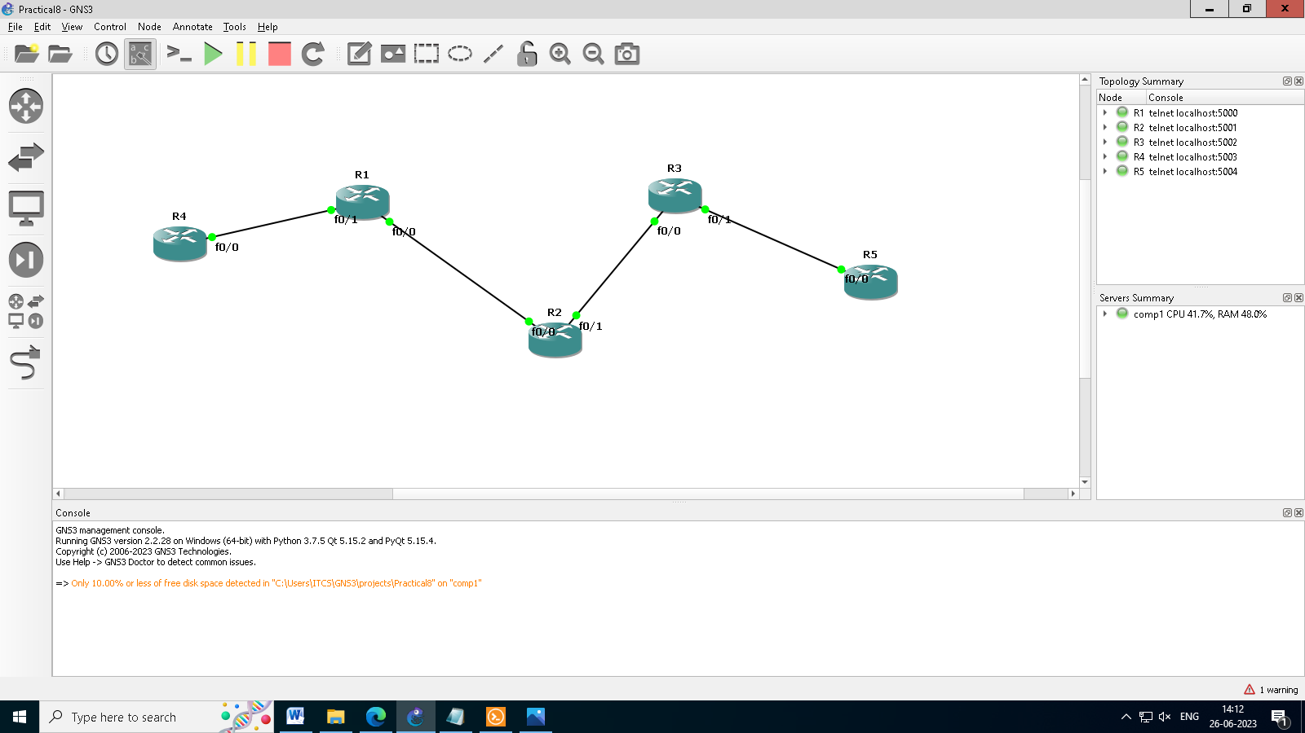

Now at this point we have R4 peering to R1 but in the global routing table of R1 which is not what we want.

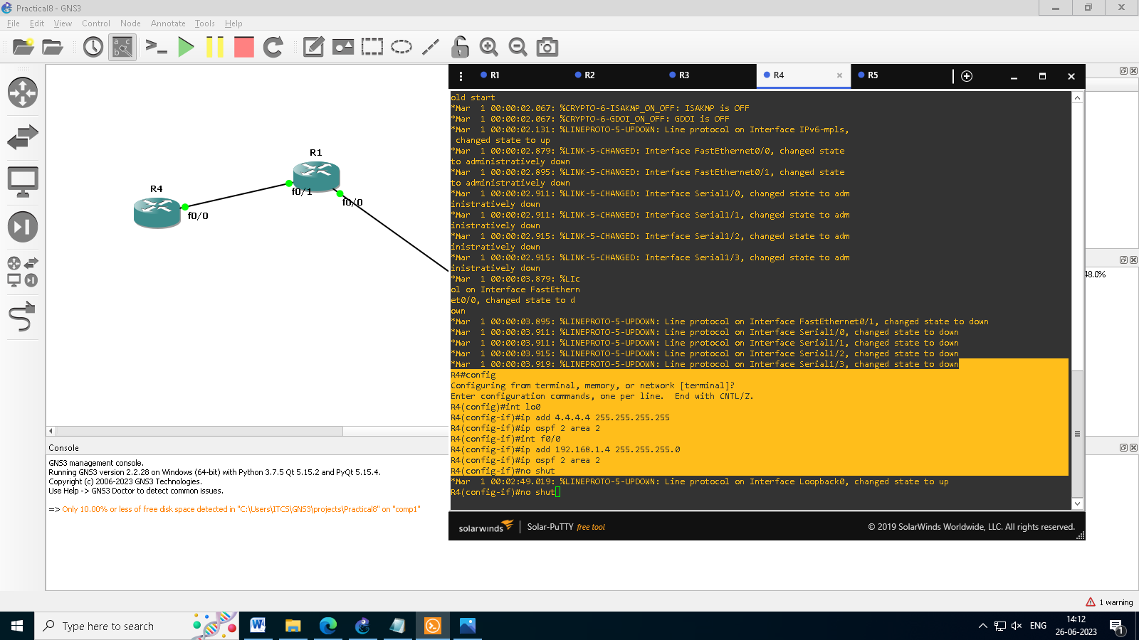

As an example if R1 was a PE Provider Edge router of an ISP and it had two customers that were both addressed locally with the 192.168.1.0/24 address space it could accommodate both their routing tables in different VRFs – it distinguishes between the two of them using a Route Distinguisher.

So back to the topology – we now need to create a VRF on R1

For this mpls tutorial we will be using VRF RED

The RD and route-target do not need to be the same – and for a full explanation please read this post on Route Distinguishers Route Distinguisher vs Route Target before proceeding.

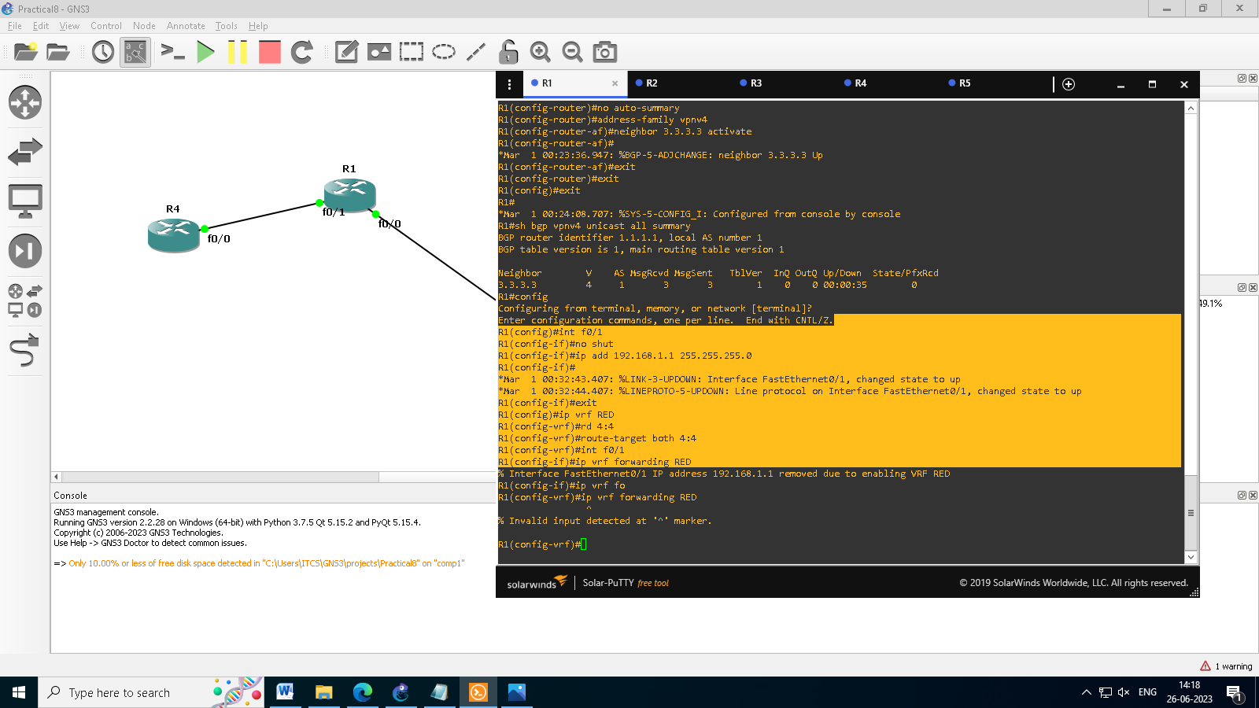

So now we have configured the VRF on R1 we need to move the interface F0/1 into that VRF

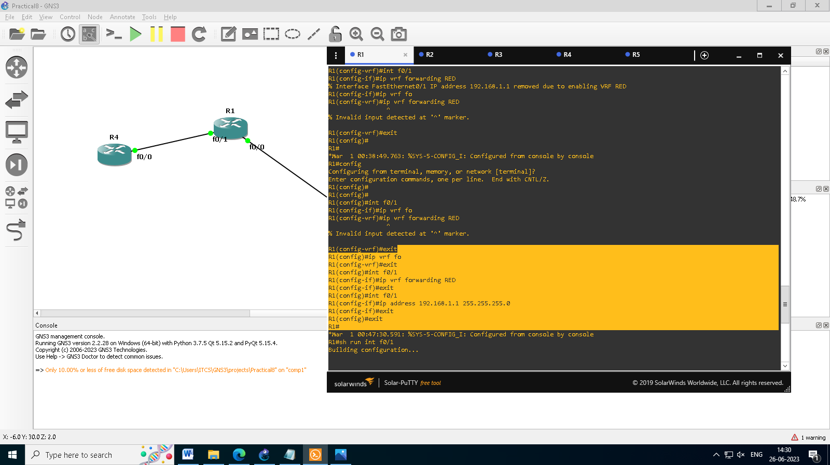

Now if we view the config on R1 int f0/1 you can see the VRF configured.

If you now issue the command ship route vrf red – this will show the routes in the routing table for VRF RED

Now we can start to look int VRF’s and how they operate –

you need to understand now that there are 2 routing tables within R1

• The Global Routing Table

• The Routing Table for VRF RED

**NOTE**: The VRF name is case sensitive!

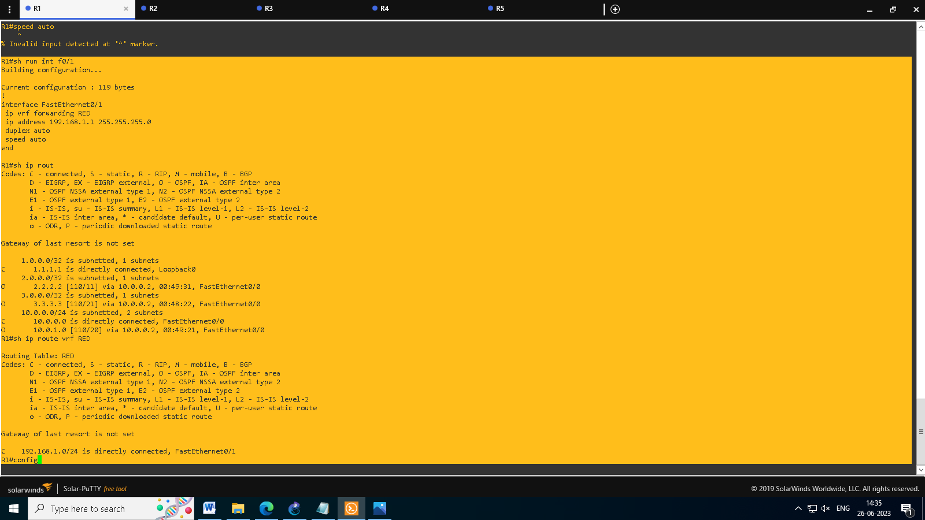

We just need to enable OSPF on this interface and get the loopback address for R4 in the VRF RED routing table before proceeding.

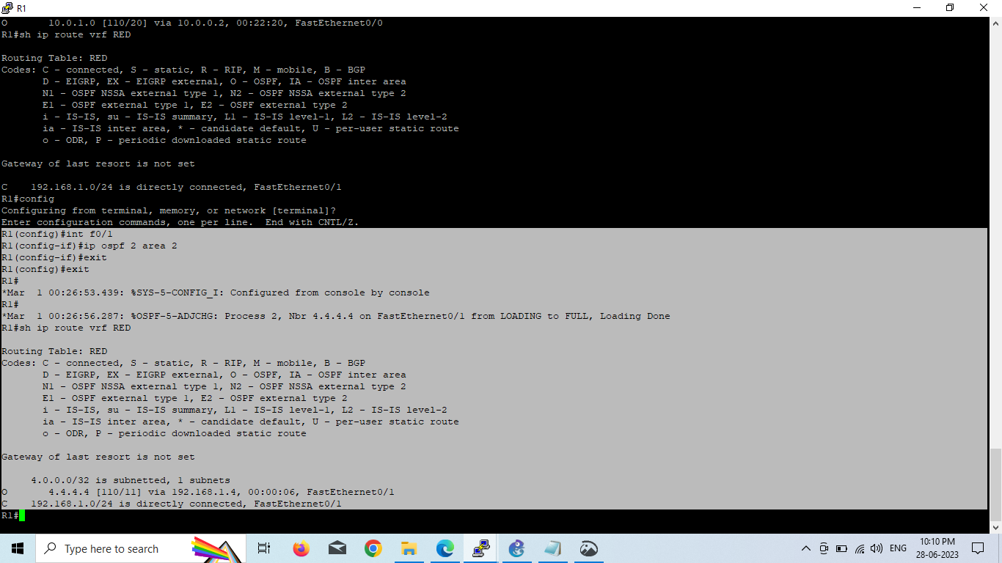

We now need to repeat this process for R3 & R5

Router 5 will peer OSPF using process number 2 to a VRF configured on R3. It will use the local site addressing of 192.168.2.0/24.

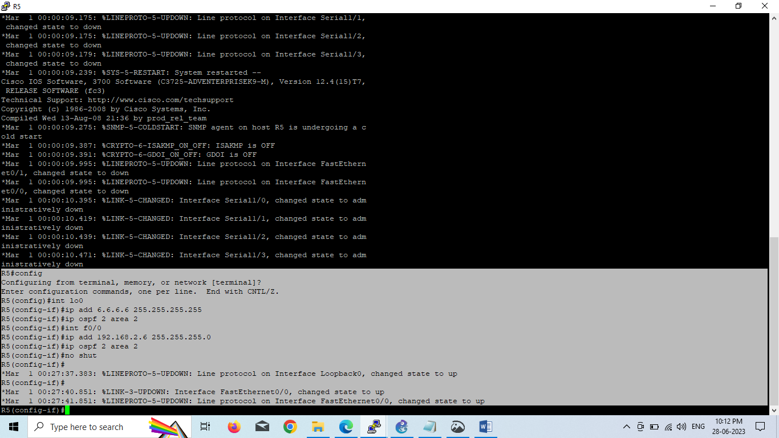

We also need to configure a VRF onto R3 as well

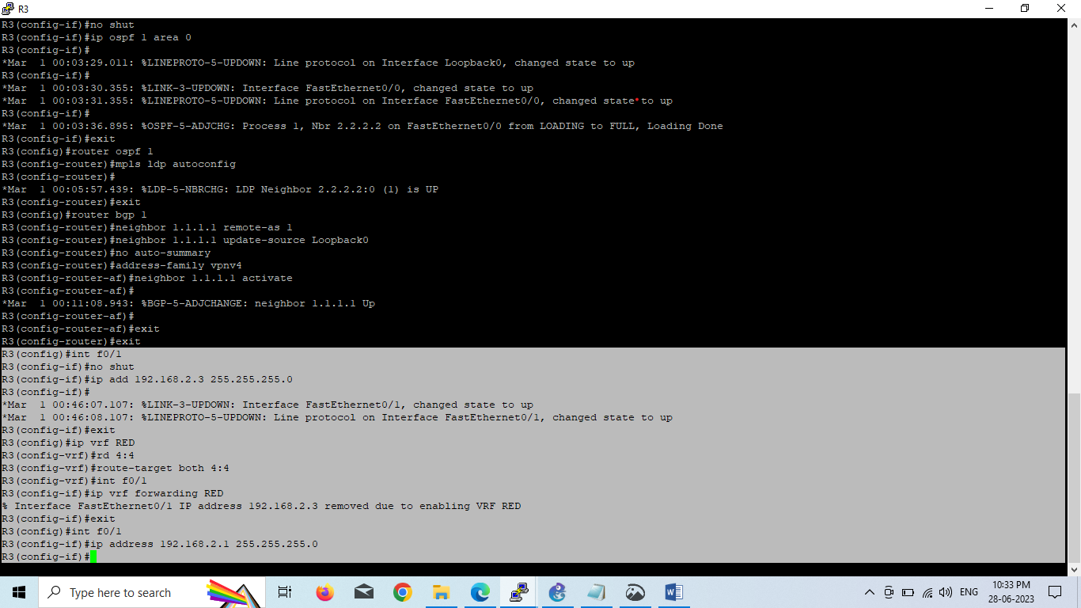

Now if we view the config on R3 int f0/1 you can see the VRF configured.

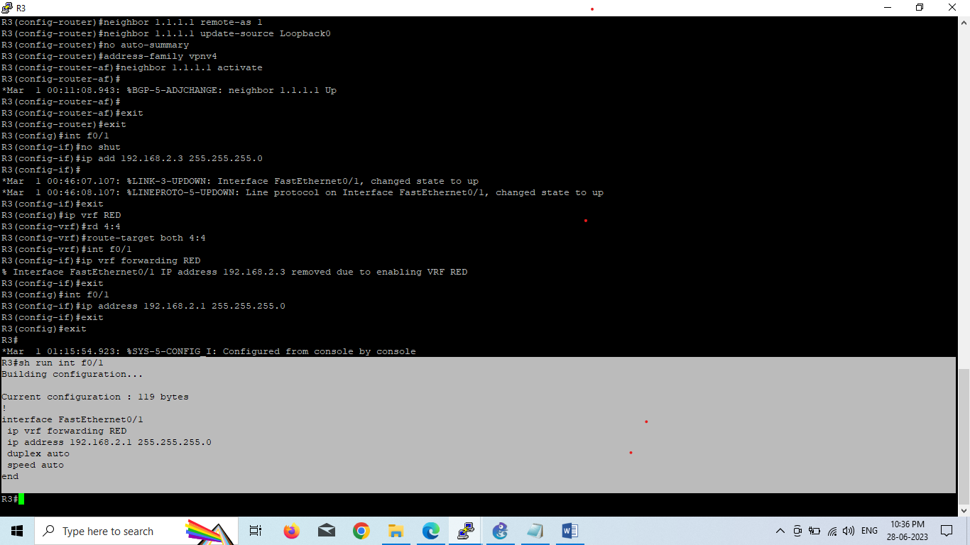

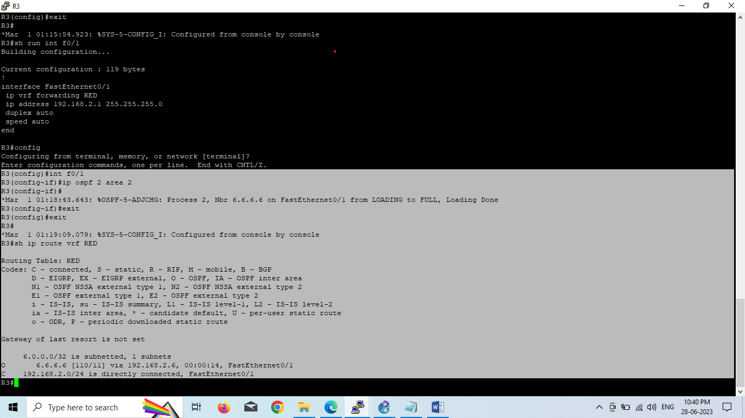

R1,R2,R3 form the MPLS Core and are running OSPF with all loopbacks running a /32 address and all have full connectivity. R1 and R3 are peering with MP-BGP. LDP is enabled on all the internal interfaces. The external interfaces of the MPLS core have been placed into a VRF called RED and then a site router has been joined to that VRF on each side of the MPLS core – (These represent a small office)

The final step to get full connectivity across the MPLS core is to redistribute the routes in OSPF on R1 and R3 into MP-BGP and MP-BGP into OSPF, this is what we are going to do now.

We need to redistribute the OSPF routes from R4 into BGP in the VRF on R1, the OSPF routes from R6 into MP-BGP in the VRF on R3 and then the routes in MP-BGP in R1 and R3 back out to OSPF

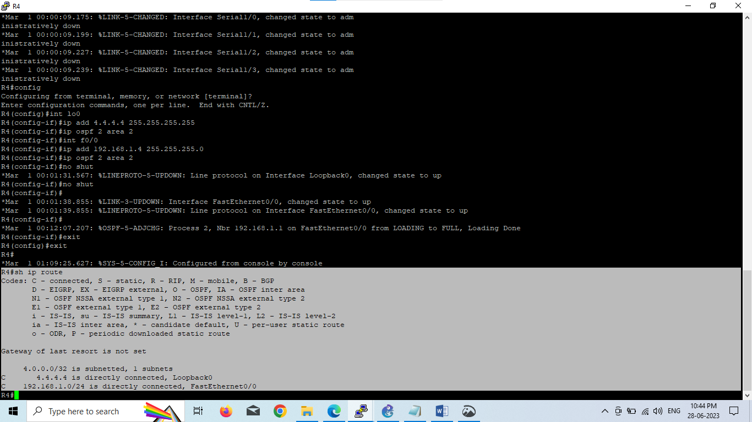

Check the routes on R1

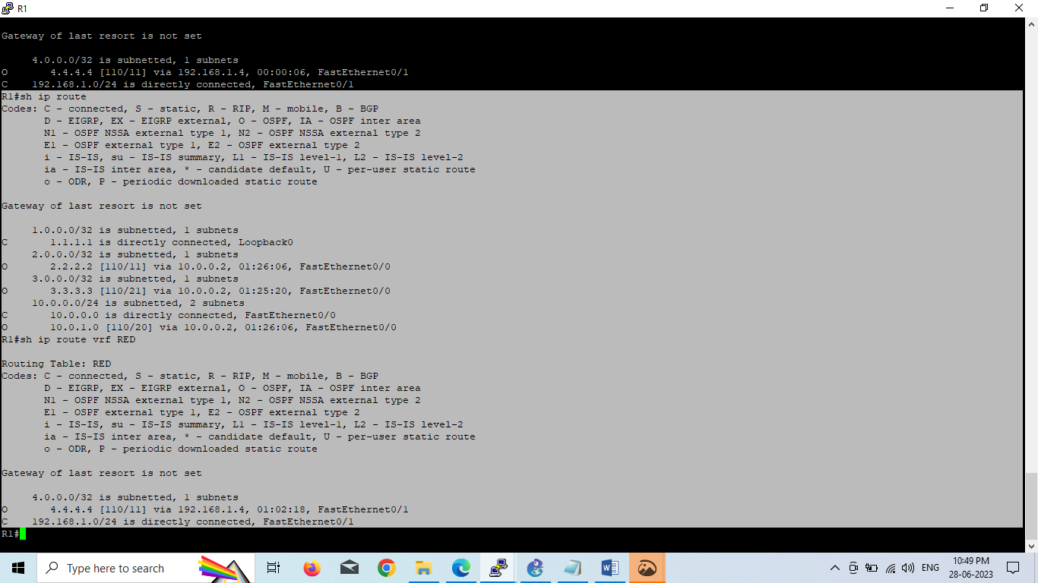

Here you can see Routing Table: RED is shown and the routes to R4 are now visible with 4.4.4.4 being in OSPF.

So we need to do the following;

• Redistribute OSPF into MP-BGP on R1

• Redistribute MP-BGP into OSPF on R1

• Redistribute OSPF into MP-BGP on R3

• Redistribute MP-BGP into OSPF on R3

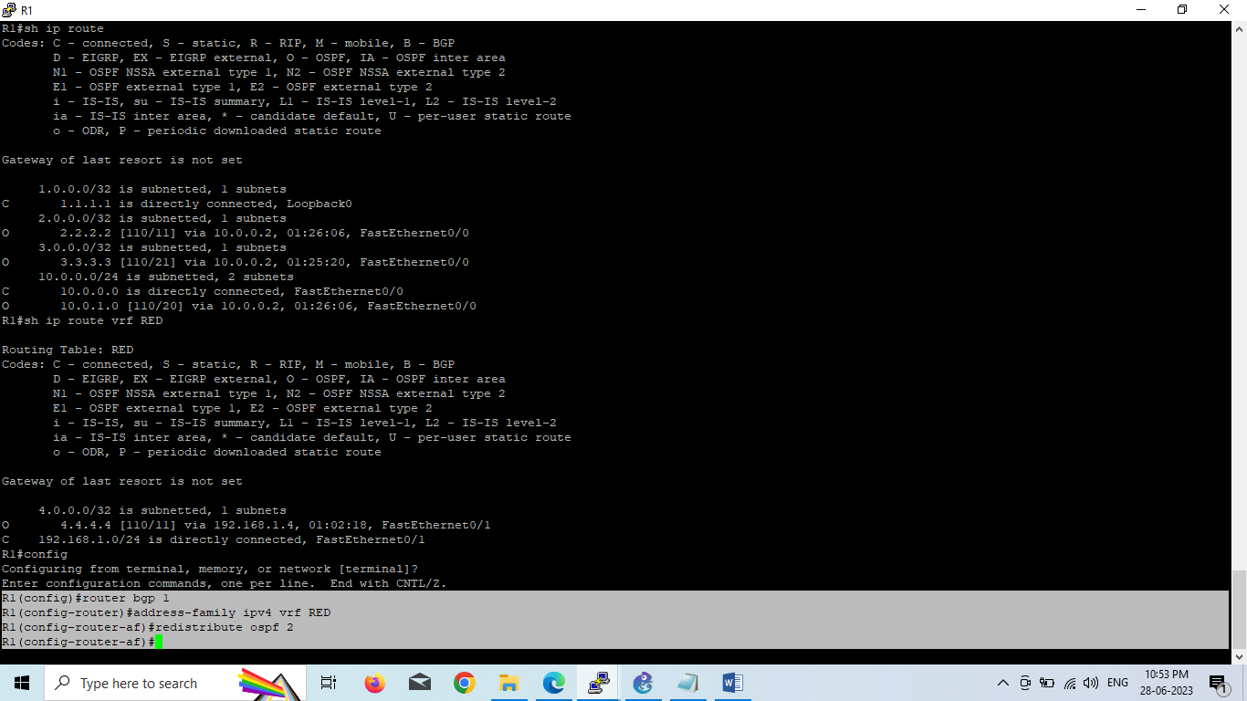

Redistribute OSPF into MP-BGP on R3

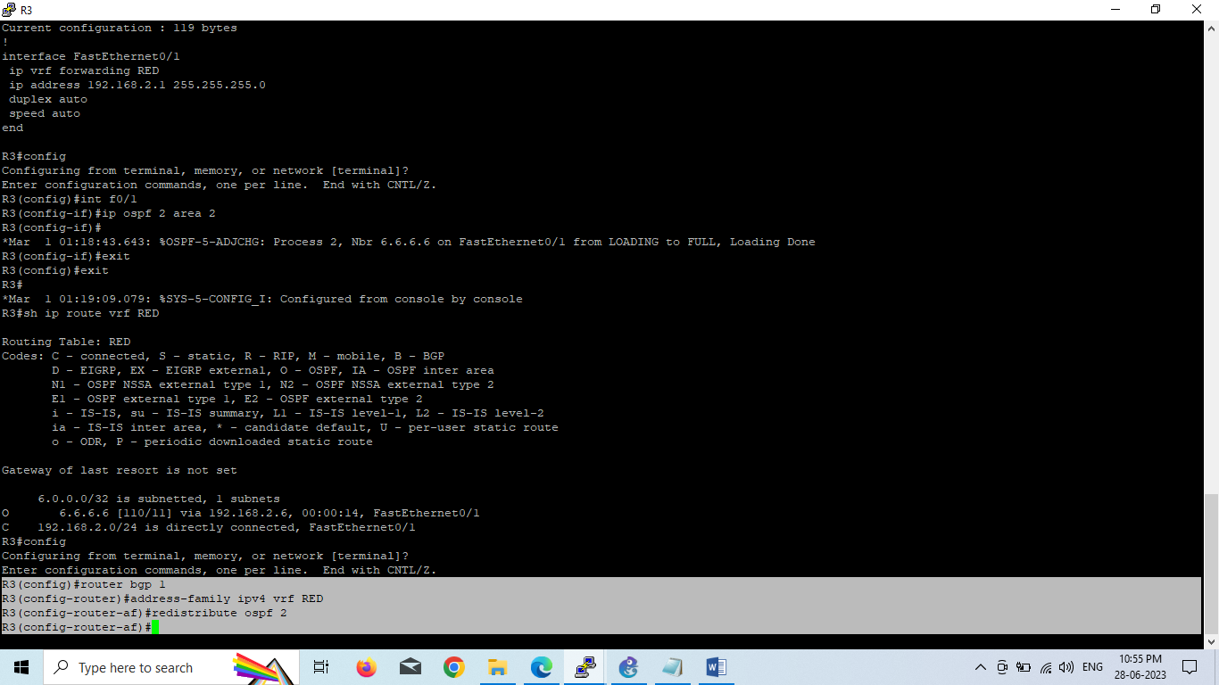

This has enabled redistribution of the OSPF routes into BGP.

We can check the routes from R4 and R5 are now showing in the BGP table for their VRF with this command.

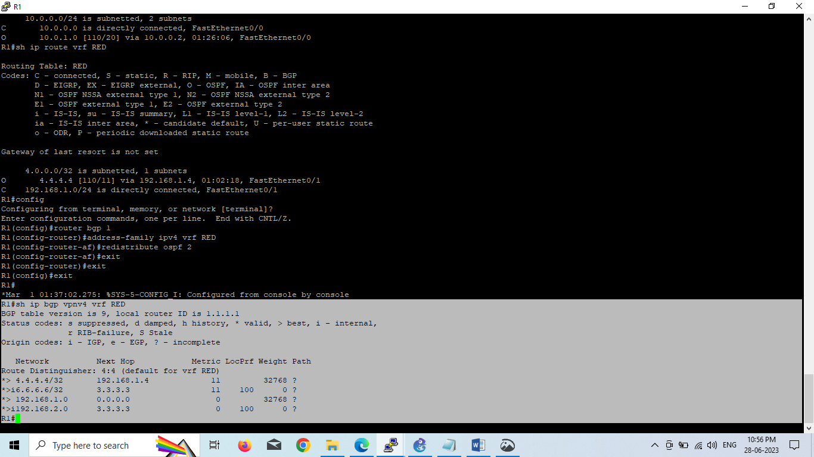

Here we can see that 4.4.4.4 is now in the BGP table in VRF RED on R1 with a next hop of 192.168.1.4 (R4) and also 6.6.6.6 is in there as well with a next hop of 3.3.3.3 (which is the loopback of R3 – showing that it is going over the MPLS and R1 is not in the picture).

The same should be true on R3

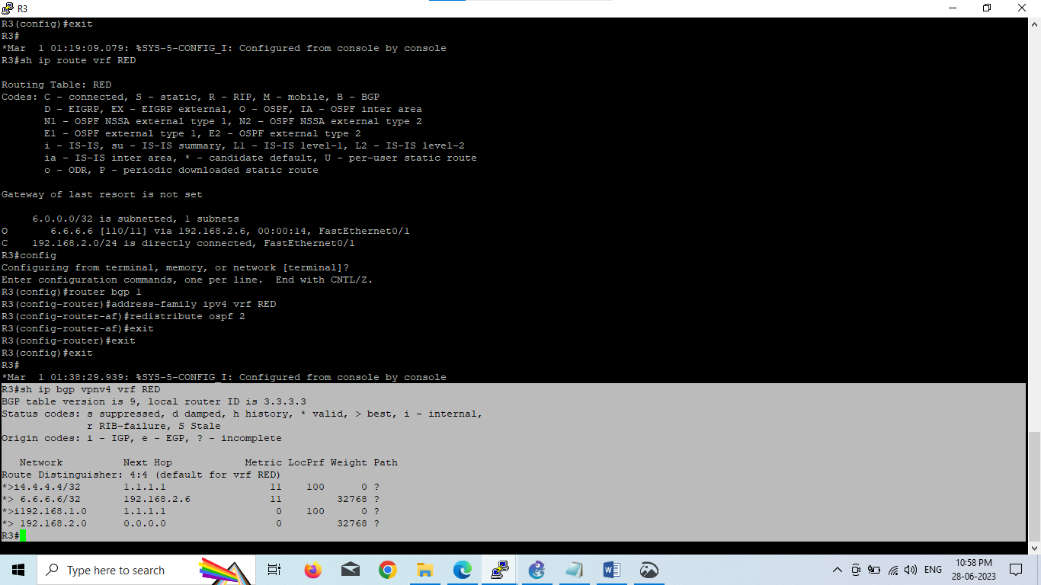

Which it is! 6.6.6.6 is now in the BGP table in VRF RED on R3 with a next hop of 192.168.2.6 (R6) and also 4.4.4 is in there as well with a next hop of 1.1.1.1 (which is the loopback of R1 – showing that it is going over the MPLS and R2 is not in the picture)

The final step is to get the routes that have come across the MPLS back into OSPF and then we can get end to end connectivity

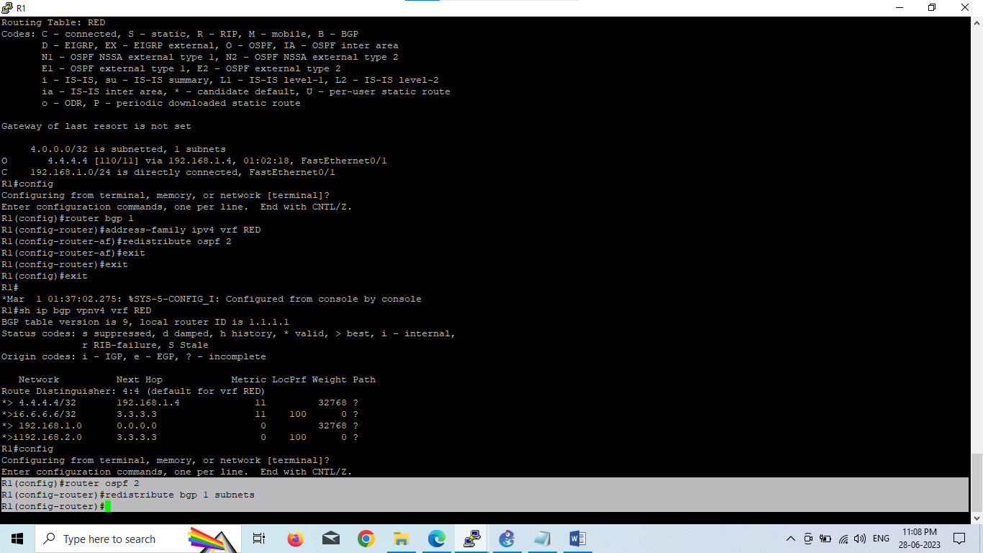

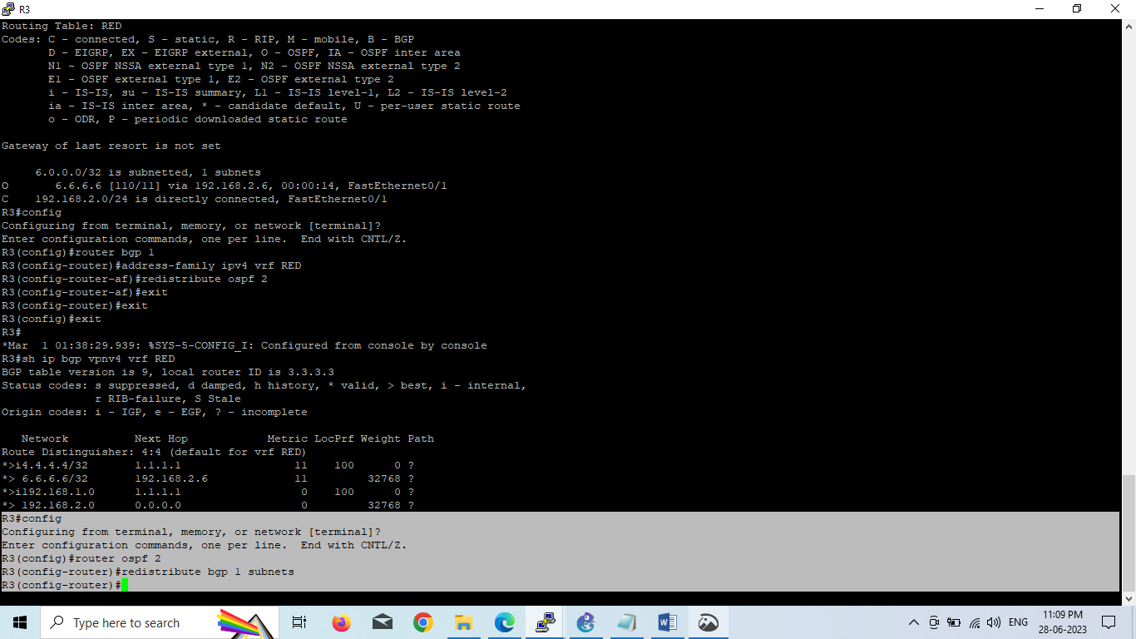

If all has worked we should be now able to ping 6.6.6.6 from R4

**Before we do let’s see what the routing table looks like on R4**

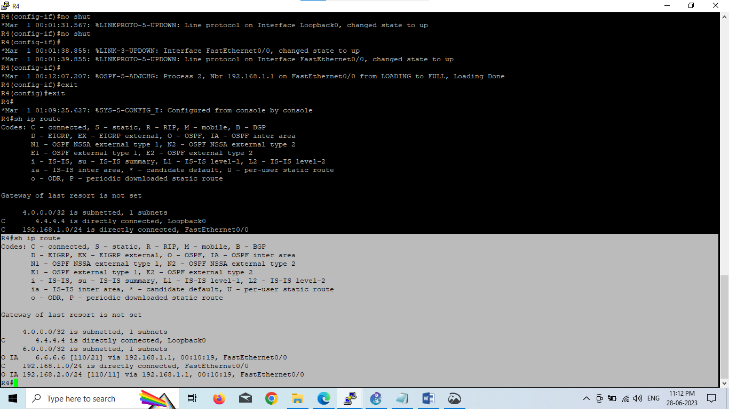

Great we have 6.6.6.6 in there.

Also check the routing table on R5

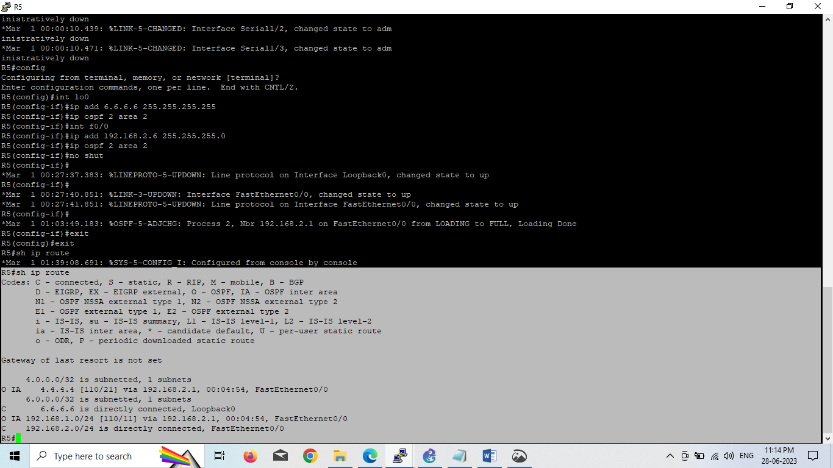

Brilliant we have 4.4.4.4 in there so we should be able to ping across the MPLS. Which we can – to prove this is going over the MPLS and be label switched and not routed, lets do a trace

